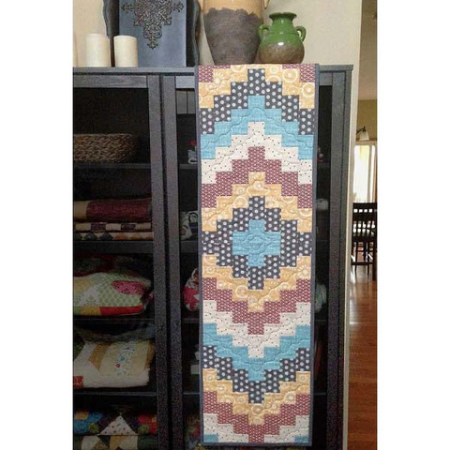
Bargello Table Runner Workshop

Time: 10:00 am – 4: 30 pm

Place: Uptown Blanco Retreat House, 514 3rd Street, Blanco

Instructor: Lucy Blum

Cost: $45.00

Finished size: 14 1/2” x 55”

Learn to make this table runner applying the Bargello piecing technique using the Waverunner pattern by GE Designs! Lucy will walk you through the steps to put this 14 1/2” x 55” table runner together, from organizing your fabrics, to cutting your strips, and piecing it together. Select Fall or Christmas fabric to decorate your table during the holidays. This would also be a lovely gift to give. Note: We will not be quilting the table runner during class.

Fabric Requirements:
- (5) Fat Quarters
- 1/3 yard for binding
- 1 yard for backing
- 16” x 60” batting
- Coordinating thread

Required Supplies:
- Sewing machine, power cord, foot pedal
- Waverunner Pattern from GE Designs – available for purchase at the Textile Studio
- Sewing supplies: seam ripper, pins, bobbins, clips & thread
- 45 mm rotary cutter, cutting mat, & ruler

General Information:
- A 10% discount will be provided for any products or supplies purchased for the workshop. Please plan on arriving prior to 10 am to set up and be ready to go.
- A lunch break will be provided, bring your own lunch or plan on ordering from one of the local restaurants
- The Retreat House provides two ironing stations. You may bring a small portable iron and ironing mat if you prefer

