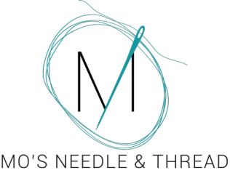
120 Maple St
Portland, MI 48875
517-647-5430
www.mosneedleandthread.com
www.facebook.com/groups/mosneedleandthread
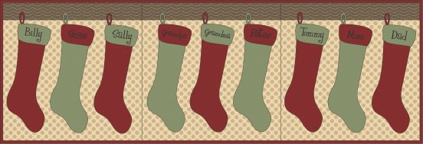
Dear Friends,
Whether we like it or not, Christmas is coming faster than we can hang our stockings! We know how hard you have all worked this year, and it's time to treat yourself! Over the next 12 days you will receive an email with daily deals exclusive to our email/facebook customers. For those that are new to our Stuff My Stocking event, let me explain how it works.
December 1st through the 12th you will receive an email from me with some fun Notions at a discounted rate to stuff your stocking! Since we have added Needlework to the shop, I thought it only fair to include not only Quilting Notions, but Needlework Notions as well. Many can be used by both hobbies. If I deem the special usable to both hobbies, there will only be one option. If I feel like an item is too specific to one side, I will offer two options. As an added bonus, you can claim both deals! If you see something you like, simply reply to the email, asking me to add it to your stocking! You only have 24 hours to reply and claim the daily deal! There is no limit on the amount that you order, so please specify the quantity and color (if that is an option). We do have a limited amount in stock, but we will try to have items re-ordered and back in stock by the 19th if possible. If you do not wish to add any of the items, simply do not reply. Email daily choices to mosneedleandthread@outlook.com
Items will be available for pick up on the 19th. All items must be paid for by December 31st. If you cannot pick your items up before the 31st, please call the shop with your information so that we may charge it. I am willing to ship items at your cost.
So now that the logistics are out of the way, let's get to the good stuff. Time to reveal your Day 9 Deals.

Deal #9: Thread Cutter Caddy-Retail $12.39 Sale $9.91
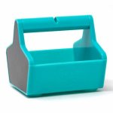
Ideal for cutting threads between chain pieced fabric. It can hold small items such as pins or thimbles. You could also use it to hold beads, or your thread tails. Magnetic sides catch pins or needles.
Deal #9: SewTites Magnetic Pin Mixer 3pk-Retail $9.39 Sale $7.51
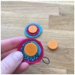 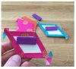 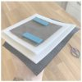 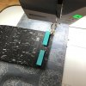 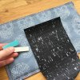
Stop putting holes in your high-end fabrics and materials – SewTites keep your pieces aligned without them! Securely hold together leather, cork, and other thick materials while you sew – simply align, snap on, and sew! Easily work your English Paper Piecing and foundation paper piecing projects. No more hand cramping and moving around pins and clips! Perfect to use when finishing needlework smalls or bags!
Remember, you only have 24 hours to reply to this email in order to stuff your stocking! There is no limit on the amount that you can order, so please specify the quantity and color (if that is an option). It is very important to include both your first AND last name, as well as your phone number. If you do not wish to add any of the items, simply do not reply to the email.
Happy Shopping!
-MO

