STUFF MY STOCKING: DAY 7

Dear Friends,
Whether we like it or not, Christmas is coming faster than we can hang our stockings! We know how hard you have all worked this year, and it's time to treat yourself! Over the next 12 days you will receive an email with daily deals exclusive to my email/facebook customers. For those that are new to my Stuff My Stocking event, let me explain how it works.
December 1st through the 12th you will receive an email from me with some fun notions (at a discounted rate) to stuff your stocking! Because I carry both Quilting and Cross Stitch supplies, I will be offering both Quilting notions and Needlework notions. Many can be used by both hobbies. As an added bonus, you can claim both deals! If you see something you like, simply click the link at the bottom of this email and fill out the form. It is very important that you use the same email/phone/name on each form that you fill out! You only have 24 hours to claim the daily deal! There is no limit on the amount that you can order. We have a limited amount in stock, but we will try to have items re-ordered and back in stock by the 21st if possible. If you do not wish to add any of the items, simply do not respond.
Our goal is to have your items available for pick up on the 21st. All items must be paid for by December 31st. It's ok if you cannot pick them up by the 31st, as long as they are paid for. I am also willing to ship items at your cost.
So now that the logistics are out of the way, let's get to the good stuff. Time to reveal your Day 7 Deals!
Deal #7: Cindy's Seam Ripper (Riley Blake)- Retail $10.39 Sale: $8.31
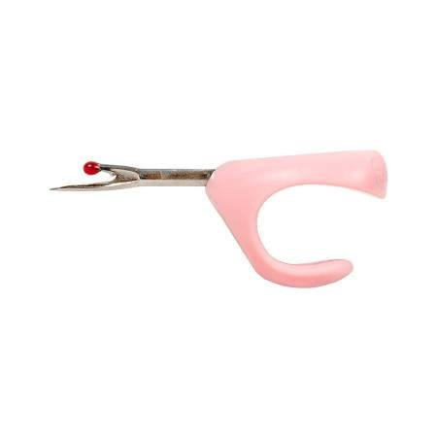
- Unique design gives you more controled.
- Perfect for cutting threads and ripping out seams.
- size: Approx 1in x 2in.

Illuminating Tweezer-Retail $5.39 Sale: $4.31
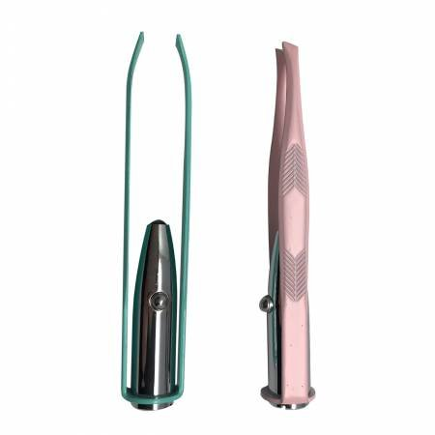 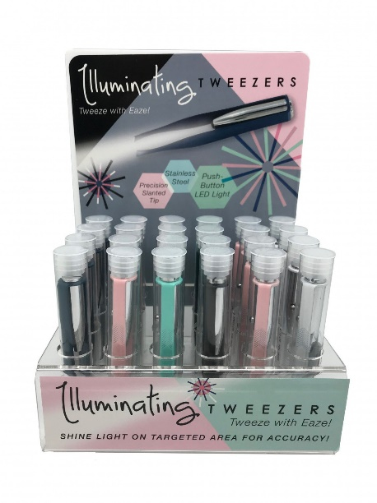
A cutting edge approach to primping, or pulling out threads. Easy push button LED light for targeted accuracy. Precision angled tip. Colors are assorted, choice not an option.
Needle Puller 3 in 1-Retail $12.49 Sale: $9.99
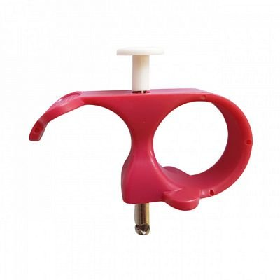
Needle puller - Perfect 3 in 1 (needle puller+cutter+thimble). Ideal for hand sewing heavy weight. It has an ergonomic design that prevents pain and soreness in fingers since the puller does the needle grabbing for you. Also helps to allow for more multiple stitches at one time to be carried on the needle. No more pulling the needle through with scissors or straining your fingers.
Remember, you only have 24 hours to complete the form in this email! There is no limit on the amount that you can order.
It is very important that you use the link below and fill out the form with the same name/email/phone number each day!
CLICK HERE TO ORDER!
If you do not wish to add any of the items, simply do not respond.
Happy Shopping!

