STUFF MY STOCKING: DAY 12
Dear Friends,
Whether we like it or not, Christmas is coming faster than we can hang our stockings! We know how hard you have all worked this year, and it's time to treat yourself! Over the next 12 days you will receive an email with daily deals exclusive to my email/facebook customers. For those that are new to my Stuff My Stocking event, let me explain how it works.
December 1st through the 12th you will receive an email from me with some fun notions (at a discounted rate) to stuff your stocking! Because I carry both Quilting and Cross Stitch supplies, I will be offering both Quilting notions and Needlework notions. Many can be used by both hobbies. As an added bonus, you can claim both deals! If you see something you like, simply click the link at the bottom of this email and fill out the form. It is very important that you use the same email/phone/name on each form that you fill out! You only have 24 hours to claim the daily deal! There is no limit on the amount that you can order. We have a limited amount in stock, but we will try to have items re-ordered and back in stock by the 21st if possible. If you do not wish to add any of the items, simply do not respond.
Our goal is to have your items available for pick up on the 21st. All items must be paid for by December 31st. It's ok if you cannot pick them up by the 31st, as long as they are paid for. I am also willing to ship items at your cost.
So now that the logistics are out of the way, let's get to the good stuff. Time to reveal your Day 12 Deals!
Deal #12: Magic Pins Quilting Fine 50pc-Retail $11.39 Sale: $9.11
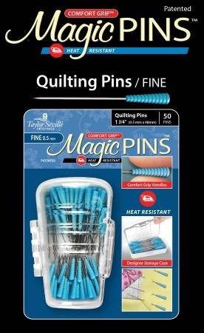
I LOVE THESE PINS!! Comfort Grip, Heat Resistant, 50pc. Taylor Seville Originals Notions make your sewing life easier. The Comfort Grip Magic Pins Fine Quilting are 1 3/4" and .5mm. They have a comfort grip head that makes picking up and maintaining a grip on the pin, easy. The Comfort Grip Magic Pins are also heat resistant, so if you iron over them, they will not be ruined. The pins come in a designer storage case that closes, so you won’t lose any pins!
Deal #12X: Stitcher's Lotion 4 oz-Retail $8.39 Sale: $6.71
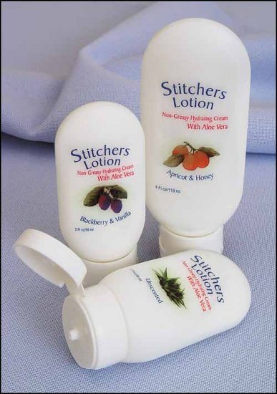
Luxuriously soothing light weight lotion that is safe to use even while stitching. Won’t stain your fabric or threads. Easily washes out if any would happen to get onto your project. CHOOSE FROM UNSCENTED, CINNAMON, BLACKBERRY/VANILLA, RASPBERRY/ORANGE.
Remember, you only have 24 hours to complete the form in this email! There is no limit on the amount that you can order.
It is very important that you use the link below and fill out the form with the same name/email/phone number each day!
CLICK HERE TO ORDER!
If you do not wish to add any of the items, simply do not respond.
In case you missed any of the previous emails, the deals are listed below. Items out of stock, should be in before Christmas, but I cannot guarantee it. I will send you an email as soon as your stocking is ready to be picked up.
STUFF MY STOCKING 2020 RECAP
Day 1: Scissor ID Magnetic Clips $10.39 SALE: $8.31
COVID SPECIAL (25%) 54" Design Wall $125.99 SALE: $94.49
Day 1X: Customizable Needle Threader $4.89 SALE: $3.91
DAY 1 LINK
Day 2: 8" Omnigrid Rotating $25.39 SALE $20.31
Day 2X: Easels Made Easy $16.39 SALE: $13.11
DAY 2 LINK
Day 3: Duckbill Applique Scissors $19.39 SALE: $15.51
Day 3X: Yo Yo Magnifier $25.39 SALE $20.31
DAY 3 LINK
Day 4: Manicure Set $4.79 SALE: $3.83
Bandages $7.39 SALE $5.91
DAY 4 LINK
Day 5: Alphabitties $8.39 SALE $6.71
Expansion Pack $8.39 SALE $6.71
Day 5X: 8" Marbled Scissors $40.39 SALE $32.31
DAY 5 LINK
Day 6: Kaleidoscope $9.39 SALE $7.51
Day 6x: Mesh Bag Set $25.39 SALE $20.31
DAY 6 LINK
Day 7: Cindy S Seam Ripper $10.39 SALE $8.31
Illuminating Tweezer $5.39 SALE: $4.31
Day 7X: Needle Puller $12.49 SALE $9.99
DAY 7 LINK
Day 8: Lori Holt Playing Cards $10.39 SALE: $8.31
Day 8X: Mini Iron $32.39 SALE $25.91
COVID SPECIAL (25%) Mini Iron II With Assortment of Tips $68.39 SALE $51.29
DAY 8 LINK
Day 9: Diagonal Seam Tape $7.89 SALE $6.31
Day 9X: Ironing Blanket $12.39 SALE $9.91
DAY 9 LINK
Day 10: Klutz Glove-LARGE $27.39 SALE $21.91
Day 10X: Easy Ball Tip Needle 24/26/28 $8.39EA SALE $6.71
DAY 1O LINK
Day 11: Sewing Machine Cleaning Brushes $5.39 SALE $4.31
Day 11X: 11" x 11" Q Snap $15.89 SALE: $12.71
DAY 11 LINK
Day 12: Magic Pins $11.39 SALE $9.11
Day 12X: Stitcher's Lotion $8.39 SALE: $6.71
DAY 12 LINK
Thank you so much for participating!
-MO

