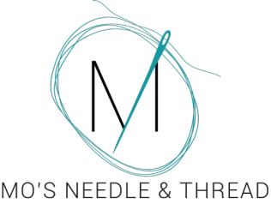
120 Maple St
Portland, MI 48875
517-647-5430
www.mosneedleandthread.com
mosneedleandthread@outlook.com
www.facebook.com/groups/mosneedleandthread
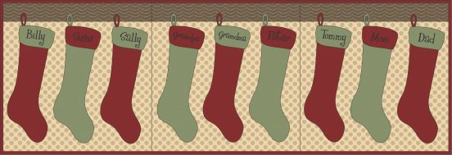

Dear Friends,
Whether we like it or not, Christmas is coming faster than we can hang our stockings! We know how hard you have all worked this year, and it's time to treat yourself! Over the next 12 days you will receive an email with daily deals exclusive to our email/facebook customers. For those that are new to our Stuff My Stocking event, let me explain how it works.
December 1st through the 12th you will receive an email from me with some fun Notions at a discounted rate to stuff your stocking! Since we have added Needlework to the shop, I thought it only fair to include not only Quilting Notions, but Needlework Notions as well. Many can be used by both hobbies. If I deem the special usable to both hobbies, there will only be one option. If I feel like an item is too specific to one side, I will offer two options. As an added bonus, you can claim both deals! If you see something you like, simply reply to the email, asking me to add it to your stocking! You only have 24 hours to reply and claim the daily deal! There is no limit on the amount that you order, so please specify the quantity and color (if that is an option). We do have a limited amount in stock, but we will try to have items re-ordered and back in stock by the 19th if possible. If you do not wish to add any of the items, simply do not reply to the email. For those of you reading this off facebook or my website, email your choices daily to mosneedleandthread@outlook.com
Items will be available for pick up on the 19th. All items must be paid for by December 31st. If you can not pick your items up before the 31st, please call the shop with your information so that we may charge it. I am willing to ship items at your cost.
So now that the logistics are out of the way, let's get to the good stuff. Time to reveal your Day 1 Deals.
Deal #1: Surgeon's Skin Secret Sample Gift Set (Choose from Orange Citrus or Light Lavender for your hand cream. Band-aid Stick and Chap-stick are both unscented.) Retail $15.75/set Sale: $12.60/set
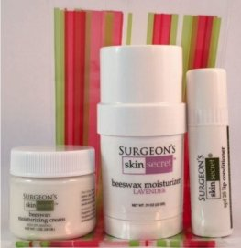
Surgeon's Skin Secret beeswax moisturizer is a non-toxic, all natural skin revitalization formula that is good for all skin conditions. It is made with 50% beeswax, lanolin and light mineral oil. Only a minimal amount is needed to be effective. When applied morning and night it begins to heal dry, chapped, cracked, irritated skin as well as minor cuts, scrapes and burns almost overnight. This long-lasting formula puts a protective coating on your skin that seals in your body's natural moisture so you can wash your hands several times before you need to reapply.

Surgeon’s Skin Secret Cream is a 25% beeswax formula that also last through several hand washings. It is available in a light Lavender and Orange Citrus. This is a not a light weight moisturizer.

Surgeon’s Skin Secret SPF25 Lip Conditioner and Beeswax Moisturizer is a 50% beeswax formula that is unscented and unflavored.
The Beeswax Moisturizer acts as a band-aid and will stop minor bleeding and help seal cracked skin.
Gift Set Includes:
Moisturizing Cream: 3 oz
Beeswax Moisturizer Twist Up Stick: .78 oz
Chapstick: Regular
This comes only as a set. Not available for purchase separately. You do have the choice of scent for your hand cream. Orange Citrus or Light Lavender. The gift set will come packaged in cellophane and tied! The perfect little gift for your secret santa exchange!
Remember, you only have 24 hours to reply to this email in order to stuff your stocking!
Happy Shopping!
-MO

