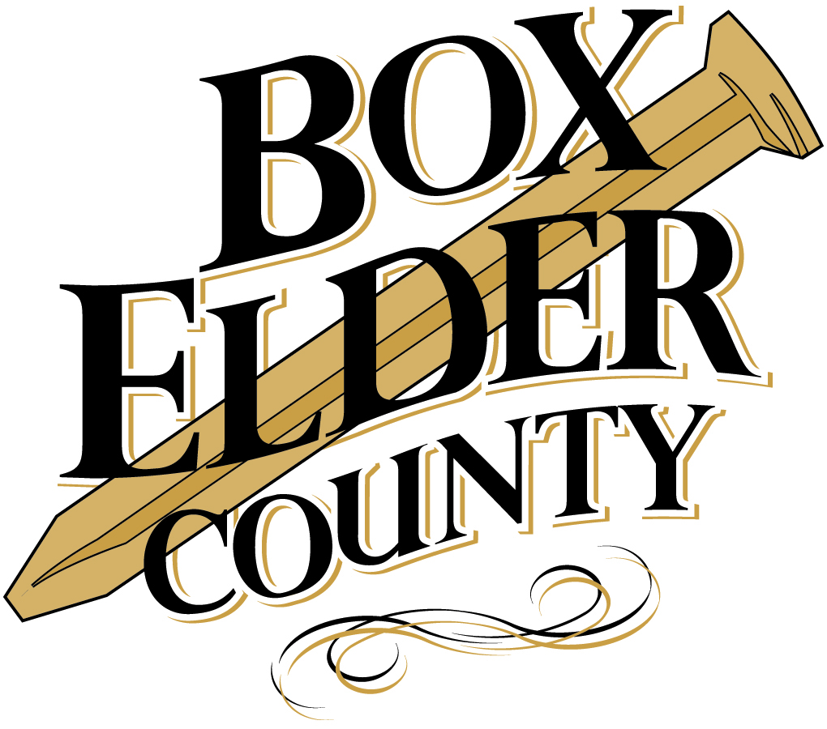
“A Healthier You is a Wealthier You”
WELLNESS INCENTIVE PROGRAM
Introduction:
Your health plan is committed to helping you achieve your best health. Rewards for participating in a wellness program are available to all employees. Employees who participate in the program will receive a discounted health insurance premium and be eligible for chances to win prize drawings during the year. If you think you might be unable to meet a standard for a reward under this wellness program, you might qualify for an opportunity to earn the same reward by different means. Contact Diane Olson at (435) 734-3313 or dolson@boxeldercounty.org or Mariana Hernandez at (435) 734-3348 or MHernandez@boxeldercounty.org and we will work with you (and, if you wish, with your doctor) to find a wellness program with the same reward that is right for you in light of your health status.
Employees will need to complete 8 wellness incentive points by June 30, 2019 to be eligible for the premium discount program and then complete 8 more wellness incentive points from July 1, 2019 through December 31, 2019 to remain eligible for the premium discount program. Of the required 8 points during the first half of the year, a blood test (a.k.a. biometric screening) and a Health Risk Assessment must be completed by March 1, 2019.
All information regarding the wellness incentive program can be found on the county website at www.boxeldercounty.org/employee-wellness.htm. All updates throughout the year can be found on the county website.
Employees must complete the biometric screening and Health Risk Assessment along with 6 additional points by June 30, 2019 to qualify for the wellness premium discount for July 1-December 31, 2019. Employees hired mid-year will be required to meet prorated point amounts depending on the month they are hired. Points are prorated on a 6 month basis (January-June, July-December).
Annual Required Points:
- Complete the online Health Risk Assessment (1 point)
- Complete a free biometric screening (blood test) at the Health Fair (1 point)
  - If you are a CDL holder, the appointment you make for your Medical Card will be considered for your point. Just submit a doctor’s note/paperwork for your point.
  - If you are a new hire and already had a blood test this calendar year in conjunction with another doctor’s appointment, just submit a doctor’s note for your point.
- Complete at least 14 additional wellness incentive points under Wellness Options for a total of 16 per year.
Wellness Options: (See page 25 of Benefits Booklet or the Employee Wellness website for details)
Points may be earned in the following categories:
- Preventive Health Screenings
- Health Management
- Coaching
- Wellness Challenges
- Wellness Seminars
- Weight Management
- Nutrition Option
- PEHP Healthy Utah

- Hiking Challenge
- Races and Events
- Health Class
- Community Events
- Health-Related Reading
- Exercise Option
- PEHP MyWellness Tracker

There is an additional award incentive for employees who achieve more than 16 wellness incentive points in the benefit year. For every point you earn over 16, you will get 1 entry for a Grand Prize.
If your spouse chooses to participate, every point they achieve earns them a raffle ticket for a Spouse’s only prize. We encourage spouses to participate in the Wellness Incentive Program.

FAQS

The following questions and answers will explain how the program works and how it applies to you.

How will a County Wellness Incentive Program help?
It is clear that nationally and locally people are affected more than ever by the additional stress, poor life style habits, and just being too busy to focus on taking care of their health. We know that people who are engaged in healthy lifestyle activities deal with stress better, are more focused at work, and tend to be healthier. Given the research and the need to improve the health of our employees we are excited to present this Program. You will note many similarities from past years (i.e. Wellness Challenges) but will also find more options for achieving better health and wellness! We know reaching health goals is a very individual process so our aim is to make it a program that allows everyone to succeed. We want to reward employees for being actively involved with well-being, realizing the benefits of more energy, better health, and productivity.

How does the program work?
Each benefited employee will receive a $54 reduction in monthly insurance premium if they participate in the program. (See rate sheet in Benefits Booklet, p. 47-48) Employees who choose not to participate in the Wellness Program will not be eligible for the $54 reduction in monthly insurance premium.

How does the Wellness Incentive work?
It involves completion of a biometric scan (1 point) and the online Personal Health Assessment (PHA – 1 point). In addition, each participating employee will also need to complete 14 additional wellness incentive points to receive the lower premium (total of 16 points).

What information will the County see?
The participation information from the Personal Health Assessment will be kept confidential in accordance with HIPPA regulations. The County will only see a list of who took the assessment and group totals (no individual information).

What if employees have a medical condition that limits their ability to participate?
If it is unreasonably difficult for you to achieve the standards of the reward under the wellness incentive program due to a medical condition, contact Human Resources who will put you in contact with a representative from the insurance company or broker. PEHP and GBS will work with you to develop another way for you to qualify for the wellness incentive.

What if the employee completes the wellness credits before the deadline?
There is an additional award incentive for employees who achieve more than 16 wellness incentive points in the benefit year. For every point you earn over 16, you will get 1 entry for a Grand Prize. Credit for wellness incentive points will be collected at the time the incentive is complete.

When will the lower premium be applied to an employee’s health insurance plan?
The points will be earned 6 months in advance of the premium. For example, January 1-June 30, 2019 qualifies the employee for the premium reduction for July 1-December 31, 2019. Earning points from July 1-December 31, 2019 qualifies the employee for the premium reduction for January 1 –June 30, 2020.

What if I participate in a program not listed on the County Wellness Incentive Program Completion Forms?
You can get credit for participating in programs not listed on the completion forms. To be eligible, the program needs to meet specific criteria for wellness and have authorization in advance. (See the Wellness Incentive Program “Criteria for Wellness Credit” form.)
- The activity needs to be a safe, effective, and healthy form of stress management, diabetes control, hypertension reduction, cholesterol reduction, weight control, or disease management supported by the guidelines given by the following organizations:
  - American College of Sports Medicine
  - American Diabetes Association
  - Center for Disease Control
  - National Institute of Health
  - American Medical Association.
- You will need to provide proof of purchase or participation in the activity, program, or treatment.
- You must participate in the program for at least two months.
Do I have to do the Personal Health Assessment (PHA) and Biometric Screening?
The Personal Health Assessment (PHA) and Biometric Screening (cholesterol, glucose, blood pressure, BMI, and waist measurements) reported in the PHA is a baseline to establish what risks there are to employees’ health. From the information assessed, an employee can determine which healthy activities they want to complete to help better their wellbeing. The activities give the employees the points for the Wellness Incentive Program.
If I go to my doctor for the wellness screening and get my cholesterol, glucose blood pressure, BMI and waist measurements checked in the doctor’s office, how do I make sure I won’t be charged?
Because of the new health care reform guidelines with the Affordable Care Act (ACA), both employees and spouses can receive preventative care provided by participating providers covered at 100%. Here are some examples of Adult Preventative services that are covered: Exams – preventative office visits, including well woman exam, breast cancer screening, cervical cancer screening, colorectal cancer screening, prostate cancer screening, certain bone density screening, lipid screening, and routine blood and urine screenings. The full list can be found at https://www.healthcare.gov/preventive-care-benefits/. PEHP will process the claims based on the provider’s clinical assessment of the office visit. If the primary reason for your visit is seeking treatment for an illness or condition, and the preventative care is administered during the visit, cost sharing may apply. This means your doctor’s office may ask you to pay a co-pay for the office visit. If you have additional questions, please contact PEHP at 801-366-7555.

What if I am in perfect health? Do I still need to participate to receive the discount?
Absolutely! Even healthy people can improve health with an active lifestyle. Most often those who are in perfect health will already be engaged in activities that count as credits toward the incentive.
Why do I need to do this? It’s just one more thing to do.
We totally understand how you feel. That is exactly why we want you to participate. The stress of doing everything is why you need to do something for your own health. The program is flexible. Do an activity that is fun and that makes you feel better. It will be worth it.
We hope you are supportive of this initiative. We believe it will make a notable different in employee health and wellness.
Can I count my yearly physical for a credit on the wellness incentive?
Yes, you can count test results for cholesterol, glucose, and blood pressure for the biometric screenings. A note from the doctor is required stating you went and had a blood test. Can I count my CDL Medical card examination for a credit on the wellness incentive?
Yes, you can count the results if cholesterol, glucose, and blood pressure are tested for a wellness point. A note from the doctor is required stating you went and had a blood test.

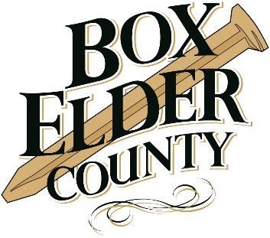
BOX ELDER COUNTY AND PEHP
PARTNERSHIP

Box Elder County values the health and overall wellbeing of its employees. For the 2019 plan year, the county has partnered with PEHP to provide a confidential health and wellness program for full-time benefited employees. Employees and spouses who elect medical coverage through PEHP and participate in Box Elder County’s wellness program during the 2019 plan year will be eligible to receive cash rebates through the PEHP Healthy Utah program and online myWellnessTracker.
To receive the PEHP Healthy Utah rebates employees must complete the following:
- PEHP Healthy Utah onsite biometric screening (dates and locations TBA)
or visit your own primary care physician and complete the “Know & Plan/Good for You Rebate” form (Deadline: March 31, 2019)
- PEHP Healthy Utah health risk assessment (April 30, 2019)
  - Please note that the health risk assessment must be completed within 90 days of your biometric screening
Healthy Utah Rebates
- $50 Know & Plan rebate: completing the biometric testing and health risk assessment.
- $50 Good for You rebate: biometric measurements fall within the predetermined guidelines for blood pressure, cholesterol, BMI, blood glucose, and being tobacco-free.
- $50 Blood Pressure Improvement Rebate
- $50 Cholesterol Improvement Rebate
- $50 BMI Improvement (for each drop of 5 BMI points)
- $25—$300 Diabetes Rebate
- $100 Tobacco Cessation Rebate
Your rebate will automatically be processed and will be sent to you within 6 weeks! This is a taxable incentive and PEHP will deduct FICA tax from your rebate check.
myWellnessTracker Rewards
- Points are awarded for completing challenges on the online myWellness Tracker
- There are three achievement levels you can reach by earning points
- You earn $50 for each level that you reach
- You can earn up to $150 each plan year
Your check will automatically be processed and will be sent to you at the end of the plan year. This is a taxable incentive and PEHP will deduct FICA tax from your rebate check.

Wellness Options:
*14 additional points are required in the areas below in addition to the points for the Personal Health Assessment and the Biometric Screening*
*All forms can be found at www.boxeldercounty.org/employee-wellness.htm*
Preventative Health Screenings: | 1 point each
(A doctor’s note will be required as proof of screening. You will be contacted if more information is needed for your points. Please turn the doctor’s note into Human Resources to get your points.)

- Physician Wellness Screening *Can count for your Biometric Screening (1 point) AND Preventative Screening (1 point).
- Pap Test (Cervical Cancer Screening) - Women 21-65.
- Mammogram (Breast Cancer Screening) - Women 40-74 (or if recommended by physician).
- Colonoscopy (Colorectal Cancer Screening) - Men and Women age 50-75 *Will count for wellness credit once every 10 years
- PSA Test (Prostate Cancer Screening) *only counts if recommend by Physician
- Annual Flu Shot - No proof needed if done on County Flu Shot day
- Shingles Vaccination *only counts if recommended by Physician (Men and Women age and above)
- Dental Exam
- Skin Cancer Screening
- Eye Appointment *full ophthalmology screening – not just vision*

HEALTH MANAGEMENT: | 1 point each
(A doctor’s note will be required as proof of participation. You will be contacted if more information is needed for your points. Please turn the doctor’s note into Human Resources to get your points.)

- Prenatal Care throughout pregnancy *Can only count this for 1 wellness point.
- Post Partum exam (between 3 and 6 weeks after delivery.)
- Chronic Disease Management (At least 1 visit to manage a chronic condition, or as recommended by your physician).
- Mental Health Management (Visit with a Clinical social Worker, Psychologist, Psychiatrist). Free through the EAP.

COACHING: | Up to 3 points each
(Proof of completion will be required. An email or signature on the “Coaching Verification” form will certify as proof or if you complete the online program, you may show proof of completion or show an employee in Human Resources that it has been completed. You will be contacted if more information is needed for your points.)

- Blomquist Hale EAP
- Free coaching sessions. Call for more information or to schedule an appointment - 1.800.926.9619.
- Employee gets a note from provider for wellness point.
- Participate in a Tobacco Cessation Program through the PEHP Quit Line. Develop health habits related to tobacco use. This also includes assistance with e-cigarettes.
- Nicotine quit medications – you may be eligible for quit medications through PEHP Quit Line. Quit medications can double or triple your chances of quitting for good.
- Participate in a PEHP Wellness Education Course (PEHP Lighten Up, PEHP Diabetes & YOU, etc.
- Participate in PEHP Health Coaching that provides education, support and rebates to help members engage in improving their health by forming action plans, setting goals, and following up monthly with a health coach (for employees with a body mass index of 30 or greater).

WELLNESS CHALLENGES: | 1-2 points each
(Participation materials/tracking sheet will be required to be turned in. Please record your participation on the completion/tracking form and turn into Human Resources.)

- 4 Week Challenge: 1 point
- 6-8 Week Challenge: 2 points
- PEHP Challenges (points as listed above)

Additional:
- Sheriff’s Office PT Testing: 2 points

WELLNESS SEMINARS: | .5 points each
(Attend a PEHP/Box Elder County sponsored seminar regarding health and wellness. Make sure you sign the roll.)

- Onsite: 0.5 point
- Lunch & Learn: 0.5 point
- 15 minute massage at work: no points

WEIGHT MANAGEMENT: | 2 points each
(Complete “Healthy Weight Verification” form. Turn in to Human Resources.)

- Lose weight: If your BMI is over 27 and you lose 10 or more pounds, provide a Physician or RN signature and earn 2 wellness credits. Weight loss will need to be documented.
- Weight management campaign – GBS
- PEHP Waist Aweigh program

NUTRITION OPTIONS: | 1 point each (for month of tracking)
(Complete “Nutrition Verification” form. Turn in to Human Resources.)

- Weight Watchers 1 month participation
- Online Food Journal and Tracking Apps 1 month log
- Registered Dietician/Nutrition/Health Coach – 1 months
- Other nutrition program 1 month participation

EXERCISE OPTIONS: | 2 points each (for each month of tracking)
(Complete “Exercise Verification” form. Turn in to Human Resources.)

- Aerobic Exercise 2 month log (Must exercise a minimum of 30 minutes, 3x/week or equivalent)
- Competitive Sports 2 month log (Must exercise a minimum of 30 minutes, 3x/week or equivalent)
- Exercise Journal and Tracking Apps (Must exercise a minimum of 30 minutes, 3x/week or equivalent 2 month log)
- Personal Trainer (with note from trainer)
- PEHP MyWellness Tracker – for every month you qualify for cash rewards, you get 1 point.

HIKING CHALLENGE: |  | 2 points (max of 4 points per year)
(Maximum of 4 points per year must complete “Hiking Verification” form. Turn in to Human Resources.)

- Take a hike of 5+ miles roundtrip with an elevation change of at least 500 ft.

RACES AND EVENTS: | See Individual Race for point value
(Complete “Races and Events Training Log Verification” form. Turn in to Human Resources.)
- 5k Walk/Jog Race: 1 point
- Tougher Mudder: 2 points
- 10K Race or 30 mile Bike Race: 2 points
- Half Marathon Race or 50 mile Bike Race or Sprint Triathlon: 3 points
- Full Marathon Race or 100 mile Bike Race or Olympic Distance Triathlon: 4 points
- Half Ironman or Full Ironman: 5 points
HEALTH CLASS: |  | .5 points each
(Complete “Health Class Verification” form. Turn in to Human Resources.)

- You may receive 0.5 point for any health class you attend that you feel was beneficial to your health outside of the PEHP/Box Elder County program. Simply complete the “Health Class Verification” form.

COMMUNITY EVENTS: | See Individual events for point value
(Complete “Community Event Verification” form. Turn in to Human Resources. If you’d like to participate in an event that isn’t listed below for points, please receive authorization for Human Resources BEFORE the event.)

Worth 0.5 point each
- Attend the County Summer Party. Make sure you sign in.
- Other community events (with preapproval).
Worth 1 point each
- Participate in a county sponsored blood drive. Make sure you sign in.

MINI BREAKS: | No points (prize drawing every 3 months)
For every attendance to a mini break, earn 1 ticket into the prize drawing. Prize drawing to be held every 3 months. Prizes will vary.
- Mini breaks Jan-March: April prize drawing
- Mini breaks April-June: July prize drawing
- Mini breaks July-Sept: October prize drawing
- Mini breaks Oct-Dec: January prize drawing
Health-Related Reading: |  | 1 points for every 5 hours
For every 5 hours of health-related reading, earn 1 point. Please send a tracking sheet of the minutes spent reading.

This includes:
- Articles
- Books
- Box Elder monthly newsletter
- Box Elder County Share-A-Book Library (See HR)
- Other health-related material (get approval if you’re not sure on the material)

Insurance Premium Rates – WELLNESS PARTICIPATION:
Total Premium: County: Employee: Per Pay Period:
Traditional Health Plan*:
Single $710.82 $604.20 $106.62 $53.31
Two-Party $1,442.96 $1,226.52 $216.44 $108.22
Family $1,919.20 $1,631.32 $287.88 $143.94
QHDHP Health Plan*:
Single $665.22 $565.44 $99.78 $49.89
Two-Party $1,350.38 $1,147.82 $202.56 $101.28
Family $1,796.08 $1,526.67 $269.41 $134.71

Insurance Premium Rates – NON-WELLNESS PARTICIPATION:
Total Premium: County: Employee: Per Pay Period:
Traditional Health Plan*:
Single $710.82 $604.20 $160.62 $80.31
Two-Party $1,442.96 $1,226.52 $270.44 $135.22
Family $1,919.20 $1,631.32 $341.88 $170.94
QHDHP Health Plan*:
Single $665.22 $565.44 $153.78 $76.89
Two-Party $1,350.38 $1,147.82 $256.56 $128.28
Family $1,796.08 $1,526.67 $323.41 $161.71

