Uintah City News
Uintah, 2191 East 6550 South, Uintah, UT 84405
www.UintahCity.com uintahcity@uintahcity.com (O) 801-479-4130 (F) 801-476-7269
October 2021

FROM THE MAYOR’S DESK…
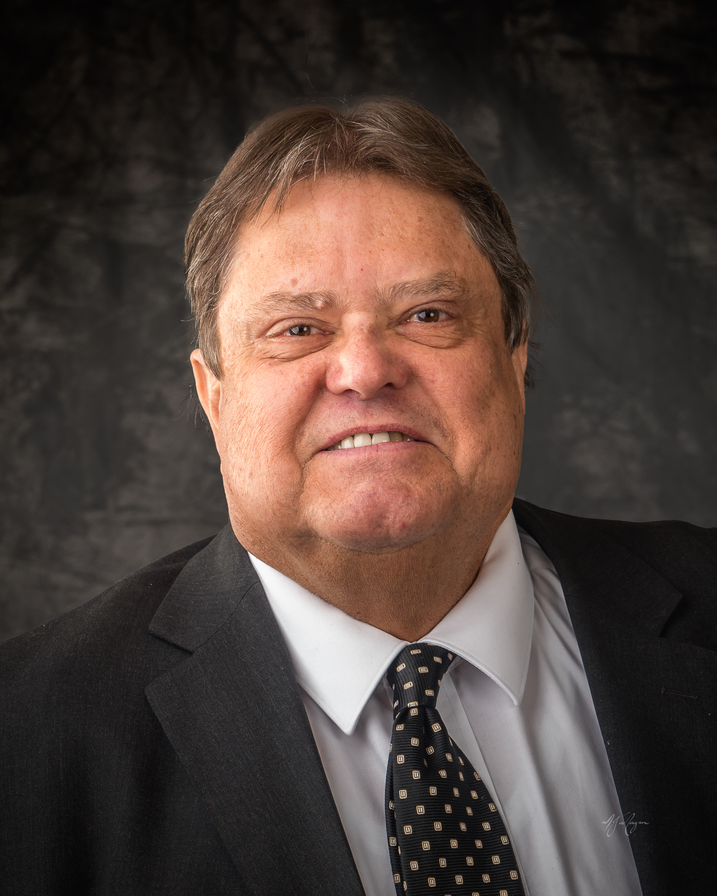

WEBER MOSQUITO BOARD
With cooler weather we should see a reduction in mosquito activity. There were two deaths in Weber County from West Nile virus this year.

COVID 19
Weber Morgan Health Department reports 192 cases among 5–18-year-old students in 67 schools. There have been over 280 deaths reported to WMHD. Please take whatever steps you think are necessary to protect you and your loved ones.

WATER
Thank you for your efforts to conserve water this year. Let's hope we have more water next year.

ELECTIONS
You should have received your ballot in the mail. If you do not receive your ballot by the 21st or 22nd of October please contact the Weber County elections office. Please vote!

Weber Fire District
You should receive a notice in the mail of a public hearing concerning WFD's intent to raise property taxes.
The public hearing will be November 9, 2021, at 6pm at the district offices.

Thanks for all you do to make Uintah a great place to live.

- Gordon Cutler
CITY COUNCILOR BELL

CULINARY WATER
Have you checked the access cover to your water meter lately? Each property has a water meter located where the culinary water line branches off from the main city line to bring water into your home. Water meter covers should be kept free of any debris and easily accessible by City Personnel. Landscaping over or covering these access covers will only make public works grumpy…please don’t make them grumpy! Please take a moment to make sure yours is clear and easily accessible, as this is the responsibility of each property owner. If you don’t know where your water meter cover is located, please call Public Works (Jeff 801-388-3558) for assistance.

GARBAGE & RECYCLING
Waste Management’s Growing Fleet of Natural Gas Collection Trucks Run Cleaner and Quieter on the Streets of Uintah
Upping the ante on its commitment to the environment, Waste Management of Utah (WM) continues to expand its cleaner-running compressed natural gas (CNG) operations in the area. To date, WM has invested approximately $35 million in its local CNG truck fleet and infrastructure which services customers throughout the Salt Lake Valley including Uintah. A major milestone on the company’s CNG roadmap was achieved in August with the grand opening of WM’s newest CNG fueling station located in West Haven.

“WM has set an aggressive expansion goal for its CNG fleet in Utah and across the country,” said Brad Kloos, district manager for WM of Utah. “Working for a more sustainable Utah and cleaner air in the communities we serve, is at the heart of our CNG operations. For every CNG truck we have on the road, there are annually about 8,000 gallons of diesel fuel that are not burned — and today we have 106 CNG trucks operating in the valley today.”

All totaled, the Utah CNG fleet annually eliminates the need for 846,000 gallons of diesel fuel and reduces greenhouse gas emissions in the valley by 1,484 metric tons. Powered by engines that emit nearly zero particulate emissions, WM’s CNG trucks also run significantly quieter than their diesel counterparts. To further conserve fuel and reduce emissions, the engines automatically turn off after five minutes of idling.

West Haven CNG Station
The new CNG fueling station in West Haven is dedicated to supporting the local WM fleet of 11 CNG trucks. Next year WM plans to purchase another eight CNG trucks.

Drivers arrive at the West Haven site for their early morning shift, detach the CNG pump that fueled the truck overnight and head out. Each CNG truck covers up to 100 miles a day with a single driver servicing residents in Uintah, West Haven, Roy, Layton, Harrisville, Marriott-Slaterville, Woods Cross, Clearfield or greater Weber County can service about 550 curbside carts during a work shift.

So, next time you see a WM Think Green / Think Clean truck in your neighborhood, wave at the driver. They are local WM employees working to help keep our community cleaner and greener.

Thank you,
- Kristi Bell
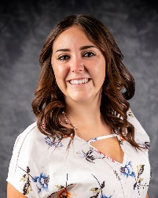
REMINDER FROM CITY HALL

Just a friendly reminder; If you are selling a property or moving out of the city, please make sure you contact us at the city to make sure we are closing everything with the city. I would hate to bill you a bill that is no longer yours.

-Tisha Dogden
CITY COUNCILOR SMITH

CEMETARY
Last December we were fortunate to be selected to host “Wreaths Across America”, a patriotic tribute to veterans buried in our cemetery and other cemeteries across the nation. Holiday Wreaths were placed on our veterans grave markers along with a short program. We were one of hundreds of locations across America participating in this event. I am happy to announce that we will have the honor of hosting this event again this year. Prior to the Chirstmas season, wreaths will be sold October 23rd and November 13th at Walmart Neighborhood Market and Fresh Market in South Ogden.

Mark your calendar : Saturday Morning 9:00A.M.
December 18th 2021
Uintah Cemetery

I enjoyed participating last year and look forward to another memorable event and hope to see you there.

- Jerry Smith

