Uintah City News
Uintah, 2191 East 6550 South, Uintah, UT 84405
www.UintahCity.com uintahcity@uintahcity.com (O) 801-479-4130 (F) 801-476-7269
November 2020

FROM THE MAYOR’S DESK…
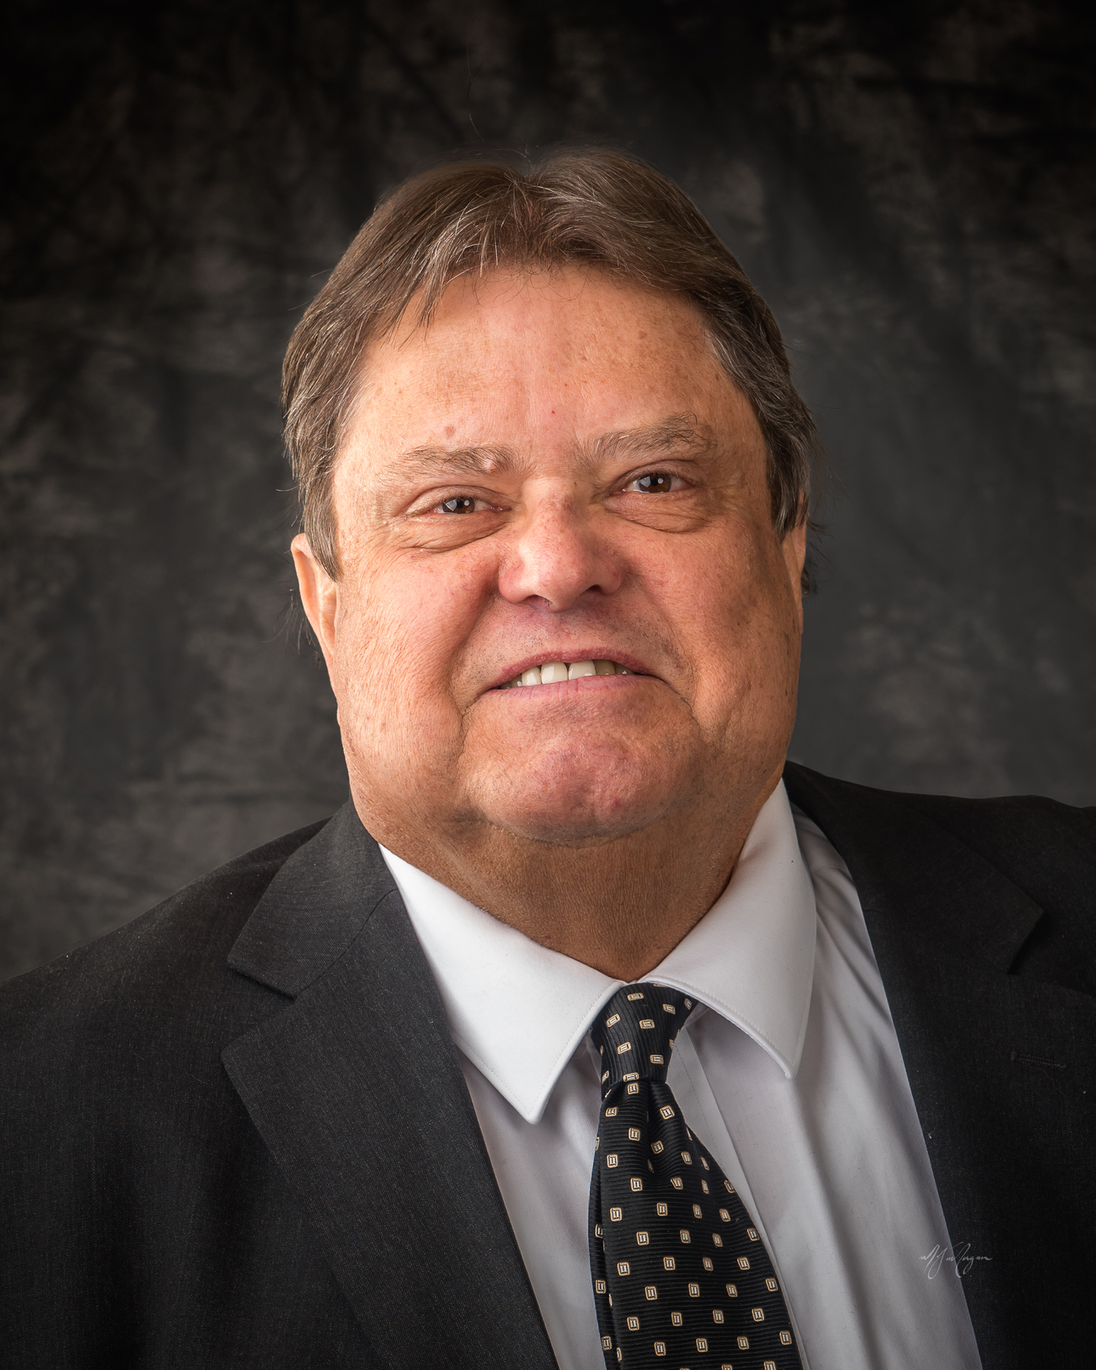

WEBER COUNTY SHERIFF'S OFFICE
There has been a rash of car burglaries in Uintah and the rest of the county. 7 in one night in Uintah. Please lock your vehicles and DO NOT leave your keys in them. Also please close your garage doors. As you get ready for the holidays do not leave valuables where they may be seen by those who wish to take them.
ROADS
Please do not park on the road way. This will help with snow removal.
Construction on Cottonwood drive has started, please slow down and watch for construction workers.

COVID 19
Due to the state mandate if you need to conduct business at the city office you will need to wear a mask. If you do not wear a mask you will be asked to come back when you have one. City staff is not to blame for this so please do not take your frustration out on them. Please try to conduct business by phone, email etc. According to Weber County, in October, Uintah had an increase of 9 additional cases of Covid 19. Contact me if you have questions.

PUBLIC WORKS
We welcome Tim Kendell as a part time public works employee.

FIRE DEPARTMENT
We continue to try and determine how best to provide fire protection to our city.
With Covid 19 restrictions it has been difficult to have in person meetings. We will continue to provide information as best as we can.

Thanks to all for making Uintah a great place to live!
Happy Thanksgiving

- Gordon Cutler
WATER
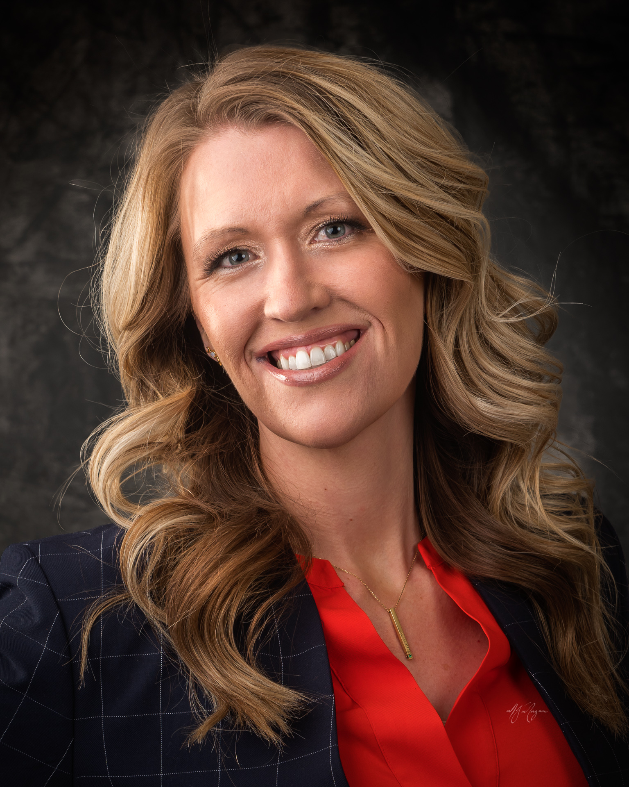
I’m sure it comes as no surprise to anyone that projects and upgrades to our culinary water system are expensive. In attempt to lessen the burden to the City, countless hours are dedicated to chasing and securing grants. In order to qualify for most of the grants we chase, the city has to show a need for assistance. This typically means that your community has a high percentage of low to moderate income homes. To qualify, a city-wide survey needs to be done at random sampling a large portion of residents. Many residents have already had me show up at their home asking to participate in the short survey needed, thank you for your time. I still have many homes left, please know that the survey is just 4 simple questions and the answers given are completely anonymous. By doing this survey, we stand a chance to qualify for grants that can help us build and maintain the City we all love.
Thank you for your participation and willingness to help!

GARBAGE & RECYCLING
The City contract with Waste Management has been automatically renewed for an additional 4 years. Effective November 1, 2020, there has been a $1.10 increase to recycling. This increase was imposed by Waste Management, no profit is made by the City with recycling fees. No price increase has been made to regular garbage cans.

COMMUNITIES THAT CARE
During December many of us make goals to make our families and/or neighborhoods stronger. BCTC is working with partners to curate both informative and fun ideas to use, especially next month when kids are home for a few weeks.
Did you know that the average young person sees upwards to 2,000 sexual messages each day, including occasional pornographic messages? Nine out of 10 males and six out of 10 females will see pornography before age 18. These messages are found in jokes, tv shows, clothing, social media, novels, advertising, etc. What can YOU do? You can start by signing up for a unique texting program that will give you information on how to make your child resilient when they see these messages. This is being offered on a limited time to the citizens in our cone communities – to learn more, go to: https://www.upwardreach.org/talk/ or scan here:

Discovery Destination! Is one of our partners whose aim is to highlight no- or low-cost activities for families in our own cities. These activities are not only fun –but some of them also include a chance to be entered into monthly prizes that will only be awarded to citizens in our area (Riverdale, South Ogden, Uintah and Washington Terrace) so your chances of winning can be pretty great! It’s fun, easy and FREE – to learn more, go to Facebook https://www.facebook.com/groups/myddbctc and the discovery hunt at https://mydiscoverydestination.com/bctchunt/.

As always, if you are interested in learning more about our coalition, please find us on Facebook: https://www.facebook.com/BonnevilleCTC or email us at BonnevilleCTC@weberhs.org.

A big welcome to Tim Kendell, we’re excited to have you join the Public Works department.
Happy Thanksgiving!
Thank you,

- Kristi Bell
ROADS
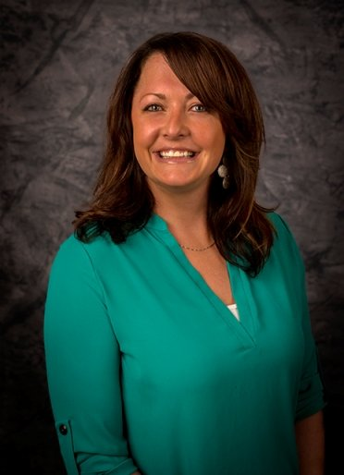
Well, it is that time of year again where we need to talk SNOW!!
I would like to ask for help making the load as light as possible for our public works department. They clear as much of the road and as close to our mailboxes as possible without causing damage. It is the resident’s responsibility to clear his or her own driveway, walkways and mailbox. When clearing these areas please be courteous and not push the snow into and/or across the road. This makes it very difficult for the plows, as the snow becomes ice.
I would also like to remind all of our citizens of our ordinance in regards to parking on the street during these winter months. Ordinance 6-2-1 reads as follows:

C. Parking During Winter Months:
1. No person, who owns or has possession, control or custody of any vehicle, shall park, or allow or permit another to park, any such vehicle upon any public street or in city rights of way between the hours of one o'clock (1:00) A.M. and eight o'clock (8:00) A.M., between the months and days of December 1 to March 1.
2. During all times, other than those set forth in subsection C1 of this section, no person, who owns or has possession, custody or control of any vehicle, shall park, or allow or permit another to park, any such vehicle upon any public street when the removal of snow from the streets is necessary, apparent or imminent, and seventy two (72) hours after the snowstorm event.
Have a happy holiday season!!!
-Michelle Roberts

