Cost of The Sheriff Department
In early January, the Sheriff’s department announced a $650K price increase that will be proportionately distributed to all contract cities and Unincorporated Weber County. Since the accouchement, I have been actively working with the Weber County Sheriff’s department and the cities that contract with the Sheriff’s department to ensure that Uintah is not over charged for this year’s contract increase, and to work with the county on a future cost distribution calculation.

Currently, the Sheriff’s Department service cost is calculated using the percentage of residence in the city versus the county, and the percentage of calls generated in the city versus the county. For example, Uintah’s population 2.19% of the county, and the number of Uintah calls is 3.07% of total calls in the county. For this contract term, the cost for Uintah City will increase by $17K, which is 15% increase from the previous year. The cost for service is shocking, but the most interesting concern is the call per resident is expected to be the 4th highest in the county. The reason for the high level of calls per resident is directly related to the types of calls our citizens are requesting. The cost distribution calculator doesn’t weight calls according to the type of call – burglary investigation that may take 3 to 20 hours has the same weight as a premises checks that may take 10 min. Due to this approach, our city will be charged at $98.57 per call, whether or not the call take 10 minutes or 10 hours.

With that said, each of us in the city can positively impact the Sheriff’s cost by reducing the non-threatening calls such as premises checks, VIN checks, welfare checks, etc. By no means am I asking to not call the Sheriffs Department for service that will thwart unlawful activities; However, I am asking that each of consider the cost of the call before calling the Sheriff’s Department.

The table below shows cost distribution of costs and the cost per call and the number of calls per resident.
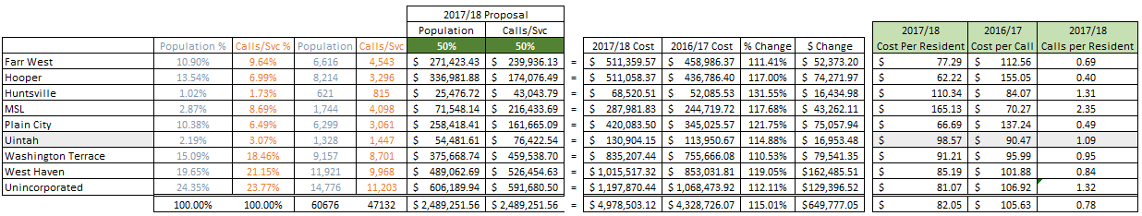

- Lawrence Flitton
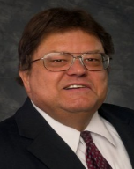
Play Ball!
SPRING-- When young men and young ladies fancy turns to baseball. Once again it is time to hear that familiar cry "PLAY BALL". Stop by the city office's to sign, your youngster, up for one of the 5 leagues that is being offered.
T-Ball, Coach Pitch. Girls softball, Boys Baseball and Boys Pony league.
Registration is open until March 26th.
Please do not let money keep children out of recreation programs.
Contact the Parks and Recreation City Council member Gordon Cutler if you need abatement of the fees.
See you at the ballpark.

- Gordon Cutler
Be Ready!
February was another challenging month weather-wise. Although we did receive more snow, the warmer temperatures and the excess of January snow that melted quickly, the February challenge was flooding. With spring around the corner, we now have the off to deal with. Please be prepared ahead of time if flooding occurs in your neighborhood. Please follow the attached tips to prepare your family for flooding that may occur. For complete information on flooding visit http://www.redcross.org/get-help/prepare-for-emergencies/types-of-emergencies/flood.
In February the department was dispatched to a structure fire, car fire and grass fire. Thankfully no major damage or injuries were reported. We also took part in a safety day with preschooler’s at Weber State University Day Care Center. You are never too young how to learn to be safe, and what better way for the children to get to meet the people that may have to save them one day in am emergency. Learning about the firefighter and the gear they wear during an event allows them to not be as scared in the event of an emergency.

It is Uintah City Fire Department’s commitment to do whatever we can to protect our residents from harm. Did you know that we have two programs FREE to all Uintah residents? We have partnered with Red Cross to install smoke detectors free of charge to those Uintah homes that do not have them, or do not have an adequate amount of them. We also offer free home safety checks. These checks are to assist you in pointing out possible safety issues you may have in your home. We rather prevent fires from happening to keep you and your families safe. Please contact the department for more information.

Comments, questions, concerns or information? Feel free to contact Chief William Pope at (801) 644-2508 or via email wpope@uintahfd.org. If you just want to stop by to meet our firefighters, we welcome our Uintah Residents.

- William Pope
City Contact List
City Council Members  Mayor Lawrence Flitton  (801) 633-5129  mayor@uintahcity.com  Michelle Roberts  801-388-0810  michelleroberts362@gmail.com  Gordon Cutler  (801) 476-0356 or  (801) 726-0613  ccgcutler@uintahcity.com  Jerry Smith  (801) 476-7502 or (801) 209-2595  ccjsmith@uintahcity.com  Greg Johnson  (801) 475-0306  johnsongregory1850@gmail.com | Fire Chief  William Pope (801) 425-2802  wpope2953@gmail.com  Planning Commission Secretary & Court Clerk  Crystal Western | (801)479-4130 | uintahcity@uintahcity.com  Park Reservations  (801)479-4130  Public Works/Maintenance  Jeff Holden (801)388-3558  pw@uintahcity.com  City Recorder: Darinda Wardell  (801)479-4130 uintahcity@uintahcity.com | Animal Control  Office (801)399-8244 or emergency (801)629-8221  Hours – Monday – Friday 8 am - 5 pm Saturday 8 am to Noon.  Blue Stakes  Dial 811, (800) 662-4111 or (801) 208-2100  Monday-Friday 7am to 5 pm  Building Inspector: Jeff Monroe  (801)479-4130 or (801)395-8288  Cemetery: Stephanie Howell  (801)814-1262 showell@xmission.com or Jerry Smith (801)476-7502 or (801)209-2595 jerryandpat1968@yahoo.com  Sheriff Dispatch: (801)629-8221

