Uintah City News
Uintah, 2191 East 6550 South, Uintah, UT 84405
www.UintahCity.com uintahcity@uintahcity.com (O) 801-479-4130 (F) 801-476-7269
December 2020

FROM THE MAYOR’S DESK…
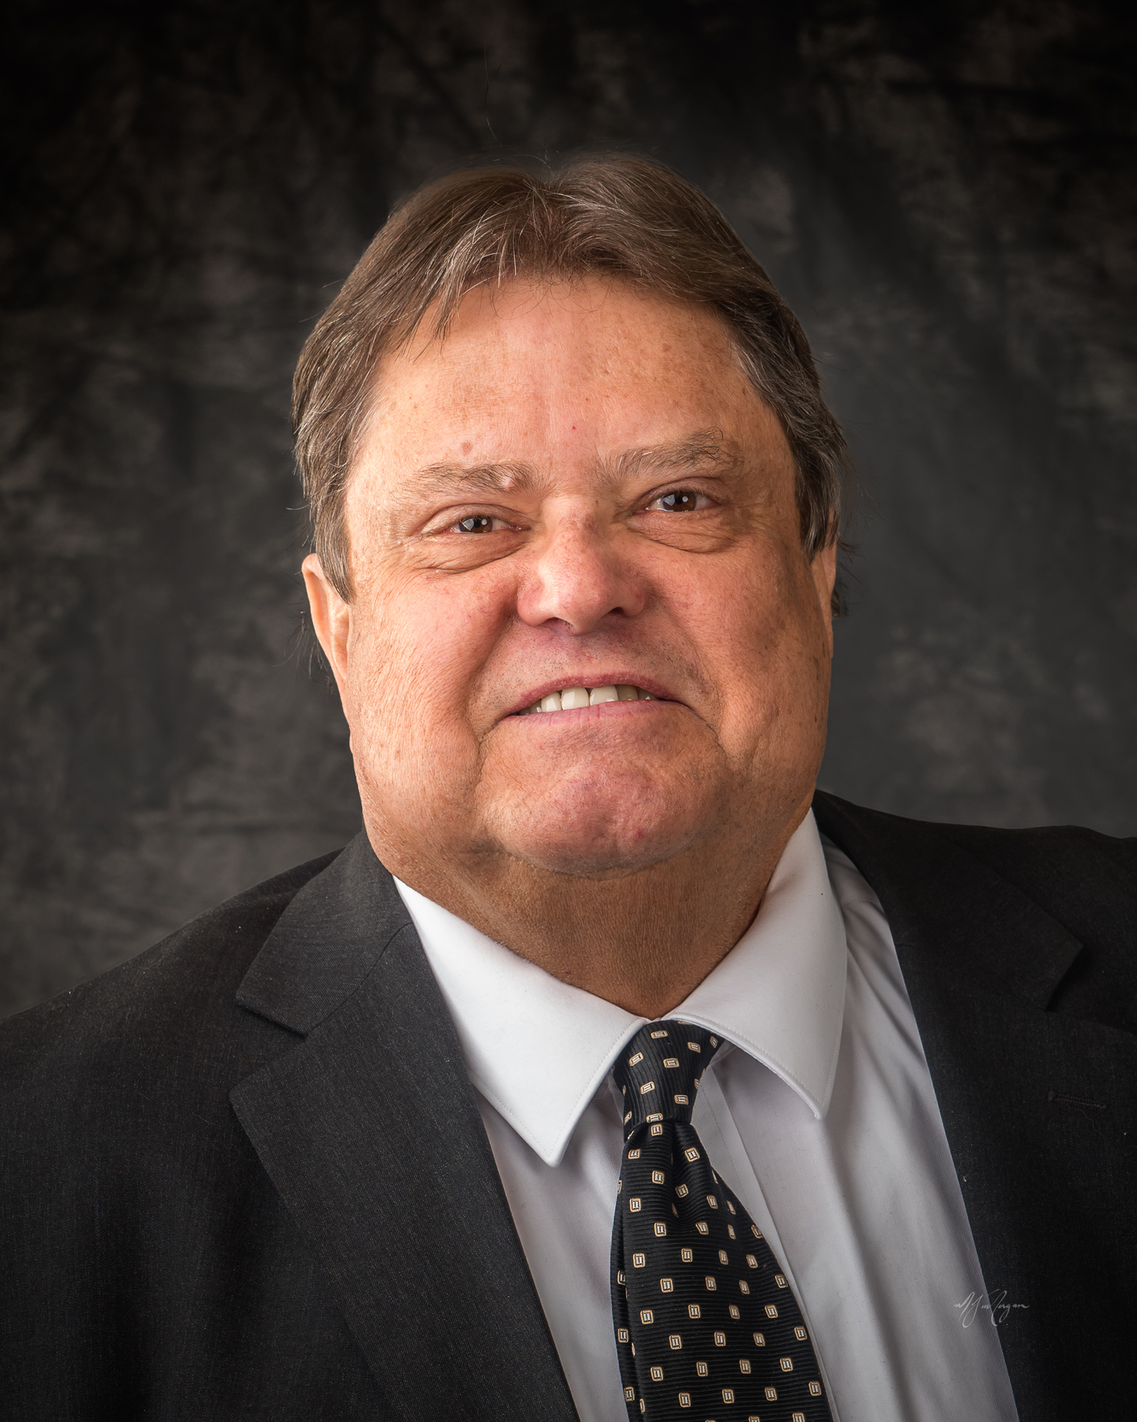

FIRE DEPT
On Dec. 8th Weber Fire District held a public hearing concerning annexing Uintah City. Four citizens, city staff, two council members and myself attended. There were no comments from the public to the Weber Fire District Board of Trustees. If you have questions about this proposed annexation contact city staff, members of the council, myself or Weber Fire District.

PLEASE READ THE ENCLOSED FLYER FOR MORE
INFORMATION ABOUT THE PROPOSED ANNEXATION
INTO THE WEBER FIRE DISTRICT

WINTER IS HERE
Please do not park where you will hinder snow removal.
Take steps to protect your property. Lock your cars at home and away. Close your garage doors.

COVID 19
According to Weber County Uintah had an increase of 17 cases from 12 Nov. to 9 Dec. please protect yourself!

CONGRATULATIONS Trace Redd won the bull riding championship belt buckle at the Junior World Finals Rodeo in Fort Worth Texas. Way to go Trace!!

Merry Christmas!
Thanks for all you do to make Uintah a great place to live.

- Gordon Cutler
GARBAGE & RECYCLING
Quick reminder that Garbage pickup can begin as early as 7am on garbage day. Please have your garbage cans out early enough or the night before. If your garbage is ever missed and needs pick up, please contact City Hall.

Merry Christmas and Happy New Year!

- Kristi Bell

Wishing you and yours a very Merry Christmas and happy Holiday season.

-Uintah City Council & Staff

