Quilt Club Newsletter
Upcoming Club Dates: July 6, August 3, September 14 and October 5.
Upcoming Help Days: July 2, August 6, September 3, October 1.
Monthly challenge for next month is Patriotic table topper/runner.
Store will be closed: Saturday July 4 for Independence Day and also September 7 for Labor Day.
New product lines are arriving now: Scary Scraps by J. Wecker Frisch, The Lure of fishing by QT fabrics, Natures Serenade by Lumin, Peppercorn Polka dots by Lumin, Harvest Hollow by QT fabrics, Gingerbread Lane by Moda, Palette by Wyndham, Sunshine by Wyndham, Zoe the Giraffe by Cloth Works, Flutter the Butterfly by Cloth Works and lots of new notions and Wide backs arriving daily.
Block of the Month-Quilt Room month 5!
Next BOM will be by Laundry Basket - Annas Baskets and will be done monthly. The price for the patterns is $80.00 for the set (10 months) and can be purchased at July club meeting. This will be done by using your choice of fabric and will start in September. This is a great pattern for scrappy!
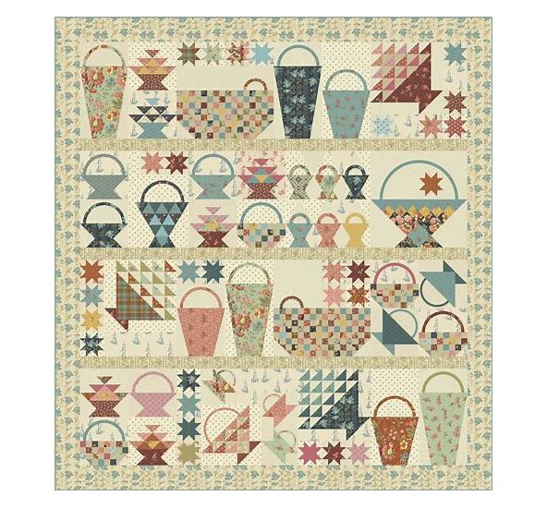
Mystery Quilt: We have all previous months’ information at the counter if you would like to participate.
If you are new to quilt club, we have a mystery quilt that you can participate in. We have instructions available at the front counter that will help you catch up. We also have the Quilt Room BOM by Heather Briggs. We have only 2 patterns available if you are on the fence. Bring your projects to “sew and tell” and receive a ticket to enter into the drawing for a free quilting at the end of the year. Your challenge entry will qualify for “sew and tell”.

