Sew Your Stash The Hourglass 04-20-2026

The hourglass unit is a traditional quilt shape (often referred to today as a quarter square). It can be used on its own or sewn as part of a block. For our project this time we are not combining it in a block but we will be sewing individual units and play with them.

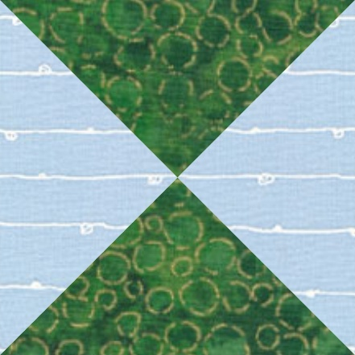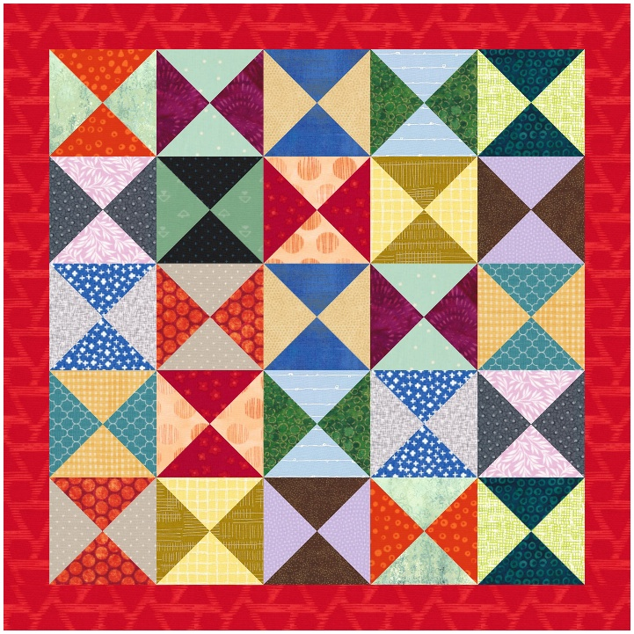

The hourglass unit uses two squares. Traditionally one light and one dark. This combination of two squares will make 2 hourglass units. No matter what size your finished hourglass will be, you will always cut your squares 1 ½” larger than the finished size for your unit. If we want 3 ½” finished units we will start with 5” squares.
Let’s start with two squares that are 5” square. First, we will make two half square triangles. Draw a diagonal on the wrong side of the light square then layer it on the dark square with right sides together. Sew a scant ¼” on each side of the marked diagonal. Cut on your marked diagonal and press the seams toward the darker fabric. You do not need to trim yet.
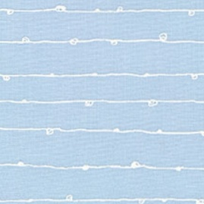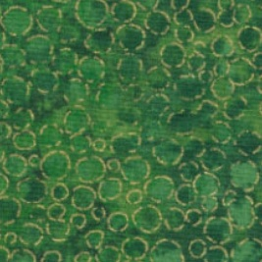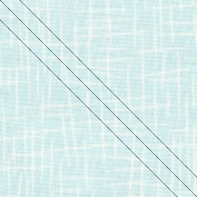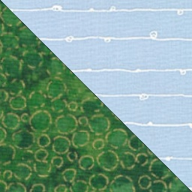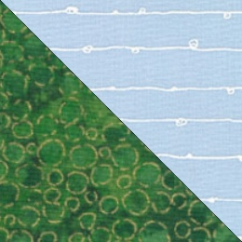

Take your 2 half square triangles and lay them right sides together with the dark triangle of one covering the light triangle of the other HST. Draw a new diagonal from dark fabric corner to the light fabric corner. Snug the middle seams, and pin if needed. You will now sew a scant quarter inch on each side of the new diagonal. Cut on the marked diagonal and you now have 2 hourglass blocks. Press seam open or in either direction and trim to 4” x 4”.

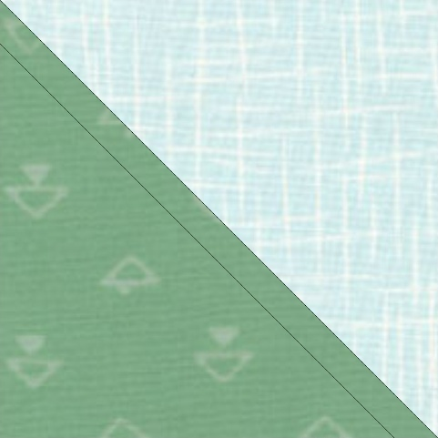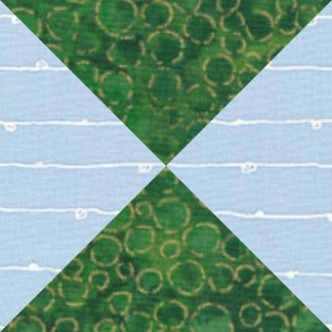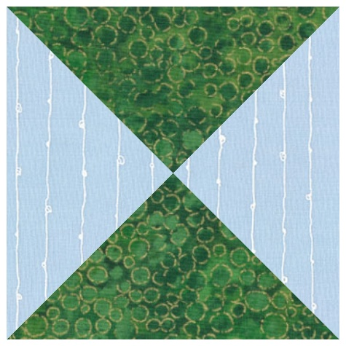

When trimming your hourglass make sure to match the centre of the hourglass with the centre measurement of your trimmed size. The diagonal on your ruler should follow the diagonal of the hourglass and the four cut corners will be centred on the spot where the two colors meet. If using directional fabric it will be the opposite in each block.
Your units are now ready to be sewn into your quilt top.

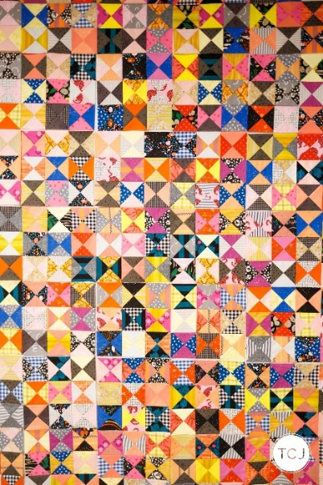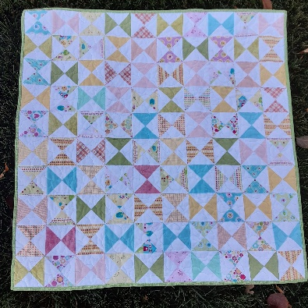
scrappy two colour hourglasses by Baby quilt by Wedding Dress Blue
Then Came June
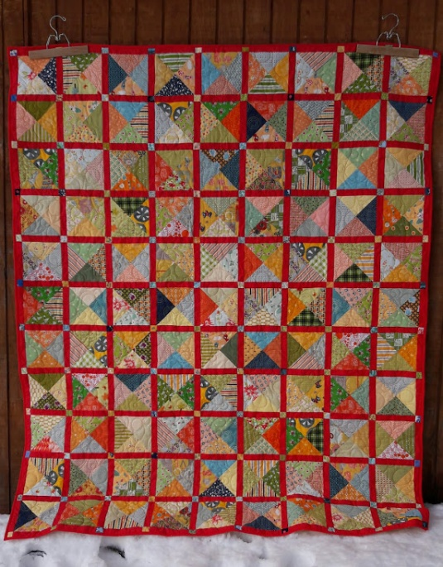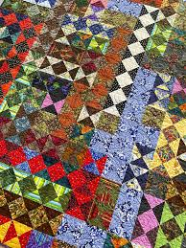
Ultra scrappy with red sashing Non traditional setting by Elaine Theriault
by Aunt Em’s Quilts
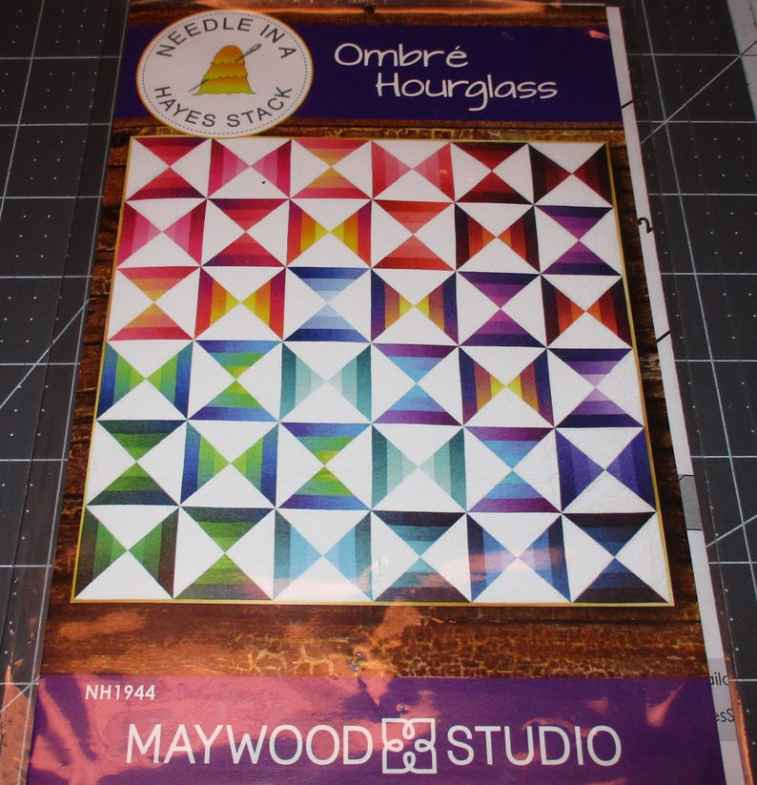
Hourglass pattern using a striped ombre fabric
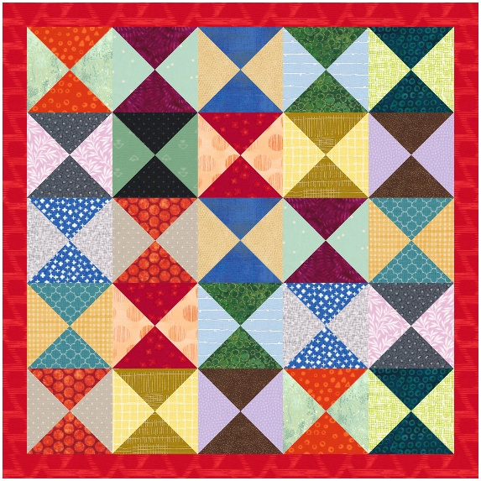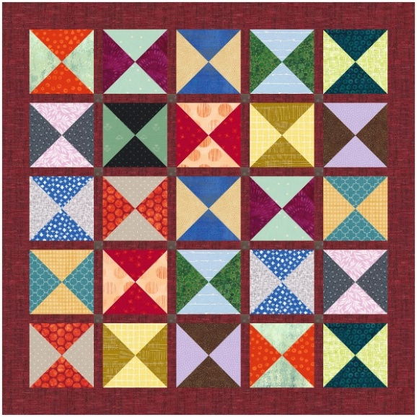
Scrappy dark to dark Dark to light and sashing separates them
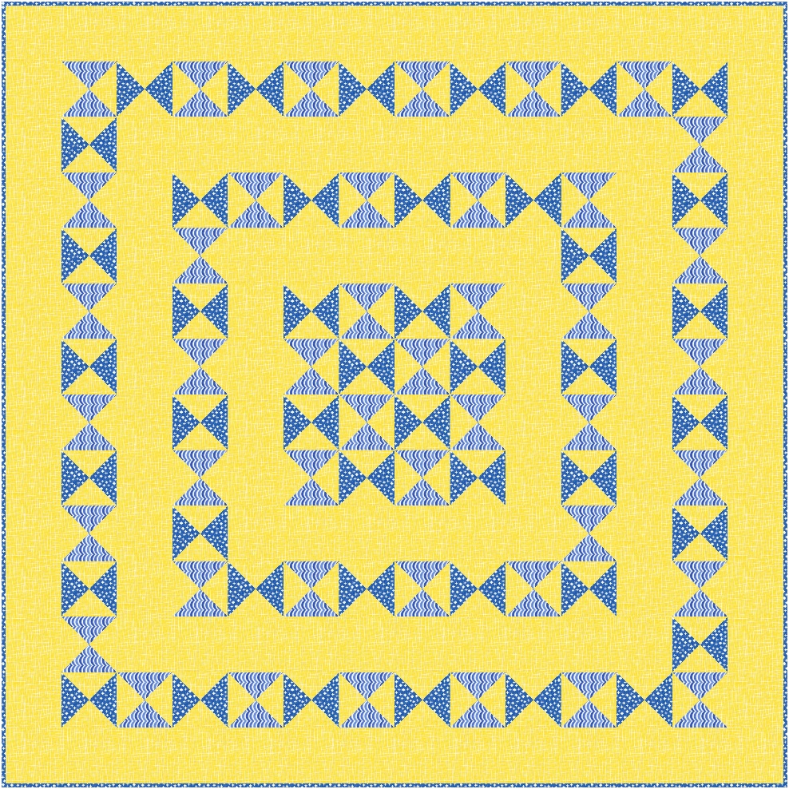
Common background with shades of blue

Sew Your Stash for Heather’s Fabric Shelf by Paulette Eccleston scraps125@gmail.com

