Class Description:
Learn an innovative technique developed ay Edyta Sitar (Laundry Basket Quilts) to spice up a traditional Shooting Star quilt block. You will use traditional pieces with an inserted "glow" that gives the center of each star a 3-D effect. Blocks can be combined to make a stunning quilt or combined with applique to make an elegant table runner. The options are endless!

Class Supplies:
- Sewing Machine in good working order (foot pedal, power cord, extension cord, bobbins)
- Basic Sewing Supplies:
  - Scissors / Snips
  - Seam Ripper
  - Straight Pins
  - Extra Machine Needles
  - Pen & Paper
- Pattern: Shooting Star by Edyta Sitar
- Acrylic Templates Set (Shooting Star by Edyta Sitar)
- 28mm Rotary Cutter
- Portable Cutting Mat (Large mats are available for sharing at the shop)
- 6” x 24” quilting ruler (or any other size to cut 2-1/2” strips
- Purple Thang (highly recommended) or stiletto
- Med / Large Embroidery Needle (It needs to be string with a sharp point … these are used to make our points extra sharp)
- Hand sewing needles (these will be used to do some very quick basting)
- Starch (you will need this to continue working at home but we will have plenty to share in class)
- Freezer Paper
- Water Soluble Glue Stick
- Thread to match your project (50wt or 60wt is preferred). One thread needs to match your background fabric as closely as possible
- Invisible thread. (YLI is my preferred brand)
- Fabric: (We will only be making one block in class)
  - One background square (12” x 12”). Note: If you are using multiple backgrounds, I suggest you purchase 1/3 yard cuts. From each cut, you will get 3 background squares.
  - One dark fabric for the star points: 1/8 yard or a fat quarter. Note: This assumes all of your star points will be the same. You may also choose to use 12 different fabrics or alternate between 2 different fabrics.
  - One light fabric: 1/8 yard or a fat eight

Photos:
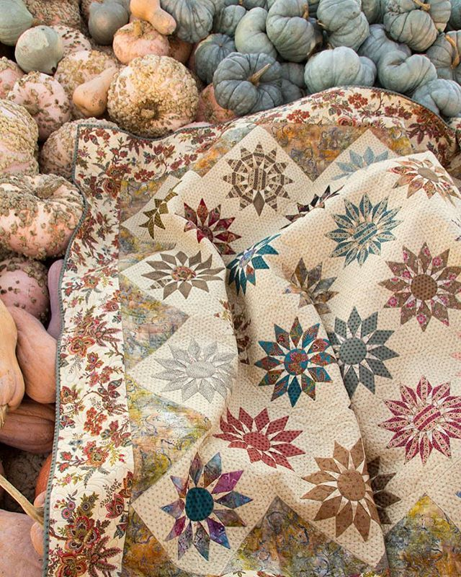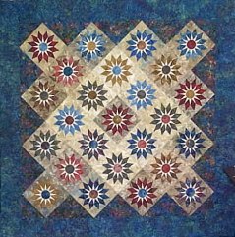
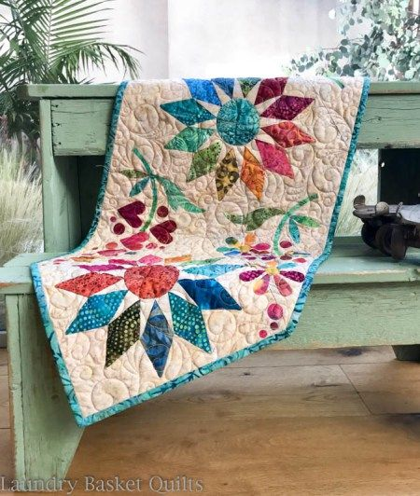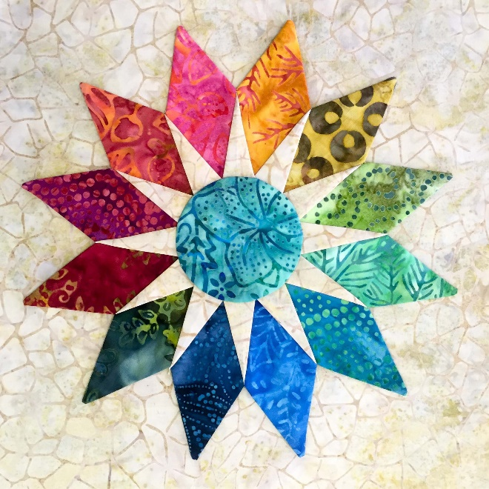

Shop Requirements:
- Provide sewing machine for demonstration purposes
- Provide pressing area and irons. (minimum of 1 per 3 students)
- Provide cutting area w/mat. (Students will provide rotary cutters and rulers)
- Ensure class supplies are available for purchase (purple thang, nylon thread, rotary cutter, pattern, templates)
- Communicate registration at least one week prior to first class. (If the class fills up, please maintain a waiting list and we schedule additional sessions)

