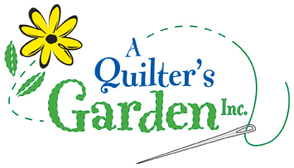
342 River St, Route 302
Montpelier, VT 05602
223-2275
quiltersgarden@aol.com
www.aquiltersgarden.net

______________________________________________________
Scrap Busting Workshop
Acadia Quilt

To continue to offer great classes at A Quilter’s Garden, we encourage you to consider us as your first choice when purchasing class supplies and fabrics.
Materials List

Please bring these sewing items to class:
- Twelve Fat Quarters and 2 ¾ yards of one coordinating fabric for sashing and borders
- Fat Quarter Love book
- Sewing machine & Manual (please ensure that your machine is in good working condition and that you can thread it, wind a bobbin, adjust your tension)
- Rotary cutter and ruler
- Basic sewing supplies such as: straight quilting pins, pincushion, needles, scissors/snips, seam ripper, etc…

See you in class! And if you have any questions or need any additional information, please call the shop at (802) 223-2275! Thank you and happy quilting!

