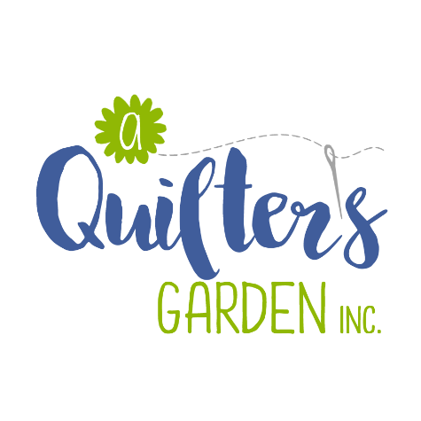
342 River St, Route 302
Montpelier, VT 05602
223-2275
quiltersgarden@aol.com
www.aquiltersgarden.net

______________________________________________________
Sprinkles Quilt
2 sessions/ 1 ½ days
To continue to offer great classes at A Quilter’s Garden, we encourage you to consider us as your first choice when purchasing class supplies and fabrics.
Materials List

Please bring these sewing items to class:
- Sewing machine & Manual (please ensure that your machine is in good working condition and that you can thread it, wind a bobbin, adjust your tension and lower your feed dogs)
- 1/4” foot for your sewing machine
- Rotary cutter and ruler (nice to have a 24” ruler to cut)
- Sprinkles pattern
- Sidekick Ruler by Jaybird Quilts or a prepared piece of template plastic as shown in pattern
- Fabrics for a baby quilt/wallhanging: 13 - 2 ½” strips for stars (approximately 1 yard) and 1 3/8 yard background fabric
- We suggest using a light grey thread 50 wt cotton
- Basic sewing supplies such as: straight quilting pins, pincushion, needles, scissors/snips, seam ripper, etc…
We will provide the foundation material.
See you in class! And if you have any questions or need any additional information, please call the shop at (802) 223-2275! Thank you and happy quilting!

