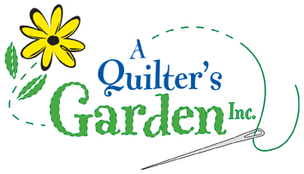
342 River St, Route 302
Montpelier, VT 05602
223-2275
quiltersgarden@aol.com
www.aquiltersgarden.net

______________________________________________________
Merry and Bright Table Runner Class
1 session/5 hrs
To continue to offer great classes at A Quilter’s Garden, we encourage you to consider us as your first choice when purchasing class supplies and fabrics.
Materials List

Please bring these sewing items to class:
- Merry and Bright Table Runner Pattern by A Season for Quilting
- Fabric Requirements per pattern
  - Focus fabric – ½ yard or 2 fat quarters
  - 5 coordinating fabrics – ¼ yard each or 5 fat quarters
  - Binding – ¼ yard
  - Backing – ¾ yard
- Sewing machine (please ensure that your machine is in good working condition)
- Rotary cutter and ruler
- Basic sewing supplies such as: straight quilting pins, pincushion, needles, scissors/snips, seam ripper, etc…
PRIOR TO CLASS Be sure to have the cutting done prior to class as noted on page 1 of the pattern.
See you in class! And if you have any questions or need any additional information, please call the shop at (802) 223-2275! Thank you and happy quilting!

