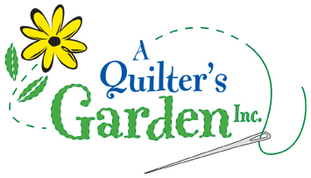
342 River St, Route 302
Montpelier, VT 05602
223-2275
quiltersgarden@aol.com
www.aquiltersgarden.net

______________________________________________________
Jelly Roll Rug Class
1 session/4 hrs
To continue to offer great classes at A Quilter’s Garden, we encourage you to consider us as your first choice when purchasing class supplies and fabrics.
Materials List

Please bring these sewing items to class:
- Jelly Roll Rug Pattern by RJ Designs
- 1 Jelly Roll (or 40+ 2 1/2” x WOF strips)
- Precut 2 1/2” batting roll or 1 1/4 yard of thin 100% cotton batting 96” wide precut into 2 ½” x 96” strips
- Batting seam tape or fusible interfacing (optional)
- Jeans needle size 90/14 or 110/18
- Clover Wonder Clips
- Best Press or Flatter
- One spool of thread at least 1200 yards using a color that matches the overall fabrics (King Tut variegated works nicely)
- Sewing machine & Manual (please ensure that your machine is in good working condition and that you can thread it, wind a bobbin, adjust your tension and lower your feed dogs)
- Sewing machine must have a 5mm zig zag stitch
- Walking foot or a dual feed foot
- Rotary cutter and ruler (nice to have a 24” ruler to cut strips and a large square ruler to trim blocks)
- Basic sewing supplies such as: straight quilting pins, pincushion, needles, scissors/snips, seam ripper, etc…

See you in class! And if you have any questions or need any additional information, please call the shop at (802) 223-2275! Thank you and happy quilting!

