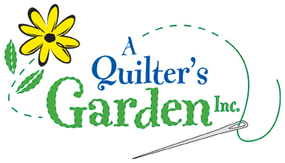
342 River St, Route 302
Montpelier, VT 05602
223-2275
quiltersgarden@aol.com
www.aquiltersgarden.net

______________________________________________________
Crisscross Woven Fabric Mats Class
1 session/3 hrs
To continue to offer great classes at A Quilter’s Garden, we encourage you to consider us as your first choice when purchasing class supplies and fabrics.
Materials List

Please bring these sewing items to class:
- Crisscross Woven Fabric Mat Pattern by Aunties Two
- Fabric strips enough for project: placemat or mug rug
- Fusible Fleece enough for project: placemat or mug rug
- Microtex needle size 90/14
- Clover Wonder Clips
- 50wt thread that matches the overall fabrics (King Tut variegated works nicely)
- Rotary cutter and scissors
- Sewing machine & Manual (please ensure that your machine is in good working condition and that you can thread it, wind a bobbin, adjust your tension and lower your feed dogs)
- Walking foot or a dual feed foot
- Basic sewing supplies such as: straight quilting pins, pincushion, needles, scissors/snips, seam ripper, etc…
Prior to class:
Please have all your fabric cut into 2 1/2” strips prior to class.
See you in class! And if you have any questions or need any additional information, please call the shop at (802) 223-2275! Thank you and happy quilting!

