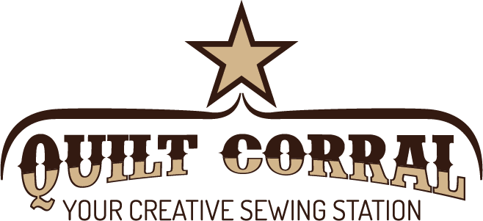
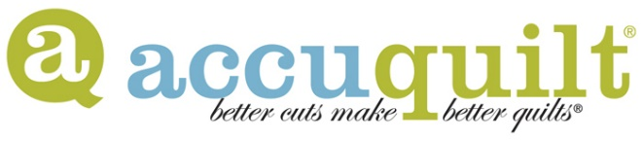
Accuquilt Go! Club $5
- Meets every other month on odd months. Starts May 24, 2018. 10 AM – 12 noon.
- Show and tell projects made with your Accuquilt Go!
- Featured die demo.
- Featured Accuquilt Go! project – includes a free project sheet that uses the featured die
- Door prizes - get tickets for coming, for bringing show and tell, and for bringing a friend
- Take and Sew – Fabric kit for a small project – this could be a pincushion, a zipper bag, a pillow, small table runner or table topper, placemat, mug rug or other small project. Price will vary depending on the size of the project. Must preregister to pick up a kit on club day.
- Convert it! Get Accuquilt Go! conversions for a select project– this could be a pattern for purchase, or a free to download pattern, or a Quilt Corral exclusive.
Accuquilt Cut and Sew $5 (plus possible kit and/or pattern fee)
- Meets every other month on even months. Starts April 26, 2018. 10 AM to 2 PM.
- Bring your own cutter and sewing machine and work on a small project in the classroom.
- Class will focus on learning to use your own cutter and converting other patterns to the Accuquilt Go! dies.
- Each class project will be a small quilt or table runner.
- Optional fabric kits available if ordered before the deadline or you may bring your own fabric.
Cut Up Your Stash
- Meets once a quarter. Starts in July 2018.
- Each class will feature a project and die selected to use up your stash.
- The quilts will be scrappy in nature so if you run out of one fabric you can fill in with another.
- The quilts will vary in size but most can easily be made smaller or larger as desired.
2 ½” Batik Strip Club
It’s back! You’ve been asking for it so we are restarting the 2 ½” Batik Strip Club. This club is basically a fabric swap.
- Once per quarter. Fabric due by the 1st Saturday of the Month for pickup after the 15th. No meetings. Starts May 2018.
- Purchase 1 1/8 yards of one batik before the quarterly deadline.
- Leave the fabric at the shop. We will cut the strips for you (on the Accuquilt Go! of course!)
- 2 weeks later pick up your assortment of 2 ½” strips.
- Get a free project sheet featuring 2 ½” strips.
- We will run this program quarterly.
- No cost to join if you buy your fabric at Quilt Corral. If bringing fabric from elsewhere there will be a $10 per exchange fee.

