101: Beginning Quilting
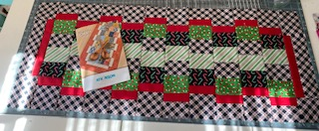
This is a great table runner for learning to use the rotary cutter and today’s technique of strip piecing. You will learn to pick out fabrics, cut strips, assemble, sandwich, quilt, and bind in 3 sessions.
When: Monday Nov 14, 21, & 28
Time: 6:00-8:00pm
Cost: $35.00 plus pattern & supplies
(Please pick up supply list when you register.)

Merry Go Round Topper
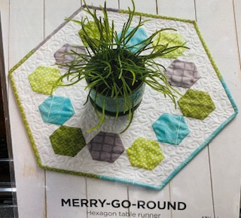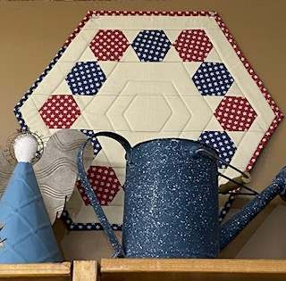
This cute litte Hexagon table topper uses just 4 fat ¼’s and background. Imagine in a Christmas fabric!
When: Wednesday, Nov 16
Time: 10:00 – 4:00
Cost: $10.00 plus pattern and supplies
(Please pick up supply list when you register.)

Fun & Done Quilt As You Go
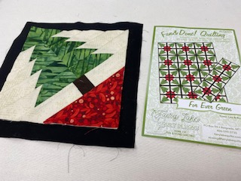
We will make a table runner in class. This project is assembled using a quilt-as-you-go technique. The piecing method allows you to complete the quilting as you assemble each block. Sew together, and you’re done…now that is fun!
When: Monday Nov 21 & Dec 5
Time: 1:00-4:00
Cost: $25.00 plus pattern & supplies
(Please pick up supply list when you register)

Make & Take Friday nights!!!
We will host 3 simple make & take projects you can whip up in just a couple hours.
When: Friday Dec 2, 9, & 16
Time: Fun begins at 5:00 (or when you can get here)
Cost: $0.00 (free) plus patterns & supplies
Dec. 2: Trendy Tote
Dec 9: Hello Pouches
Dec 16: Button Boats
See pics below and pick up a supply list when you register.

