The Block of the Month…
At the June Dinner we agreed on a new way to implement the Block of the Month. The plan is to present a new block each month.
If you decide to join the program you will need to select a focus fabric and then fabrics that compliment that fabric. Now when you begin each month’s block you will use those fabrics so that your blocks will build into a quilt top. All of the blocks will measure 12 and 1/2 inches.
At any time you might choose to use one or more blocks to complete the entire top rather than using all 12.

When you have completed your quilt top we will have an exhibit at a general meeting and then you will have a choice to keep the top and finish it, or donate it to the guild’s charity project.

The blocks for each month will be available as an attachment to the online edition of the Newsletter or, for those who receive a hard copy, available at the table when you sign in to a meeting.
And , of course, we need to celebrate the many members who have provided the sunshine over the past year:
Board members, who are leaving: Joyce Fischer, Barbara Samide, Anne Albano, and Pat Ronga and Mo Roth.who did such a wonderful job with the charity quilts.and Anna Hanrahan who leaves Programs to man the Web Page.
Librarian, Laura McNeice who arrives each meeting laden with books and magazines.
Mary Jane Miller who picked up the Newsletters each month and paste the stamps and labels on and mailed them.
Stephanie West and Angela Quartararo who made coffee and organized the cake for our meetings.(and the folks who brought the cake!)
Mary Ann Mooney who puts the June dinner together every year, and the folks who help her.
Mush Masters who quietly does all kinds of things
All the people on page 3 who have volunteered to help run the Quilt Show.
Joan Sculli who has all of us on her trusty laptop.
Elsa Shea, Joy McKeon, June Gerbracht and JoAnne Sorrentino who have agreed to fill the vacancies on the board.
Barbara Samide, who sell raffles and 50/50 chances for the Guild.
And of course, Sharon Salkewicz and Deborah Kircheim whose untiring efforts
have and continue to

We hope everyone will like the change!

July Block of the Month Card Trick 12 inch block
Download Instructions: Click here to download a .pdf with these block instructions. (Problems downloading our .pdf? Click here for troubleshooting tips.)
Cutting Instructions
Background
... Piece A - Cut two squares 4 7/8" x 4 7/8"; sub cut diagonally to make a total of 4 half-square triangles
... Piece B - Cut one square 5 1/4" x 5 1/4"; sub cut diagonally to make 4 quarter-square triangles
From each of FOUR different prints (purple, green, magenta, and dark blue), cut the following:
... Piece A - 1 square 4 7/8" x 4 7/8"; sub cut diagonally to make 2 half-square triangles
... Piece B - Cut one square 5 1/4" x 5 1/4"; sub cut diagonally twice to make 4 quarter-square triangles (Note: 2 triangles will be leftover for each print)
Piecing the block
Step 1. Sub Unit A. Using Diagram I as a guide, sew background fabric, Piece A to one each of the print fabric, Piece A. Make 1 pieced-square unit for each fabric combination.
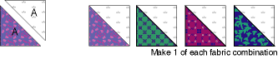
Step 2. Sub Unit B. Sew background quarter-square triangles (Piece B) to one each of the four print fabrics. Sew Piece A prints to each quarter-square units, using Diagram II as a fabric combination guide.
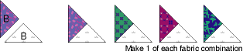
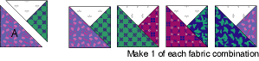
Step 3. Sub Unit C. Referring to Diagram III for fabric combination, sew print fabric quarter-square triangles (Piece B) together to make square.
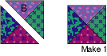
Diagram III
Assembling the Block
Step 4. Using Assembly Diagram as a guide,
piece sub units together to make rows. Piece rows together to make Card Trick block.
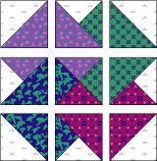
Assembly Diagram

August Block of the Month
The Dutchman’s Puzzle
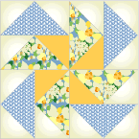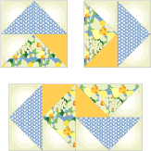
Finished Size 12" x 12" final assembly design
Cutting Instructions
Fabric 1 ... Background
... Piece 1A - Cut 12 squares 3 1/2" x 3 1/2"
Fabric 2 ... Blue Print
... Piece 2B - Cut 4 rectangles 3 1/2" x 6 1/2"
Fabric 3 ... Floral Print
... Piece 3B - Cut 4 rectangles 3 1/2" x 6 1/2"
Fabric 4 ... Gold
... Piece 4A - Cut 4 squares 3 1/2" x 3 1/2"
ASSEMBLY INSTRUCTIONS
Step 1. Draw a diagonal line on wrong side of, Piece 1A background squares. Using Diagram I as a guide, layer Piece 1A background square and Piece 2B blue print rectangle, right sides together. Sew directly on top of drawn line. Cut away excess fabric 1/4" from seamline. Press seam allowance toward background triangle. Repeat for other end of rectangle. Make 4 Flying Geese units of each color combination shown in Diagram I.
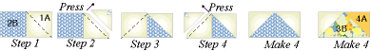
Diagram I
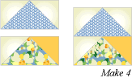
Step 2 Using diagram II assemble 4 quadrants
September Block of the Month

Shoo-Fly  Cutting Instructions  Light Fabric  ... Piece 1A - Cut 2 squares 4 7/8" x 4 7/8"  ... Piece 1B - Cut 4 rectangles 2 1/2" x 4 1/2"  ... Piece 1C - Cut 1 square 4 1/2" x 4 1/2"  Dark print  ... Piece 2A - Cut 2 squares 4 7/8" x 4 7/8"  ... Piece 2B - Cut 4 rectangles 2 1/2" x 4 1/2" | Block Size: 12" Finished  Beginner Level
Piecing the block
Unit 1 - Pieced-square
On wrong side of Piece 1A cream squares, draw diagonal line with the marking tool of your choice. Layer square with Piece 2A green print square, right sides together. Sew 1/4" seam on each side of marked line; cut apart on marked line. Press open to make pieced squares (Diagram I). Make 4.
Unit 2
Sew Piece 1B cream rectangle to 2B green print rectangle to make pieced squares. (Diagam II). Make 4.
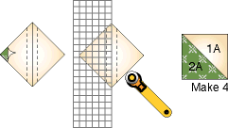  Diagram I | 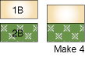  Diagram II
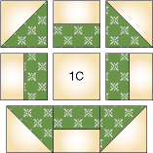
.
Assembling Block
Using Assembly Diagram as a guide, sew pieces and units together to make rows.
Sew rows together.

October Block of the Month - Party Hats
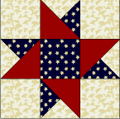
Finished Size: 12˝ x 12˝
Cutting Instructions:
Background
... A - Four squares 4 1/2" x 4 1/2"
... B - One square 5 1/4" x 5 1/4" cut twice diagonally
Red
... C - Two squares 4 7/8" x 4 7/8" cut once diagonally
Blue
... A - One square 4 1/2" x 4 1/2"
... B - One square 5 1/4" x 5 1/4" cut twice diagonally
Assembly Instructions:
Step 1. Using Diagram I as a guide, sew pieces together to form pieced-square.
Diagram I
Step 2. Referring to Assembly Diagram, turn pieced-squares to form star. Sew together pieced-squares, background squares, and blue square to form rows. Sew rows together to make block.
The source for our September/October blocks is McCall’s collection of patterns on line. www.mccallsquilting.com

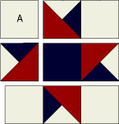
Assembly diagram

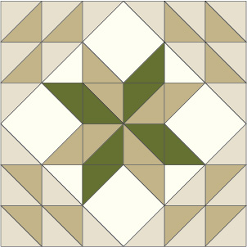
November Block of the Month – Meadow Star
Cutting instructions
Beige
8 squares 2 7/8˝ x 2 7/8˝
8 squares 2½˝ x 2½˝
Tan
8 squares 2 7/8˝ x 2 7/8˝
4 squares 2½˝ x 2½˝
Cream
4 squares 4½˝ x 4½˝
2 squares 2 7/8˝ x 2 7/8˝
Green
2 squares 2 7/8˝ x 2 7/8˝
4 squares 2½˝ x 2½˝
Remember, we are using our own colorway for these blocks so please subsitute your colors for those suggested
Piecing the Block
Finger-press cream print 10˝ square in half on both diagonals; use folds as placement guide.Draw diagonal line on wrong side of beige 2 7/8˝ square. Place marked square on tan 2 7/8˝ square, right sides together (Diagram I-A). Sew ¼˝seam on each side of marked line; cut apart on marked line. Open and press to make 2 pieced squares. Make 12. In same manner, make remaining pieced squares in fabric combinations and quantities shown in Diagram I-B
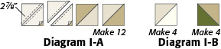 9.

Sew together 3 beige/tan and 1 beige/cream pieced squares to make corner unit (Diagram II-A). Make 4. Sew together 4 green/tan pieced squares to make 1 center pinwheel (Diagram II-B).
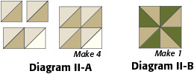
Draw diagonal line on wrong side of 2 beige, 1 tan, and 1 green 2½˝ squares. Referring to Diagram III, place beige and green marked squares on opposite corners of cream 4½” square, right sides together, aligning raw edges. Sew on marked lines. Trim away and discard excess fabric. Open and press. Repeat process to add 1 beige and 1 tan 2½˝ squares to remaining corners to make edge unit. Make 4.
.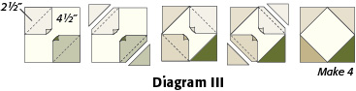
Arrange and sew 3 rows using 4 corner units, 4 edge units, and 1 center pinwheel (Diagram IV). Sew rows together to make Meadow Star Block.

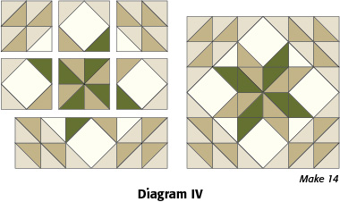

December Block of the Month

Spinning Star
Cutting Instructions  Background  ... Cut 6 squares 3 7/8" x 3 7/8"  Blue Print  ... Cut 4 squares 3 7/8" x 3 7/8"  Floral Print  ... Cut 6 squares 3 7/8" x 3 7/8"  Remember that you will be using your own choice of fabrics! | Size: 12" Finished
ASSEMBLY INSTRUCTIONS
Piecing the block
Pieced Squares: On wrong side of lightest fabric, draw diagonal line with the marking tool of your choice. Sew 1/4" seam on each side of marked line; cut apart on marked line. Press open to make pieced squares.
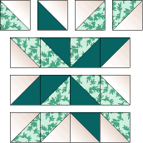
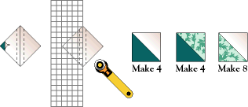 Assembly
Layout pieced-square units using Assembly Diagram as guide. Sew rows together to make block.

Pattern from McCall’s Quilting.

Block of the Month – January
Log Cabin

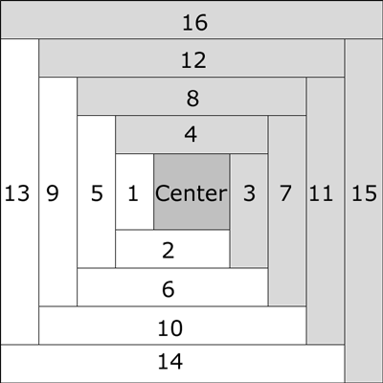
Directions:
Using three colors, choose one for a 2 ½” center for the block.
Label the other two colors A and B. Cut them into 1 ½” strips.
Using a long strip when you sew is the easiest way to go. Just trim each to the proper size after it is sewn .
Starting with the center square and a 1 ½” wide strip of fabric A, sew right sides together as shown in the diagram. Trim the extra fabric. Press towards #1.
Next, still using fabric A, right sides together, sew #2 to #1 and the center, press towards #2.
Continue, remembering to switch to fabric B when you get to #3. Follow diagram for colors. Stop when your block measures 12 ½”

February Block of the Month –
Pieced Hearts-
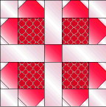
Cutting Instructions:
Fabric 1
... 16 squares 1 1/2" x 1 1/2" (Piece 1A)
... 4 squares 2 1/2" x 2 1/2" (Piece 1B)
... 4 rectangles 2 1/2" x 5 1/2" (Piece 1C)
Fabric 2,
... 4 squares 3 1/2" x 3 1/2" (Piece 2D)
Fabric 3,
10.

... 1 square 2 1/2" x 2 1/2" (Piece 3B)
... 8 rectangles 2 1/2" x 3 12" (Piece 3E)
ASSEMBLY INSTRUCTIONS
Step 1. Draw a diagonal line on the wrong side of Piece 1A squares. Align squares with Piece 3E rectangle, top corners, right sides together (Diagram I). Sew on previously drawn line. Cut away excess fabric leaving 1/4" seam allowance. Make 8 total pieced rectangles.
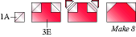
Diagram I
Step 2. Referring to Diagram II, sew together 2 pieced rectangles, Piece 1B and Piece 2D to form corner unit. Make 4 total pieced squares.
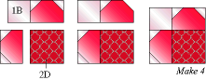
Diagram II
Step 3. Referring to Diagram III for unit/piece placement guide, sew 3 rows using 4 corner units, 4 background strips, and red 2 1/2˝ square. Sew rows together to make Pieced Hearts Block.
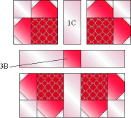
We have been working on this Block of the Month Project since July, If you are missing any patterns, drop me a note at romartin@optonline.net.
I will send you the back copies! Marie Martin
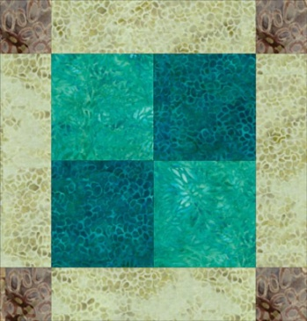
March Block of the Month - Unequal Nine-patch block
Cutting Instructions
•Dark: (1) 4-1/2" x 9-1/2" strip
•Light: (1) 4-1/2" x 9-1/2" strip
•Lighter Fabric: (1) 5-1/2" x 8-1/2" strip and (2) 2-1/2" x 8-1/2" bars
•Darker for Frame Corners: (2) 2-1/2" x 5-1/2" strips
Directions
1. Sew the two 4-1/2" x 9-1/2" strips together lengthwise . Press seam allowance towards the darker strip.
2. Square up one end of the strip set and then cut (2) 4-1/2" segments from it.
3. Beginning at the squared up end, cut (2) 4-1/2" segments.
4. Flip one unit around (top row, center illustration) so that like colors are aligned diagonally from each other. Sew the two units together, matching edges and the center seam. Press.
5. Sew a 2-1/2" x 5-1/2" darker frame/corner strip to (shortest) opposite sides of the 5-1/2" x 8-1/2" lighter frame fabric. Press seam allowances towards the narrower strips.
6. Square up one end of the strip set and then cut (2) 2-1/2" segments.
7. Sew a 2-1/2" x 8-1/2" bar to the top and bottom of your block center as shown, lower left illustration. Press seam allowances towards the block center.8. Sew the strip pieced frame units to the remaining edges of the block center as shown, matching edges and seam intersection.
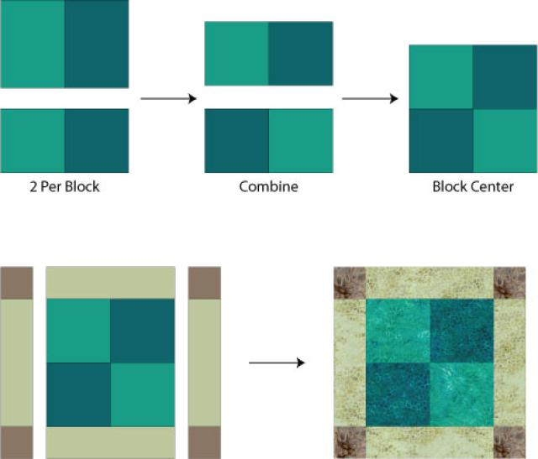
April Block of the Month - Lousianna Pinwheel
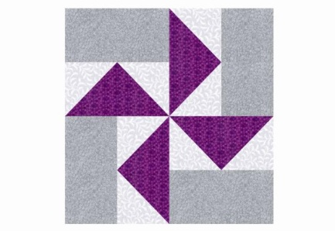
Fabric 1 cut 1 7-1/4" x 7-1/4" square
Fabric 2 cut 4 3-7/8" x 3-7/8" squares
Fabric 3 cut 4 3-1/2" x 6-1/2" rectangles

Now for a bit of a challenge…
This block requires the construction of 4 flying geese. There are many techniques for doing this and we know that you have a favorite method. If so…go to it! If not Google or U tube a lesson and teach yourself this valuable technique.
Assembling the Quilt Block…
1. Find the 3-1/2" x 6-1/2" fabric 3 rectangles. Figure 2.
2. Sew a 3-1/2" x 6-1/2" rectangle to the top of a Flying Geese as shown in Figure 3 -- the geese should 'point' at the rectangle. Press seam allowance towards the plain rectangle.
3. Repeat, making a total of four Figure 3 units.
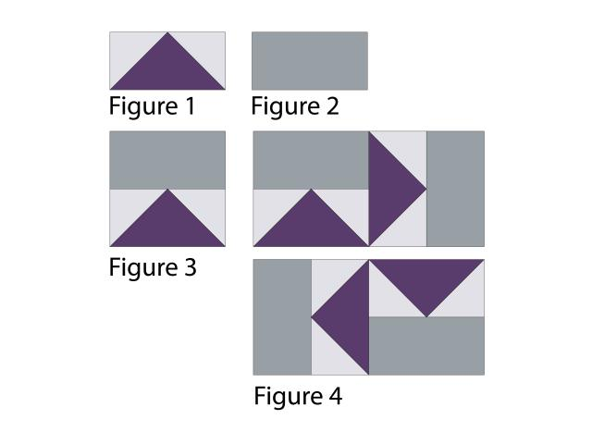
4. Arrange the four Figure 3 units into two rows as shown, Figure 4.
5. Sew the units in each row together. Press seam allowances towards the geese.
6. Join the rows and press seam allowance either way. You could wait to press the final seam, until you know how blocks will be joined. At that point, it might be possible to press seam allowances in adjoining rows in opposite directions,

