Thread Painting for Fusible Applique
Class is free with the purchase of Blue Hen Quilt Shop’s Black Eyed Susan wallhanging or block.

Call the shop to reserve your spot now!

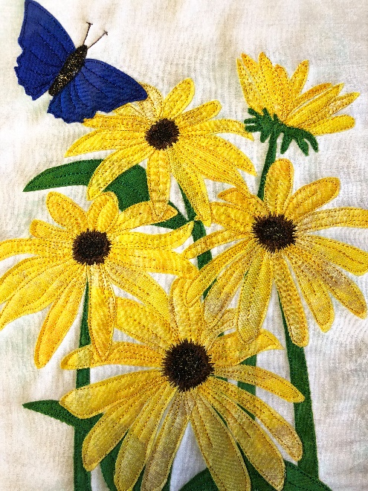

You will need:
Black Eyed Susan kit
Applique Pressing sheet
Steam a seam as noted on the kit.
Optional – Stabilizer (tear away or even batting)
Threads to match – yellow variegated, green, brown and blue.
Free motion foot
Sew slip and gloves (or something for your hands)

Have all the pieces of the applique adhered to the steam-a-seam and cut out before class.

