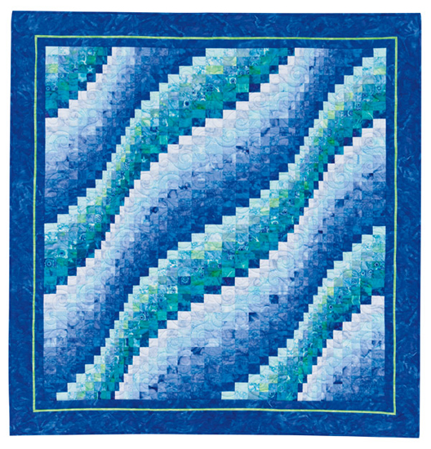

Supply List
“Surf Song” Wall Hanging
Teacher: Kathi Miller

Finished quilt size: 46½” X 48½”

Tools and notions needed:
- Sewing machine in good working order. Know how to operate your machine.
- Basic sewing supplies: spare sewing machine needles, thread, several full bobbins, pins, seam ripper, pencil (writing not marking), 6” x 24” ruler, 12-14” ruler (4-6” width), 17” x 23” cutting mat (or whatever mat you have that is this approximate size).
- 45 mm. rotary cutter with a new blade.

Book: Twist-and-Turn Bargello Quilts by Eileen Wright. Required.

Fabric requirements:
This quilt uses 20 fabrics in two color groups: 12 fabrics in one color group (blue) and 8 fabrics in a similar color group (blue-green). Fabrics in each color group should range from light to dark. You can mix Batiks and regular fabrics. Other color ways would work too. Golds and oranges/rusts is another good choice. Study the book for examples. I would be happy to meet with you at the shop to help select your fabrics.
- ¼ yd. of each of 20 fabrics for Bargello (these are regular ¼ yd. cuts rather than FQs)
- 1⅜ yds. of a dark fabric for borders and binding
- ¼ yd. for border accent
- 3⅜ yds. backing fabric
- 55” x 57” piece of batting

Preclass homework: Please come to class with three 1½” strips cut from each of the 20 fabrics for your bargello. Take care to cut your strips accurately – you don’t want any “wobbly” strips.

Please feel free to contact me if you have any questions. My home number is 360.694.0501. Email is miller1623@comcast.net.

