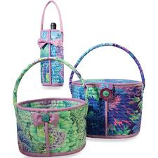

Rockport Basket Supply List

Rockport Basket Pattern
1 Yard of Fabric for the bag
½ yard fabric for binding
Batting-Foam 1 yard (fusible, or not)
Bottom – Peltex (Pellon72F) ¾ yard
Sewing machine, along with basic sewing supplies

