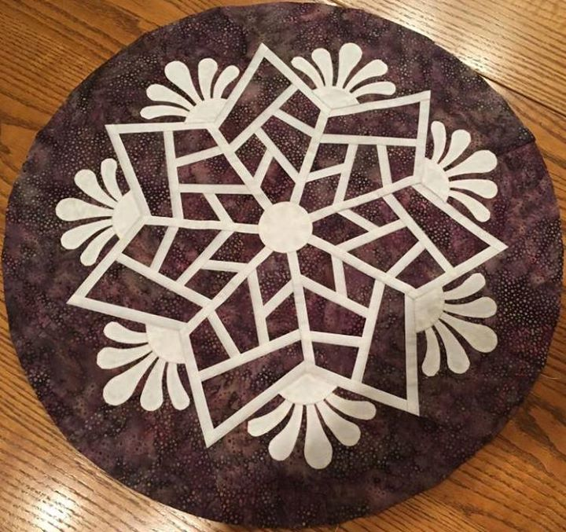
Class Title: Scandinavian Snowflake

Pattern: Quiltworx Scandinavian Snowflake

Skill Level: Advanced Beginner

Instructor: Susan Sears
Quiltworx Certified Instructor

Special Notions: 12” Add-A-1/4” ruler
UHU Glue stick or similar washable glue stick (Elmer’s)
SewLine, Bohin, Fons & Porter or similar brand fabric glue pen
Microtex 70/10 or 75/11 needles
Flower head pins (I use the blue Clover flower head pins & the yellow flower head pins)
Purple Thang or Stiletto
Scotch Tape
Stapler and Staple Remover
Strip of template plastic with a straight edge at least 3” x 12” long
Ziploc bags, 1-gallon size or larger (to organize sections)
{I like the Hefty 2.5 gallon size}
Jumbo Paper Clips, about 50 (to help with organization)

Sewing Supplies: Sewing Machine and accessories including your book
¼” presser foot for sewing accurate ¼” seams (a guided foot is not recommended)
50 wt thread to blend with fabrics
Scissors
Pins
Seam Ripper
Cutting Mat (not required since Lyons Quilting has mats for each table) & Ruler, at least 6” X 18” or similar size
60 mm Rotary Cutter
Class Information:

Scandinavian Snowflake is a fun placemat pattern that includes enough papers to make four 20” placemats or table toppers. It is a good introduction pattern to the basics of paper piecing and the applique method used Quiltworx. Please read the pattern before class.

I encourage you to use Quiltster to color your quilt. Quiltster is a color design software. It is available from Quiltster.com for a nominal fee. If you decide not to subscribe to Quiltster, I can help you with colors using my copy. Please let me know if you would like me to help you with your design. It will help if you have an idea of the colors that you would like to use in your quilt. Once you have colored your quilt, Quiltster will give you a yardage table to help with fabric purchases.

Please have your fabric cut for the first class as shown in Class 1 Instructions.

If you have any questions, please call or e-mail.

Thanks…See you in class!!!

Susan Sears
303-859-6064
ssears6804@aol.com

Scandinavian Snowflake Class 1 Instructions
If you have previously taken a Quiltworx class and are comfortable doing so, please cut out the papers. Remember, the Template Layout Sheets are cut out on the outside black line. The Foundation Papers or Units are cut out a fat 1/8” outside the black line. Place in the listed bags.
Please have the following fabric cut before class. Place all in the bag listed.
Unit A Snowflake (this is enough fabric to make 4 placemats)

Fabric A1 Background, Unit A Background Template Layout Sheet #1
- Cut (7) 11” x WOF (42”) strips of Fabric A1 Background or (1) 11” x WOF (42”) strips of 7 different Fabric A1 Backgrounds.
- Stack right sides up into one stack of 7 strips.
- Place in Bag A1 along with the TLS #1.
Fabric A2 Accent, Unit A Accent Template Layout Sheet #2
- Cut (7) 5” x WOF (42”) strips of Fabric A2 Accent or (1) 5” x WOF (42”) strips of 7 different Fabric A2a-A2g Accents.
- Stack right sides up into one stack of 7 strips.
- Place in Bag A1 along with the TLS #2.
Fabric AP1 Applique (this can be one color or 7 different colors or scraps)
- Cut (1) 13-1/2” x WOF (42”) strips of Fabric AP1 or (7) 4-1/2” strips of 7 different Fabric AP1a-AP1g.
- Place in Bag A1 along with the Unit A1 and applique sheets.

