Machine Quilting Part 2
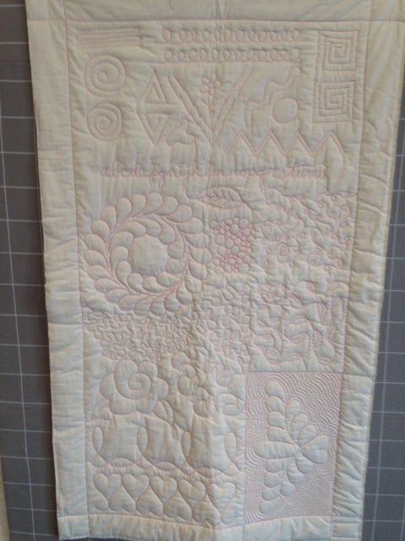
Donna Mae Norris 303-776-1749

Material:

For fabric choose a solid, pale color or muslin. Choose a good quality batting such as Quilter’s Dream or the batting you use in your good quilts.
- 1 yd. of fabric, plus two 15" square pieces of fabric
- Batting: 22" X 36" piece, plus one 15" square piece of batting

Equipment: (Other additional items will be provided by the instructor at no extra cost)
- Sewing machine in good working order. Dust out bobbin case or oil before class as recommended by your machine manufacturer.
- Extension to your sewing surface if you have one.
- Single hole throat plate—optional, bring if you have one.
- Darning foot or free motion foot. If you have more than 1, bring them all.
- Basic straight stitch foot
- One extra empty bobbin
- Machine needles—top stitch, quilting or jeans, size 90/14
- Safety pins (1" in size), about 10, PLUS about 10 straight pins
- Blue wash-out marking pen
- Machine thread that is the same color but a little darker in value than your fabric
- Water soluble thread—Wash Away or Vanish thread
- Typing or copier paper—about 5-10 sheets and pen or pencil
- Thread snips or scissors
- 5” blunt tip scissors, like a child’s (Fiskars has one). It needs to be sharp so you may have to buy one.
- Cutting mat will be supplied by the shop.

Optional:
- Quilting gloves—Machingers brand is popular or finger cots or rubber gloves
- Teflon slider sheet—such as Supreme Slider

Before class: Please prepare your “quilt” as shown on the next page.

Before class: To spend time in class quilting, please do the following:

*Fill 1 bobbin with your machine thread AND 1 bobbin with the water soluble thread. (Don’t forget the 1 extra empty bobbin.)

*Cut the 1 yard piece of fabric along the fold line to make 2 pieces of fabric about 36” by 20-22”. Using the blue wash-out pen, mark the lines shown below on your quilt top.

*Starch your backing fabric using spray starch or Best Press.

*Layer the batting and fabrics to make a quilt. Baste as you usually do. Using a walking foot or basic straight stitch foot, sew on the lines to make boxes like the ones shown.

Your dimensions don’t have to be exactly the same as shown, just try to get close. If you make your quilt at least 1 day in advance, you can spritz the top to remove the blue lines before class, but the quilt needs to be dry on the day of class.

*Don’t do anything to the 15” squares of fabric and batting. We’ll do those in class.

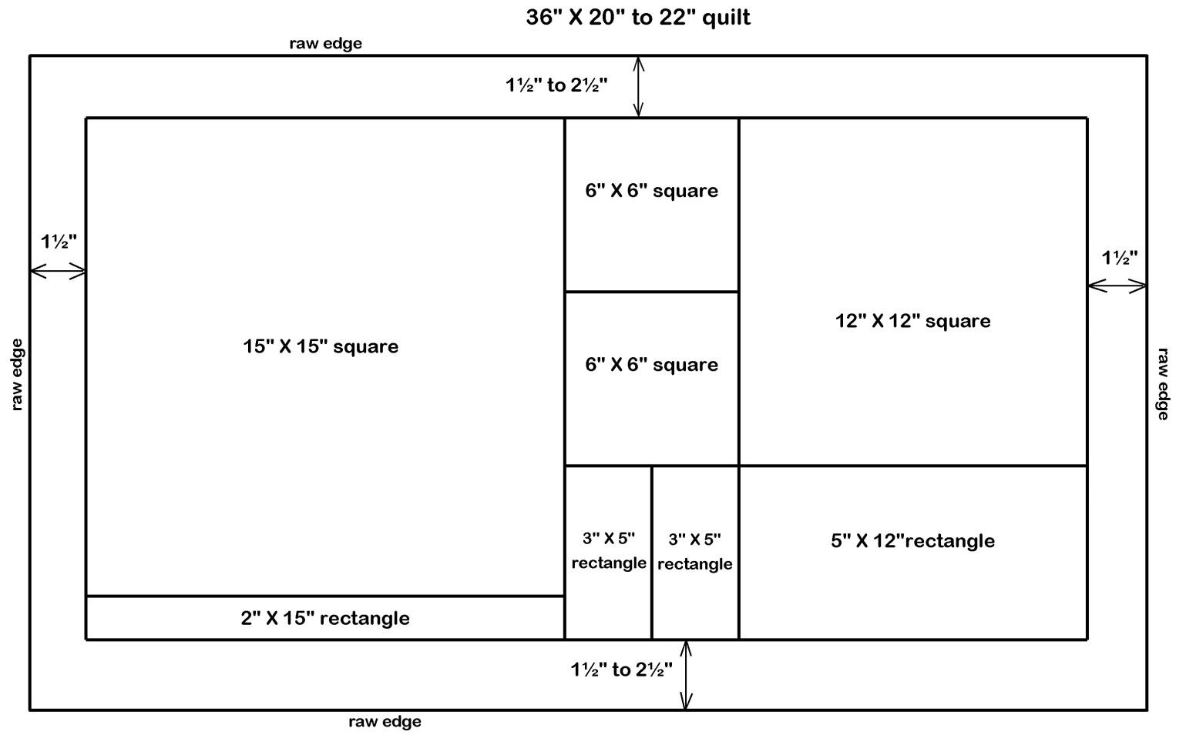
Note: Because this is a full day class, there will be a break for lunch. You may bring your own lunch or we will place an order from the Lyons Dairy Bar (they have great sandwiches!). Please bring cash if you would like us to order for you.

Class Policy - Please Read!
You are not officially enrolled in a class until you pay in full. You may call and pay by credit card. For a full refund you must cancel your spot in a class 72 hours in advance of the first class session. If you cancel within the 72 hours, you will only be refunded with store credit if we are able to refill your spot. If you are unable to pick up a physical copy of the supply list, please ensure that we have your correct email address to send it to you. If you don’t receive it in a couple days, it is your responsibility to please follow up and make sure we sent it to the right place! Register by phone or in person; no emails please!

