Class Title: Any Quiltworx Double Wedding Ring

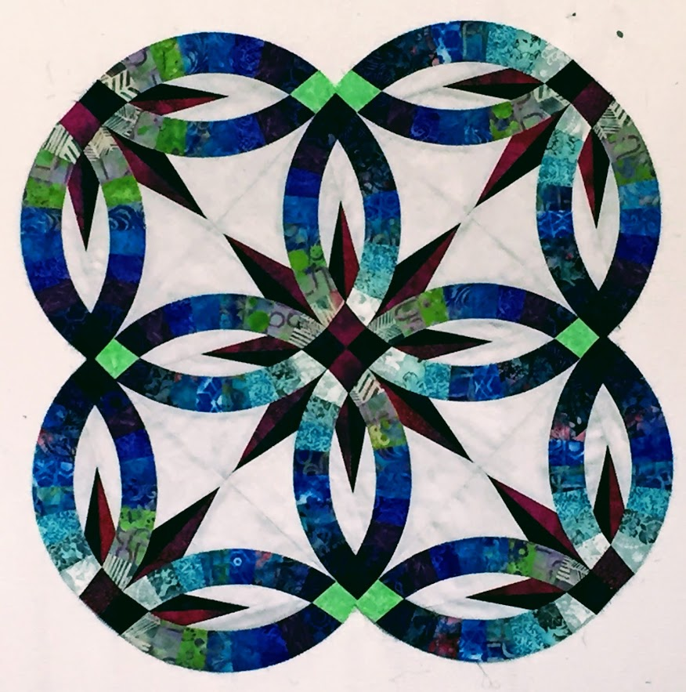
Patterns: Please choose one of the Quiltworx Double Wedding Ring patterns listed –
Wedding Star Table Topper**
Bali Bed Runner**
Bali Wedding Star
Gemstone Wedding Star**
Flowers for My Wedding Ring
Grandma’s Wedding Ring
(the patterns listed above use Judy Niemeyer/Quiltworx 2-1/2” strip sets by Timeless Treasures)

Skill Level: Advanced Beginner

Instructor: Susan Sears

Special Notions: Creative Grids Wedding Ring Ruler Set (this is highly recommended)
6” & 12” Add-A-1/4” ruler
Strip of template plastic with a straight edge at least 3” x 12” long
Acorn Precision Piecing Easy Press Fabric Treatment Pen
UHU Glue stick or similar washable glue stick (Elmer’s)
SewLine, Bohin, Fons & Porter or similar brand fabric glue pen and refills
Microtex 70/10 or 75/11 needles
Flower head pins (I use the blue 0.45 mm Clover flower head pins & the yellow flower head pins)
Purple Thang or Stiletto
Scotch Tape
Strip of template plastic with a straight edge at least 3” x 12” long
Ziploc bags, one gallon size or larger (to organize pattern sections; I use the 2.5 gallon size)
Jumbo Paper Clips, about 50 (to help with organization)
Rotating Cutting Mat (at least 12” square; not required but recommended)

Sewing Supplies: Sewing Machine and accessories including your book
¼” presser foot for sewing accurate ¼” seams (a guided foot is not recommended)
50 wt thread for piecing
Scissors, Pins, Seam Ripper, 60 mm Rotary Cutter & Ruler

Class Information:

All the Quiltworx Double Wedding Ring patterns listed above are good advanced beginner patterns and use Quiltworx strip sets. These strips sets have been cureated by Judy & Judel Niemeyer with Timeless Treasures. Each set contains 48-2 ½” strips, pre-sorted by Quiltworx into 6 groups of 8 strips, arranged light to dark. (You can cut your own strips if you desire but you will need to have them sorted into 6 groups of 8 strips from light to dark for class {we do not have time to sort them in class}). The sewing techniques that will be demonstrated include strip piecing the arcs and curved piecing. Please read the pattern before class.

**Please note – I recommend choosing one of the smaller wedding ring patterns such as the Bali Wedding Star Table Topper, Bali Bed Runner or Gemstone to learn the technique. Double Wedding Ring quilts require a lot of sewing time to complete.

You must have your 2-½” strip sets and pattern for the first class. Background and star point fabrics can be purchased after the first class.

I encourage you to check for pattern corrections on the Quiltworx website www.quiltworx.com/corrections/. Each pattern has a print date on the back page. Print out any listed corrections after your pattern print date.

If you have any questions, please call or e-mail.

Thanks…See you in class!!!

Susan Sears
303-859-6064
ssears6804@aol.com

If you have previously taken a Quiltworx class and are comfortable doing so, please cut out the papers. Remember, the Template Layout Sheet (TP) are cut out on the outside black line. The Foundation Papers (NP) are cut out a fat 1/8” outside the black line. You will need to cut out the A & B arcs for the first class. If you have not taken a Quiltworx class previously, I will teach you how to cut out papers in the first class.

