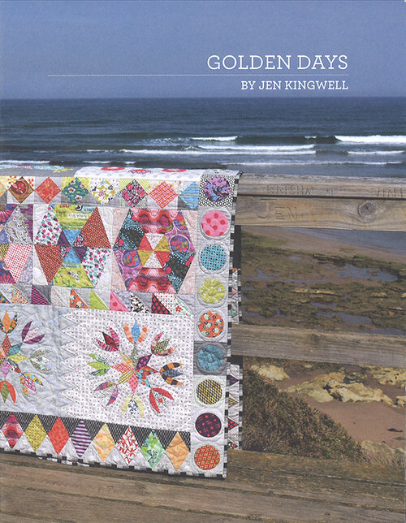
Class Title: Golden Days

Pattern: Golden Days by Jen Kingwell

Skill Level: Intermediate Skill Level

Instructor: Susan Sears

Fabrics: Scraps and more scraps, a mix of light, medium and dark values

Quilt Specific Supplies:

Applique Stabilizer for either turned edge or raw edge, your choice
Golden Days Acrylic Template set**
Small 60 degree diamond ruler

Sewing Supplies:

Sewing Machine and accessories including your book
¼” foot for sewing accurate ¼” seams (a guided foot is not recommended)
50 wt neutral or gray thread to blend with fabrics, such as Aurifil
SewLine or similar brand fabric glue pen and refills
Microtex 70/10 or 75/11 needles
Straight pins (blue Clover flower head pins or Clover 0.4 mm glass head pins)
Purple Thang or Stiletto
Scissors
Seam ripper
12-1/2” x 8-1/2” or 4-1/2” Ruler
Cutting Mat (not required if local quilt shop has mats for your use)
Rotary Cutter with new blade, 45 or 60 mm
Acorn Precision Piecing Easy Press Fabric Treatment Pen

Class Information:
This is a great scrappy quilt designed by Jen Kingwell. There is a mixture of pieced blocks and applique blocks. The blocks will be demonstrated in class with time to sew them in class and at home.
Here is the class plan –
- Border & Filler Strips
- Woodward & Fractured Hexagons
- Applique
- Wagon Wheel & Hopscotch
- Tulip & Alternate Block
- Assembly

If you have any questions, please call or e-mail.

Thank you…See you in class!!!

Susan Sears
303-859-6064
ssears6804@aol.com

**please note – These are EXPENSIVE! I had issues with my set of templates NOT being the correct sizes. They were off by 1/32” to 1/16”. There are paper templates in the book that can be used instead of the acrylic templates. I will demonstrate using both in class.

