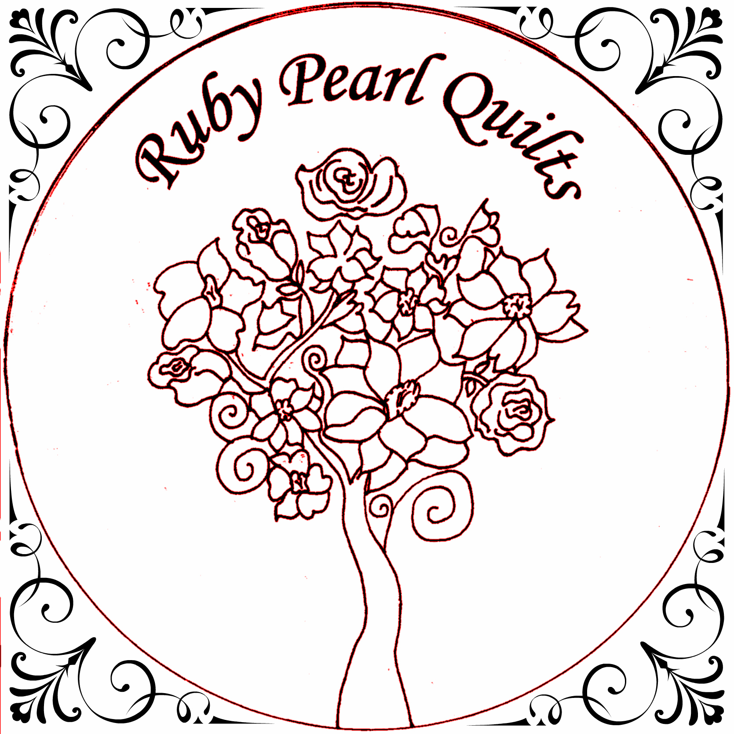
Open House....Saturday January 6, 2018
Featuring BERNINA…made to create

Date, Time, and Location of performance

Ruby Pearl Quilts,
“The Musical, 2018”

THE CLASSES
ABACUS 80x90 Instructor: Kleo
“I Count The Tears” – The Drifters
Even though the abacus was the ancient calculator, there is absolutely nothing ancient about this quilt! Its young and fresh look is a tribute to the new generation of Native Americans.
It features the Tula Pink “Spirit Animal” line.
You will enjoy making this quilt by using the Fons & Porter Flying Geese ruler.
Class Fee: $55.00 + Kit Saturday, January 13 - 10-4
SMALL SAMPLER 40x40 Instructor: Joy
“Will You Still Love Me Tomorrow” – The Shirelles
Start your quilting journey with this sweet little sampler by Alex Anderson. Learn how to choose fabrics, rotary cutting, piecing techniques, borders, quilting and binding. This class is for beginners and is also great as a refresher course. Basic sewing knowledge is required and there is sewing homework between classes.
Class Fee: $130 + Kit (which includes book)
Tuesday, Jan 16, 30 – 1- 4 Wednesday, Feb 7, 21 – 1- 4

HEART TABLE RUNNER 9x31 Instructor: Kleo
“Love is In The Air” – John Paul Young
Create a lovely wall hanging to warm you décor, for the month of February. Inspired by those cute little boxes of chocolates, to celebrate St. Valentine’s Day!! Techniques include quarter square triangles and half square triangles and piecing.
Class Fee: $55 +Kit, Thursday, January 18 ⁻ 10-4
PUMPKIN HARVEST QUILT 74.5 x 52.5
“Harvest Moon” Neil Young Instructor: Kleo
This is a fun quilt with a quaint cottage theme. The curved look of the pumpkins is created with simple machine piecing, so no templates are needed!! Featuring Tilda’s Harvest Collection.
Class Fee: $55.00 + Kit and Book Friday, January 19 - 10-4
PRETTY DRESSES 50 x 58 Instructor: Rosario
“Devil With The Blue Dress On” Mitch Ryder
What Fun!!! Lots of pretty fabrics, needle turn appliqué or easy machine appliqué! Needle turn appliqué gives it more depth and definition. However, definition can be obtained with quilting if you decide to fuse and machine appliqué the dresses. Either way, these dresses are made to impress!!
Class Fee: $55.00 +Kit Tuesday, January 23 - 10-4
PERFECT FORM OR PINCUSHION QUILT
“Lady In Red” Chris de burgh Instructor: Joy
Ahh the Tomato Pincushion. Every sewer has had one in their lifetime. But, did you know that according to tradition, placing a tomato on the mantle of a new home ensured prosperity by warding off evil spirits. You can never be too careful.
Or...create your Perfect Form with this delightful collage dress form set upon a pieced background. It's much easier than dieting. Either one of these quilts would make a great addition to your sewing room.
Class Fee: $65 + Kit Wed, January 24 – 10-4
CAMDEN BOWLS Instructor: Joy
“Life Is Just A Bowl Of Cherries” Judy Garland
I honestly had so much fun making my first Camden Bowl I can’t stop making them! They’re so easy to make, very practical and great as gifts. The pattern gives options for 3 sizes and uses fusible interfacing and batting from Bosal. And don’t worry; we have all the supplies you need to make the bowls in all three sizes.
Class Fee: $55 + Materials Thursday, January 25, 10-4
LITTLE MISS MUFFET 18”round Instructor: Kleo
“Little Miss Muffet” HooplaKidz
Little Miss Muffet sat on her tuffet and her friends said: “Omg!! Did you make that at Ruby Pearl Quilts?!!?!??” …and with pride she exclaimed: “Yes!! And Kleo will be teaching how to make slip covers for it, too! Can you imagine changing the look, to go with Christmas, Easter, even Birthdays”? If you have already made a round tuffet this is the class for you!!
Class Fee:$55 + Kit Friday, January 26 - 10-4
COTTAGE QUILT 52 x 77 Instructor: Rosario
“Our House” Madness
This adorable quilt will be such a lovely addition to your home or cottage. It is created with a “cottage” block and a “tree” block, repeated in different fabric combinations and separated by narrow sashing. It uses fabrics from Tilda’s “Cottage” Collection.
Class Fee:$55 + Kit, Book Saturday, January 27 - 10-4
DEFINITELY CANADIAN 31X35 Instructor: Joy
“Canadian Girls” Dean Brody
The patriotic quilt by Janet Crone is a large maple leaf with all the provinces of Canada represented on it. Hand appliquéd or fused, either method stunning.
Class Fee $65.00 + Kit
Wednesdays January 31, February 28, March 28 - 10-2
PATCH FOX Instructor: Rosario
“Fox” Karim Ouellet
These foxes are full of mischief and ready to play. The pattern provides the option of making a large and/or a small one. This Foxy Lady will be such a hit on Valentine’s that you will want to make more …maybe for your friends!!
Class Fee: $55.00 +Kit and Book
Thursday, February 1 - 10-4
FREE MOTION 48” square Instructor: Joy
“The Locomotion” Little Eva
This class is perfect for beginners or experienced quilters looking for a refresher course. There is not a lot of piecing on this quilt, the focus is on quilting the top which will be pieced at home. The top will then be finished off with scalloped edges and bound with bias binding.
Class Fee:$65 + Kit Thurs., Feb. 8, 15, March 15 – 1-4
HAPPY ENDINGS Instructor: Kleo
“Happy” Pharrell Williams
Come and learn different and fun techniques and styles of binding to finish your beautiful creations, including some tools to make it easier. Be in-a-bind no more!!!
Class Fee: $55.00 + Book Friday, February 23 – 10-4
YOU RULE
“Ruler of My Heart” Irma Thomas Instructor: Patricia
Quilting with rulers is so much fun, and the results are stunning. We will be teaching how to use the Westalee or Bernina ruler set, whichever you prefer.
Class Fee: $65, Ruler Kit Extra Saturday, February 24 – 10-4

BE HARE OR GO SQUIRRELY Instructor: Rosario
“White Rabbit” Jefferson Airplane Now here is a totally fun class to make these adorable stuffed animals!! You have your choice of making a rabbit or a squirrel. The delightful squirrel is made from pieced squares and it’s an easy introduction to making stuffed animals. The rabbit is a little more complicated than the squirrel, as it is made from pieced equilateral triangles, rather than squares. The assembly process however is the same. Both kits will be available for purchase, so you can make both.
Class Fee: $55.00 +Kit and Book Thurs., March 1 - 10-4
GREEN WITH ENVY, GIRL’S DAY OUT 70 x 77
“Sisters” – Irving Berlin Instructor: Kleo
Just in time for St. Patrick’s Day. The classic black and white design with splashes of green will make you the envy of your peers!!! The techniques used are piecing and appliqué.
Class Fee: $55.00 +Kit Friday, March 16 - 10-4
MORE HAPPY ENDINGS Instructor: Kleo
“I Believe In Happy Endings” Neil Diamond
Just when you thought you learned everything there is to know about binding, techniques just multiplied overnight!! Ugghhhh!! Have no fear! At this class Kleo will make it fun and easy to grasp these techniques. Phew!!! “Happy Endings” is a prerequisite for this class.
Class Fee: $55.00 + Kit & Book Friday, March 23 - 10-4
NOTE; If you see a class you like but can only come during the evening please let us know and we will try to accommodate you.
Visit us at www.rubypearlquilts, Facebook, Twitter and Instagram.

DIRECTOR’S NOTE
Please join us Saturday, January 6, 2018 for…
“Ruby Pearl Quilts…The Musical”
We have put together a fun list of classes, each with a theme song which is listed in red italics just below the quilts title. The songs will be playing throughout the day of the Open House. If you have signed up for a class and hear the song associated with your class playing, you will receive a ticket for a grand prize to be drawn at the end of the day. Each time you hear it, you receive a ticket. How cool is that! Join us for a day filled with fun, music and of course, popcorn. See you there, Joy
THE CAST
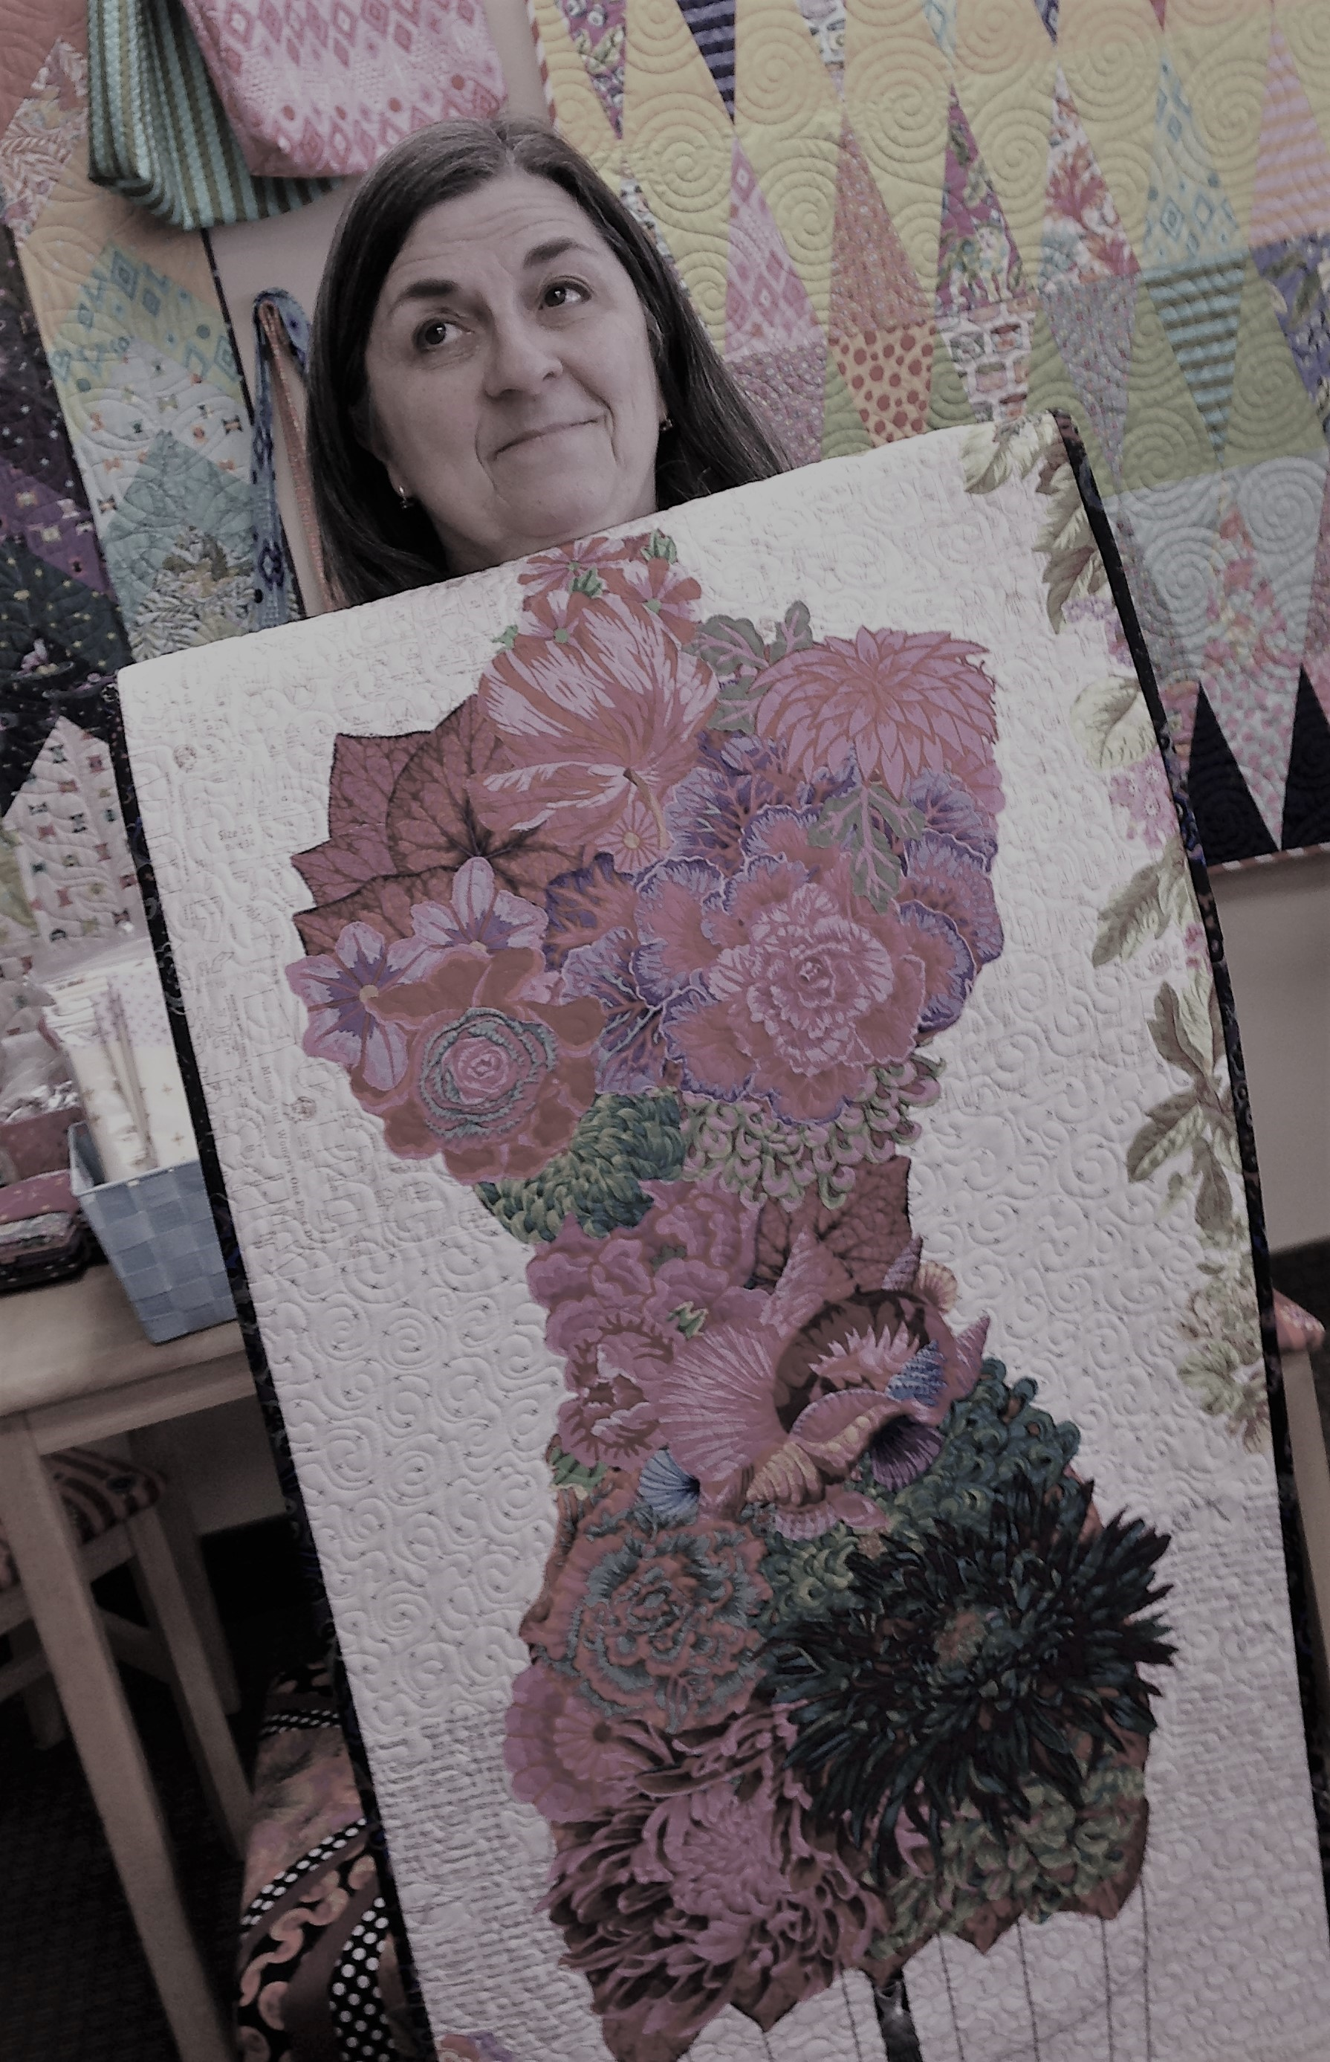 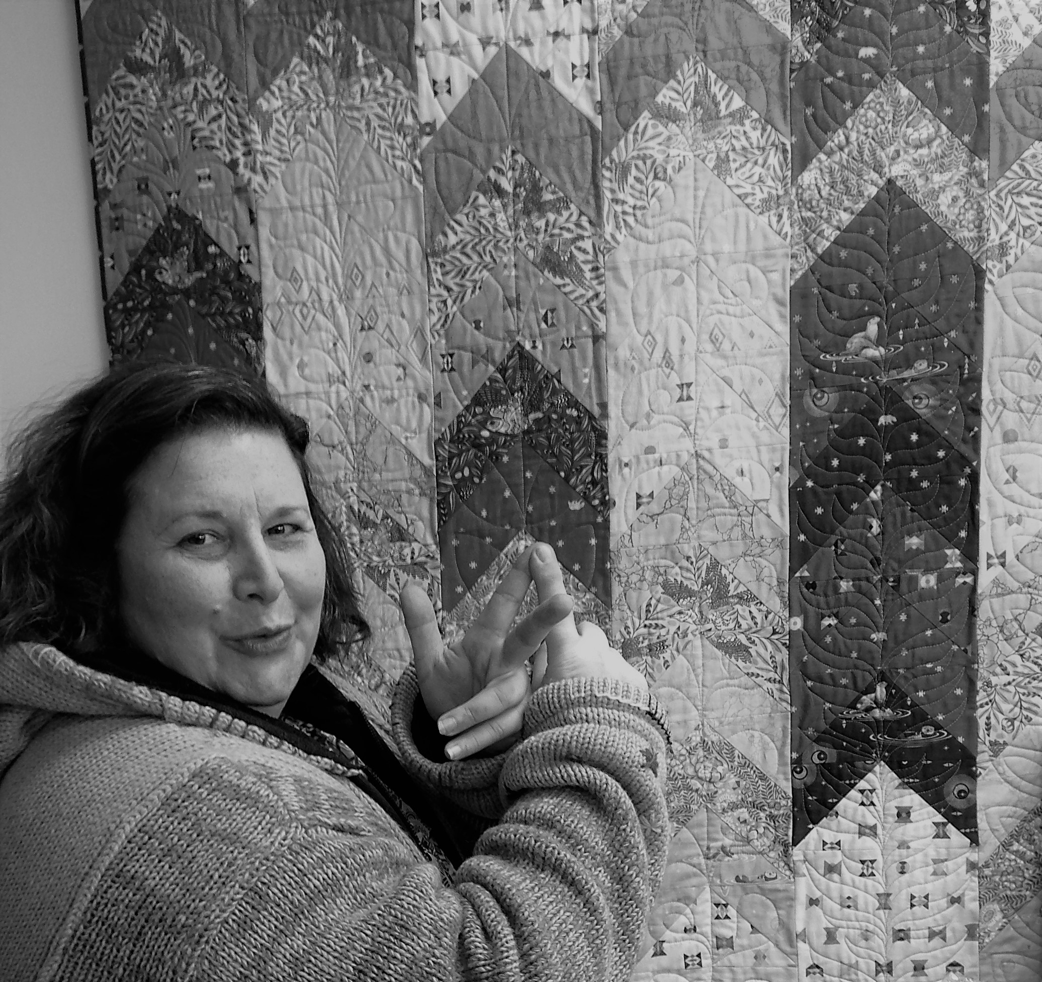 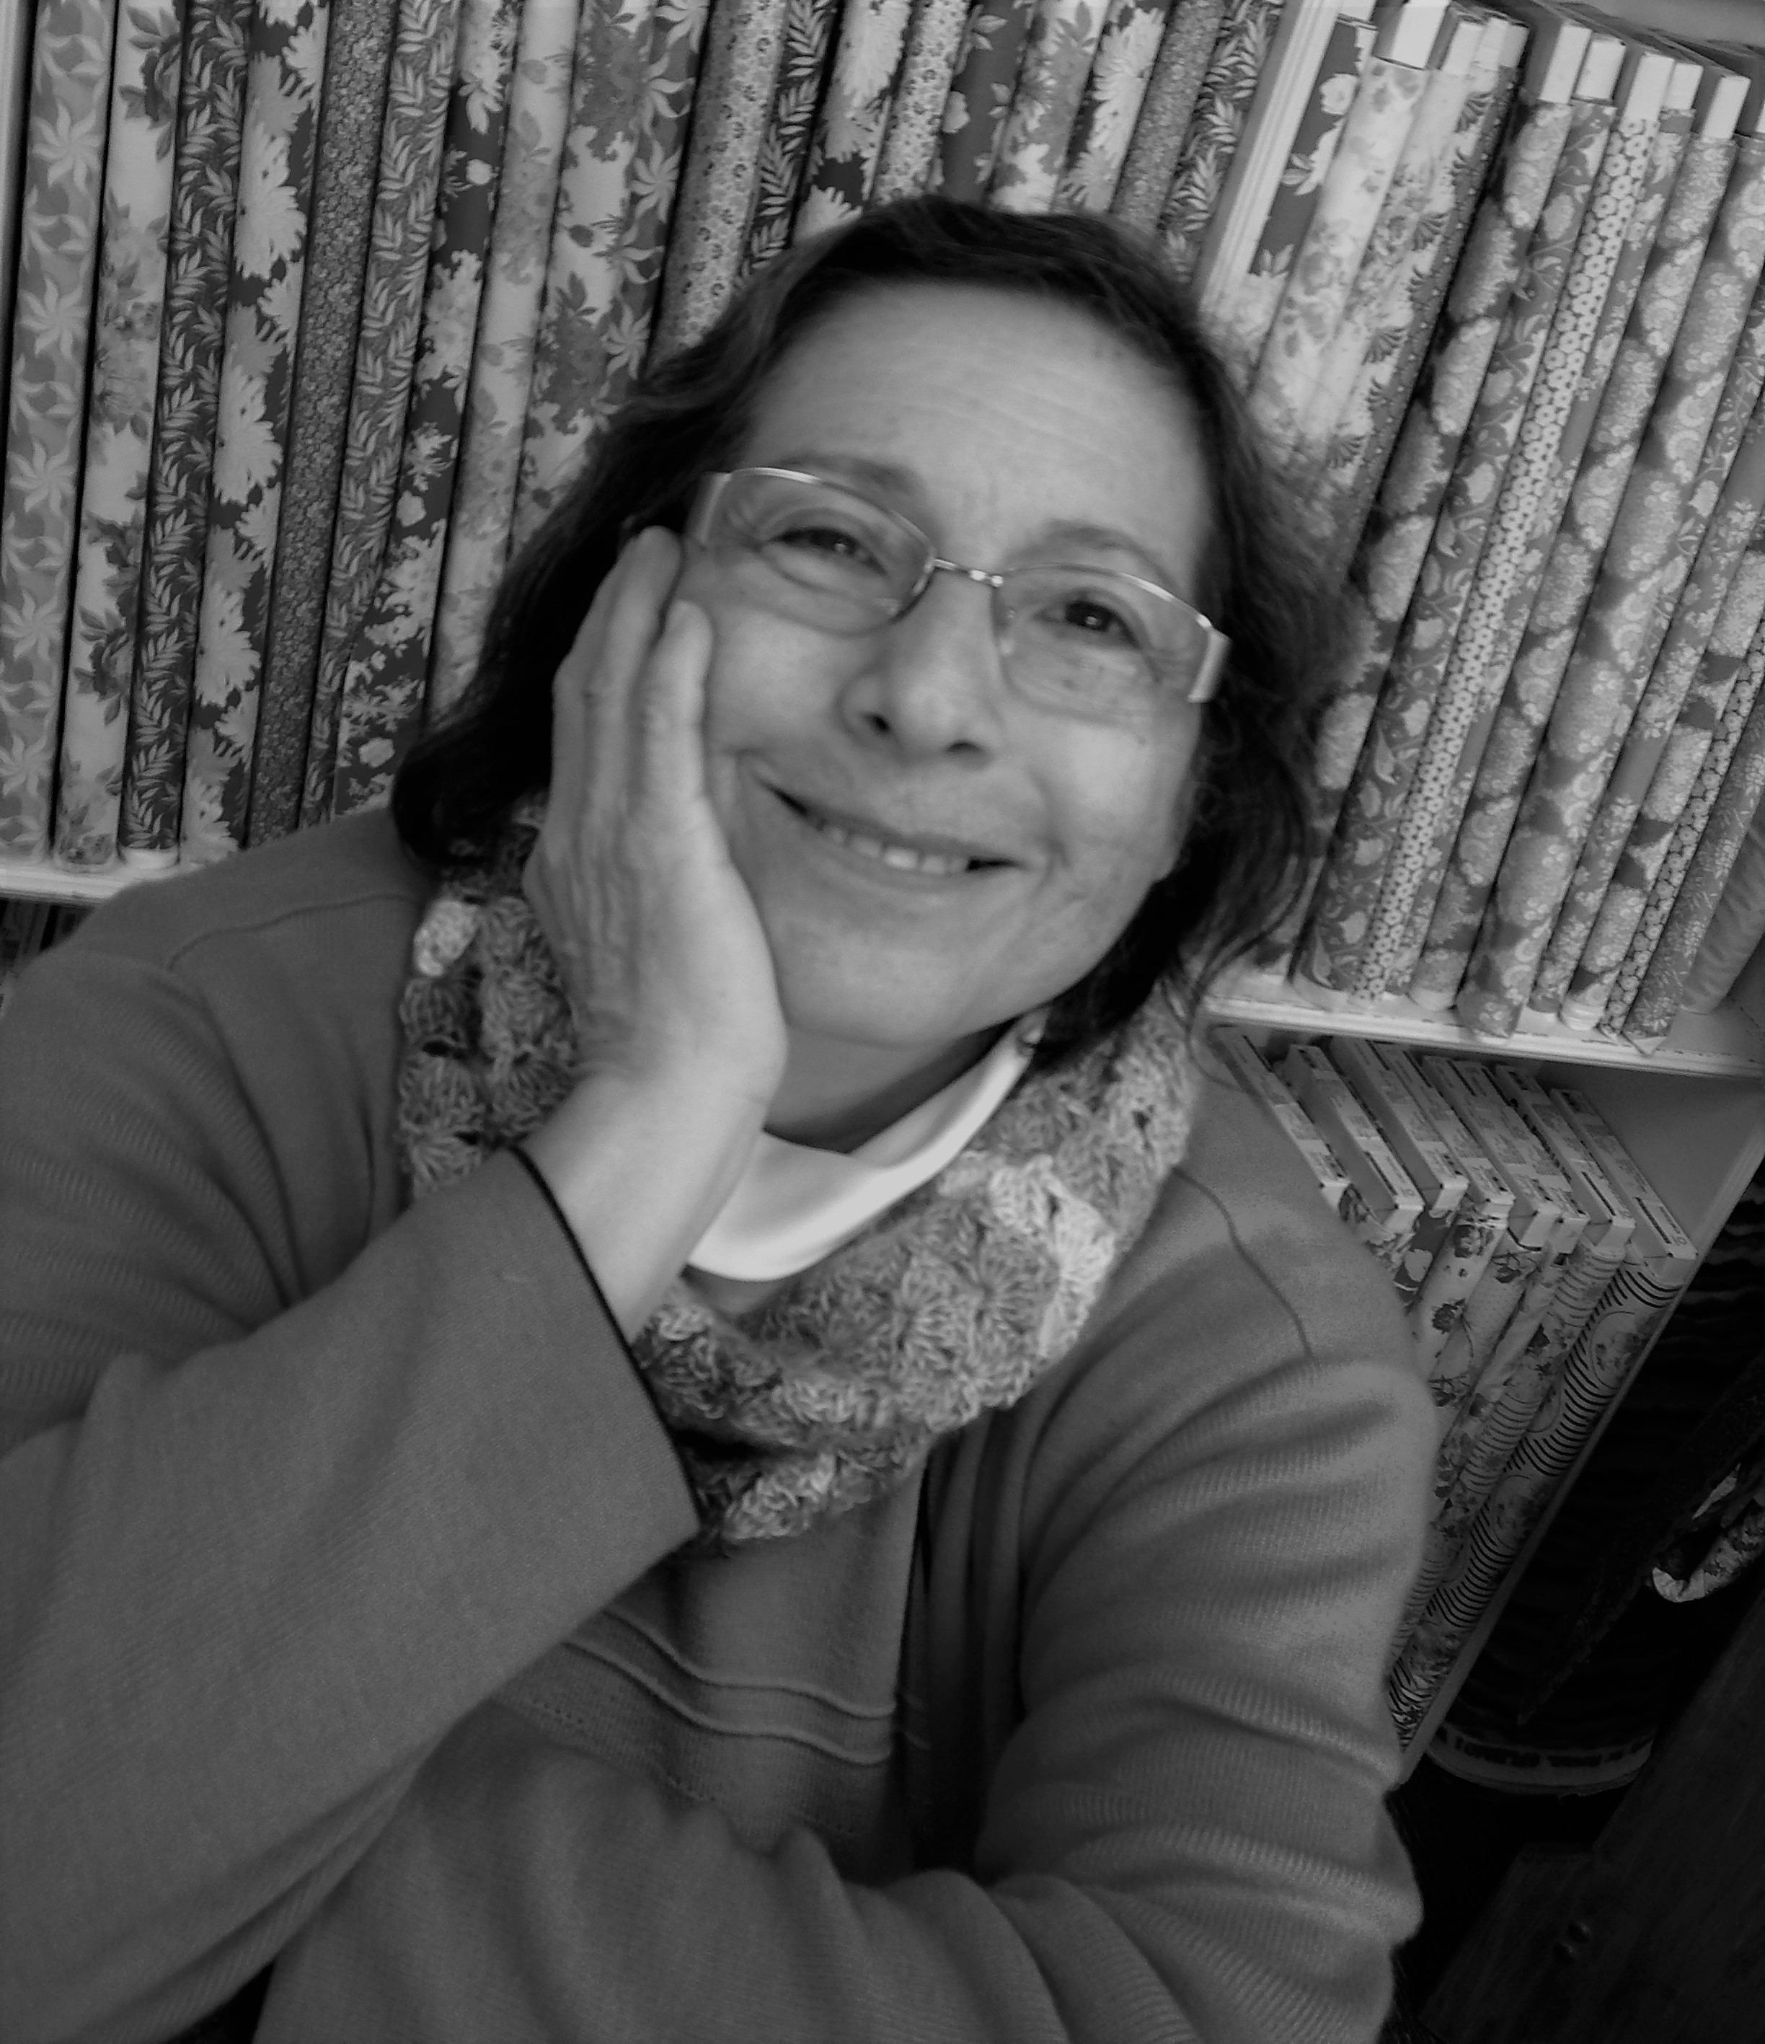
Joy Kleo Rosario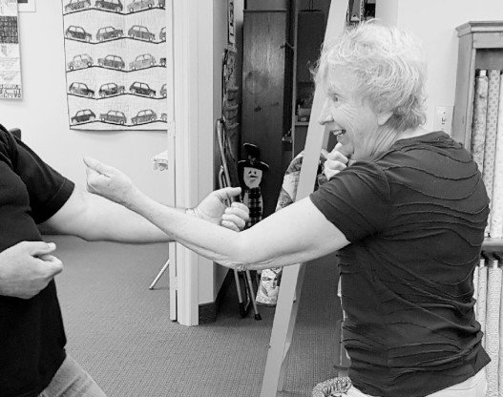
Choreographed by Linda

