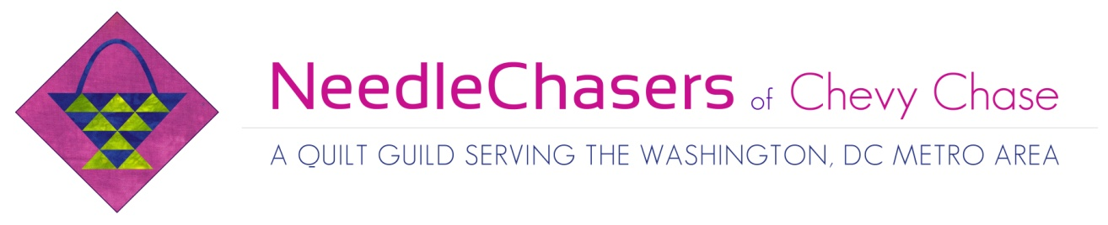NeedleChasers Event Registration Form
Thank you for your interest in this NeedleChasers Event. This is your official registration form for the workshop listed below. Please complete this form and submit it with your payment to Kim Kellman. Check should be made payable to NCCC. We will not be accepting electronic or credit card payments for this workshop. Your spot in this workshop will be secured only when this form and payment are received.
Registration Information
- Teacher’s Name: Gloria Loughman
- Workshop: Color is Magic (Tuesday) and Layer by Layer (Thursday and Friday)
- Date and Time: Tuesday, September 4, 9:30 a.m.- 4:30 p.m.
Thursday, September 6, 9:30 a.m. – 4:30 p.m.
Friday, September 7, 9:30 a.m. – 4:30 p.m.
- Location: North Chevy Chase Christian Church
- Supply list:
- Visit Gloria’s website for the supply list for the Color is Magic workshop or see the page at the bottom
- Visit Gloria’s website for the supply list for the Layer by Layer workshop or the page at the bottom

- Workshop fee: $250.00 NCCC members, $300.00 for non-members (checks only please made out to NCCC)
By completing this Workshop Registration form, I agree to the following Cancellation Policy: To receive a refund and cancel your place in the workshop, Kim Kellman must be notified electronically or by phone at least 45 days prior to the event. Requests received after this date will be honored only if there is a person on the waitlist able to fill your spot. If for any reason the event is cancelled, full refunds will be issued.
Print two copies, keep one for your records and send the completed form, along with your check to:
Kim Kellman, 8511 Hempstead Ave, Bethesda, MD 20817
Name _____________________________________________
Signature __________________________________________
Email _____________________________________________
You will receive a written confirmation for your space in the workshop via email or U.S. mail
Color is Magic

This is a stress free class where students will have fun experimenting with color and design. Participants will begin by studying and experimenting with some structured color schemes. They will then move on to create a simple landscape quilt that features an unusual palette of fabrics. The emphasis will be on color choice and value, using colors that may never have been seen before in nature but work harmoniously together for a stunning and different effect. There will be a choice of two patterns, so that the emphasis is on the color selection and not drawing out a pattern.

Approx size 30 cm x 42 cm

Requirements
Bring a picture, card, image etc that you love because of the colors used. Look in magazines, travel brochures, art books, greeting cards etc. The design is not important, only the color scheme used. (You won’t be actually making this design but it will be the basis of your color scheme)
Sewing machine in excellent working order, machine manual, tools and accessories. Darning foot is essential.
Color Wheel - available from the tutor
A set of colored pencils that has a good range of colors
Pen and note book, pencil (2B), pencil sharpener, eraser, cellotape.
Pins – lots of straight pins
1/2 yard (yard) of non-iron Tear – away (available from the tutor for $6 yard /yard) 1/2 yard (yard) of Freezer paper
1/2 yard (yard) of fusible webbing such as Steam a Seam, Wonder Under etc.
Threads to blend with color scheme chosen
Spare machine needles, scissors (fabric and paper), small sharp scissors, quick unpick. Foam brush (only if you want to paint fabric)

Fabric
Bring a range of fabrics that reflect the colors used in the picture you have selected because you just love the colors. Furnishing fabrics, landscape prints and hand-dyed fabrics work well. It is important to bring more fabrics rather than less, so the illusion of perspective can be introduced and variations in surfaces maintained. You will need lights, mediums and darks in each of the colors. Also, bring a quarter of a yard (yard) of white cotton fabric if you decide to paint a sky etc. Gloria will provide the paint.

Layer by Layer

If you are ready to try something different, experimenting with designs, patterns and fabrics, this class will help you take that next step. Combine elements of landscape in an abstract way to create something unique and visually exciting.

Gloria will have the patterns for four abstract designs or you can design your own. If you decide to design your own, bring some photos, sketches etc to use as inspiration.

Requirements
Sewing machine in excellent working order, machine manual, tools and accessories. Darning foot is essential and an open toed embroidery foot would be useful.
Pen, Pencil, eraser, cello tape, black medium felt tipped marker (e.g. Sharpie)
Large sheet of white paper if you are designing your own landscape– needs to be at least as big as proposed quilt size.
Pins
1 yard (yard) of non-iron Tear – away (available from the tutor)
1 yard (yard) of Freezer paper
1 yard (yard) of fusible web - e.g. Steam a Seam 2 Lite, Wonder Under – the amount used will vary according to design.
Nylon thread – Wonder Invisible thread or Monopoly (Made by Superior) recommended Neutral colored thread to blend with background fabrics
Threads to match colors of surface appliqué.
Machine needles size 60, and topstitch machine needles size 80
Scissors (fabric and paper), quick unpick (seam ripper).
Rotary cutter, ruler and small cutting board may be useful.

Fabrics
Bring a range of fabrics that have a variation in pattern and value. A suggestion is to choose two or three colors that work well together and then select fabrics making sure you include some lights, mediums and darks. Another starting place is to choose a fabric you like then add other fabrics that blend with this. Remember you need at least one highlight fabric – something that will stand out and provide some contrast. Gloria will have hand dyed fabrics available so you won’t be left short. A few fat quarters or quarter yards plus some smaller pieces will be fine.

