Pins & Needles

Name of Class: Simple Sack
Teacher’s Name: Dana Belzinskas
Store: East Store Phone Number: (440) 446-1484

10% off all class materials the day of class
Supply List:
- Simple Sack pattern by Atkinson Designs
- ½ yard main fabric
- ½ yard contrast fabric
- All purpose thread to match
- Bobbin wound with thread to match contrast fabric

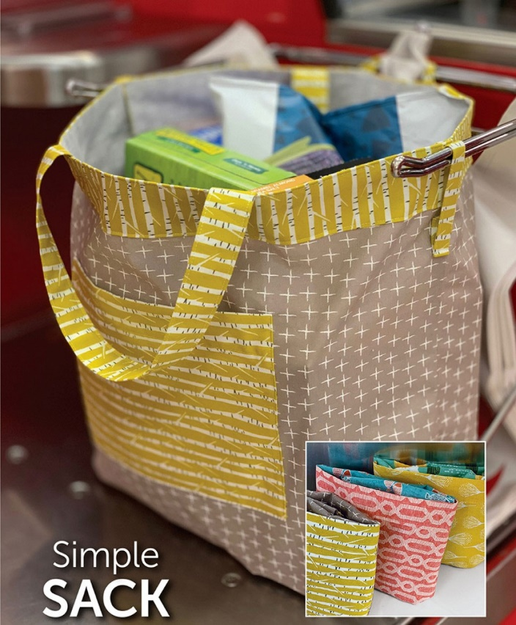

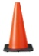Your payment is your commitment to your class and to the instructor. Refund will be issued IF a minimum enrollment of (2) is not met. You must give a 3-day notice to transfer the fee to another class. Student must have basic knowledge of their own sewing machine, including how to operate and thread your own machine.
Please note: Neither your instructor or Pins & Needles can be responsible for forgotten supplies and/or equipment. Please be sure to have all of your supplies properly labeled.

