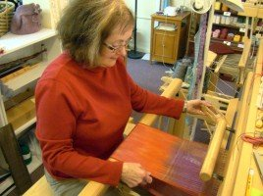
Thirty years ago, Linda Adamson took her sewing skills to the next level when
she wanted to create original fabrics. She found a weaving teacher in Bloomington
and has been honing her craft, with exceptional results, ever since. “Weaving is
such a creative medium,” says Linda, our September Fiber Artist of the Month
and owner of Tabby Tree Weaver in Arcadia. By being an original fiber artist, she
demonstrates that weaving truly is an art. Speaking of demonstrations, she’ll be
doing one from 10:30-12:30 Sept. 17 in the shop. Come watch her work on a floor loom.
“There are so many different weave structures and so many different ways to weave them” Linda continues.“Add to that the different fibers you can work with and it becomes an endless adventure. You never can learn it all, and since gaining knowledge is my hot spot, I can go on forever learning through this medium.” Linda makes original fabrics by using multiple weave structures in one piece. She also makes each piece unique from all the others she creates. She dyes some of her own yarns and involves many types of fibers.
Did you stop in for the weaving demonstration? Here are a couple photos. Thank you, Linda, for sharing your art with us.
