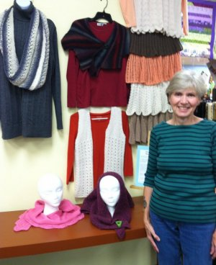

It’s a safe bet to call Anna Hutchens a success story. We think you’ll agree her work is stunning.
“I’ve been knitting with Penny Little and friends at AIS for four years,” she said. “I’ve learned so much in that time and now appreciate making items with a quality yarn and good needles.”
She knits garments from head to toe, and everything in between. Her gray, cream and black cowl is elegant, while her multi-colored socks look so snuggly and fun. Everyone in the Tuesday morning class loved the tiered skirt she knitted, and many of the items she has chosen to display as Fabric Artist of the Month are patterns that Always In Stitches carries. The multi-colored wingspan wrap is a Ravelry pattern we featured.
When Anna isn’t knitting, she drives a school bus for Westfield-Washington Schools and works part-time at Wooden Key Hallmark store in Carmel.
“My other interests are my children and grandchildren and their activities, gardening, some traveling, cooking,” she added. “And I’m an animal lover, especially dogs.”
She wishes everyone “happy knitting!”

