+

“Let the beauty of the Lord our God be upon us, and establish the work of our hands for us.” Psalm 90:17
Stitchin’ News
What’s in store at Always In Stitches
1808 E. Conner St., Noblesville, IN www.alwaysinstitches1.com (317) 776-4227
September 1-15, 2016

Bring in quilts you want done for Christmas
It’s not too early to bring in quilt tops you want to be wrapping and tucking under the Christmas tree. In fact, it’s getting late.

We will guarantee that quilts brought in by Oct. 1 will be done before the holiday. We will accept quilts after that date and will try to have them done in time for Christmas gift-giving, but we cannot promise they will be done before Santa loads his sleigh.

Download a quilting brochure from the Quilting Services page of AlwaysInStitches1.com to learn how to prepare your quilt for longarming and what it will cost.

If you’ve been certified to use the Fusion 24 longarm machine, don’t put off scheduling rental time for your Christmas quilts. The calendar likely will fill up quickly.

Become a knitter 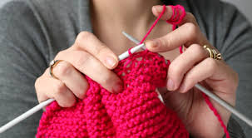
If you’ve ever wandered through the yarn department and said, “Someday, I’m going to learn to knit,” we’re giving you the opportunity.

Veteran knitter Janet Vawter will offer Beginning Knitting twice a month starting in September. Her two-hour class will cover basic techniques. You’ll get a good start on making your first scarf that you can finish at home.

You have two chances to take the class, and both are from 10:30-12:30. Beginning Knitting will be held the first Saturday or the third Friday of the month starting Sept. 3.

Don’t think, “I can’t learn in two hours.” You will. If you have problems when you start to work on your own – we all do – there are three Open Stitch sessions each week where you can drop in to get free hands-on help: 10:30-12:30 Mondays and 5:30-7:30 Tuesdays and Thursdays.

Don’t put it off. Get in on the knitting fun today and register for your first class.

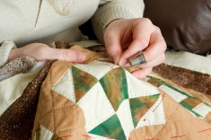

Power down.
Try hand quilting
Hand quilting lets you quilt while you’re outside, visiting with friends and family, or on the go. Learn the basics in Linda Heavner’s hands-on Hand Quilting class. You’ll also get information on needle choices, thread choices, stencils and batting.

She’s offering this new, one-session class twice, 1:30 Oct. 14 and 10:30 Oct. 29. The class fee is only $15, and you probably have all the supplies you need. Click, visit or call to register.

Where did summer go?
Labor Day is Sept. 5
The shop will be closed

Help us collect 200 pillowcases
We’ve set an ambitious goal to collect 200 finished pillowcases for Ryan’s Case for Smiles (formerly ConKerr Cancer) through Sept. 17, as part of the American Patchwork & Quilting Challenge. Make them at home or come to the shop for a Sew-a-thon, 10:30-4:30 Sept. 17. We will provide machines, supplies and fabric at no cost. Please call the shop, (317) 776-4227, to reserve a spot as space is limited.

Choosing batting can be baffling
You get lots of choices when choosing peanut butter for sandwiches. Crunchy or creamy. Name brand or store brand. Natural or conventional. Similarly, there are many choices for batting – the peanut butter in your quilt sandwich. Sometimes, selecting it can be more baffling, particularly for beginners.

McCall’s Quick Quilts offers good advice, starting with asking yourself some questions: How do you want the quilt to look? How close together will rows of quilting be? Are you quilting by hand or machine? What is the end use of the quilt? The answers to all of these questions will affect which batting you choose for the project.

Most batting comes in standard, pre-cut sizes: Crib, 45-by-60-inches. Twin, 72-by-90-inches. Full, 81-by-96-inches. Queen, 90-by-100-inches. King, 120-by-120-inches. We offer a craft size, 46-by-36-inches, and several battings by the yard, as well.
.
Batting also comes in a number of different fibers, though not all come in all standard sizes. If you prefer an old fashioned-looking quilt that’s a little rumpled and well loved, consider using batting that is mostly cotton. Keep in mind that cotton batting requires more quilting than some other fibers. If you like “puffy” quilts, use a high loft polyester batting. If you don’t want to do a lot of quilting, use regular or low loft polyester. Batting also comes in wool and silk fibers but these are not as readily available as cotton and polyester batting. Always In Stitches routinely stocks wool batting in pre-cut packages and on the bolt.

Carrie Nelson writes in The Cutting Table, Moda’s blog, “You should know that I will try just about any batting at least once because I’m curious. And I might like it – and I won’t know if I do if I don’t try it.”

Remember that we’re here to help. If you aren’t sure which batting is right for your project, ask the capable and experienced quilters on our staff.

Want to learn more about batting? Check out Moda’s blog, http://blog.modafabrics.com/2016/04/tip-jar-its-about-whats-in-the-middle/#more-11101

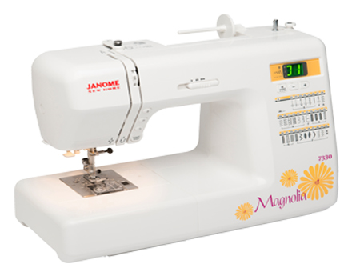
Try, then buy
If you enjoy using the rental machine and don’t want to part with it, we’ll make you a deal on the price and credit any rental fees toward your purchase.

Renting makes classtime ‘as simple as valet parking’
When you’re interested in taking any of our quilting or sewing classes but dread packing up your machine, hefting it into and out of the car (twice!), then having to set it up in the shop or back at home, we have a simple alternative: Rent a machine while you’re here.

It’s only $5, and we make it as simple as valet parking. Call us at least a day in advance to reserve a machine. We’ll have it ready when you arrive, complete with bobbins, a needle and the basic accessories you’ll need to use it. Arrive for your class a few minutes early, and we’ll give you a quick operations tutorial. When the class is over, we’ll pack it up, heft it and put it away.

Renting is also an excellent alternative to Machine Separation Anxiety, that panicky, sweaty-palms feeling some of us experience while our machine is being serviced or repaired. The take-home rental rate also is $5 per day for the first 15 days, $1 per day for days 16-30.

We’re sew-cial

2

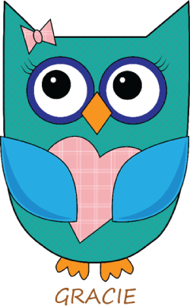
Project Linus mystery quilt: Gracie’s Get Well Garden
Project Linus has opened registration for Gracie's Get Well Garden, the organization's 2016 Mystery Quilt Challenge. From what we can see, it's going to be really cute!

The Project Linus HQ staff will send quilters that sign up one clue per week for seven weeks starting in mid-September. Each clue will include detailed instructions for making at least one block. Some clues will include links to videos to learn more techniques. Visit www.projectlinus.org for details and to register.

Soooo much to love about Let’s Go Sew
The DIY website Sew4Home has won over people just like you: sewists and quilters with an eye for quality and an undeniable creative flair. Their step-by-step tutorials for sassy, fashionable accessories and home decor are hard to beat.

We can’t wait to host them Sept. 30-Oct. 2 at Let’s Go Sew. Liz Johnson, Sew4Home senior editor, says attendees can expect “Soooooo much!” from the retreat. “They’ll spend three days with the expert guidance of professional instructors and educators, leaving with three finished projects: a patchwork pillow, a designer bag and an embroidered pouch. They’ll learn the tools, tricks and techniques to create beautifully finished results from putting in zippers and in-the-

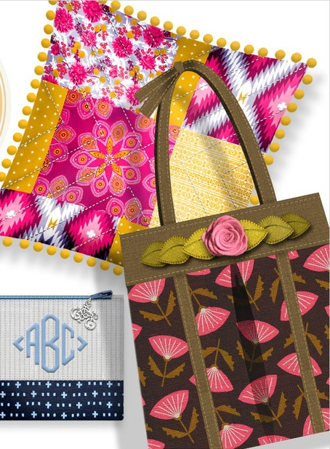

hoop quilting and monogramming to how to box the corners of a bag. We want to give people the confidence to not only make things for themselves, but also to be self-assured enough to possibly start that DIY or Etsy business they’ve been dreaming about.”

Sewists of all skill levels will enjoy the getaway, where all you bring is you. Machines, fabric, notions, Saturday lunch and snacks throughout the weekend are provided. It should be especially attractive to new sewists, particularly “20-somethings who are excited to discover sewing and see how fun it can be to create something unique,” Johnson adds. “We want them to be exposed to the fun in person, using great machines and tools and fabric and thread.” Sign up at Sew4Home.com/SewingEscape.

The cost to participate is $15. If you choose to designate the “Hamilton County, Ind.,” chapter, thank you! The entire $15 comes back to the local chapter, which is coordinated through Always In Stitches. If you don't designate a chapter, the funds go to the national office. Either way, kids who are seriously ill, traumatized or otherwise in need win.

Chapter funds do not pay any salaries; we're all volunteers. Chapter funds do help us cover the costs of purchasing supplies such as labels and Blanketeer patches, as well as fabric, filling and notions for the growing demand for weighted blankets, postage, etc.

Build your life’s prayer plan
Develop a prayer plan for your life in a nine-week Bible study that customer Vi Goodrich will lead from 10:30-noon on Wednesdays starting Sept. 14 in the shop. Discussions will include what prayer is, the various types of prayer, understanding why and how God wants us to pray, learning to respond in prayer to spiritual warfare, and truths about God that will help you pray in faith. “The Battle Plan for Prayer,” the book that inspired the film “War Room,” is the basis for the Bible study, which is free. Reservations are encouraged and can be placed online, in the shop or on the phone.

Master your serger in all-day workshop

Louise Beaman, a certified sewing educator, will teach how to streamline your sewing using your serger at the Serger Basics Workshop, 10:30-4:30 Sept. 24. Learn about its parts and how it works. How to thread it and adjust tensions. Practice using it to turn corners, serge on a curve or circle, gather and adjust for decorative stitches. This all-day class blends what you need to know about the mechanics of sergers with the many ways you can use one creatively and for everyday projects. Click, visit or call to register.

_______________________________

__________________________________________
Open 10-5 Mondays, Wednesdays, Fridays, Saturdays ⋅ 10-8 Tuesdays, Thursdays ⋅ Closed Sundays
Open ‘round-the-clock at www.AlwaysInStitches1.com

Always something stitching in our classrooms, around the shop
Crochet
Anita Crochets
Every Tuesday, 2-4:00 ⋅ Every Thursday, 5:30-7:30 ⋅ $10
Bring a project to start, trouble shoot or finish at this hands-on class for all skill levels.

Cross-Stitch
Needle Nuts
Every Thursday ⋅ 4-7:30 ⋅ Free ⋅ Join in any week
Be ready to laugh and learn with this group of cross-stitch lovers. They’ve discovered the joy of cross-stitching and fellowship.

Fiber Events Outside the Shop
Black, White and More
Through Sept. 2 · SullivanMunce Cultural Center, Zionsville
Charm Club hosts display of quilts using black and white plus one accent color.

35th Year! Quilts in the Park
Sept. 8-10, 9-6:00 · Sept. 11, 1-5:00 · Falls Park, Pendleton · $5 · svqg.freewebspace.com
Presented by Spring Valley Quilt Guild. Seven entry categories for quilts to show; no charge to enter quilts.
Fun for All Needle Crafters
Bible Study Based on the Book that Inspired “War Room”
Wednesdays, Sept. 14-Nov. 9 · 10:30-noon · Free · Reservations appreciated
Develop a prayer plan for your life as you discuss many facets of prayer and truths about God that will help you pray in faith. Book is not needed to participate.

Sew-A-Thon for Ryan’s Case for Smiles
Sept. 17 · 10:30-4:30 · Free, including supplies but phone reservations needed
Set aside part of all of your day to sew pillowcases for Ryan’s Case for Smiles, formerly ConKerr Cancer. Machines, fabric and supplies will be provided, though you may bring your own machine if you prefer to use it.

Surprise Party
Sept. 26 ⋅ 2-3:00 ⋅ $12 ⋅ Click, visit or call by 5 p.m. Aug. 19 to register
Always fun. Always a surprise. Enjoy a hands-on activity or presentation, light refreshments and a freebie to take home while in the company of like-minded stitchers. Theme: Harvest.

Only a few spots left! Barn Quilt Painting
Oct. 15 · Noon-4:00 · $45, includes all supplies · Click, visit or call to register
Paint a 2-by-2-foot quilt block on wood, suitable to hang outdoors – and no seams to rip! Choose from one of four block designs – Snowflake, Christmas Tree, Pinwheel Star, Red, Green and Yellow Star.

Classes fill quickly! Watercolor Painting
Nov. 3-5 · Times and prices vary · Click, visit or call to register
No experience? Can’t draw? No worries. Gayle Middleton Jones will walk you through it stroke by stroke. Take one, two or all three classes. All supplies provided. Mats sold separately. Potting Shed, 10-4:00 Nov. 3 and 4, $80. Front Door, 4-8:00 Nov. 3, $25. Barn, 10-4:00 Nov. 5, $50. See images of the paintings in the shop or in our online calendar.

Knitting
Knitter in the Spotlight: Wendy Johnson
In the Yarn Department through Sept. 30
Wendy Johnson designs knitting patterns for all skill levels that feature lace and colorwork, traditional and modern. Get a discount on yarn for projects using her patterns.

Open Knit and Open Stitch
Every Monday, 10:30-12:30 ⋅ Every Tuesday and Thursday, 5:30-7:30 ⋅ Free
Drop in any session to get uninterrupted stitching time. Instructor on hand to help.

2 Opportunities every month! Beginning Knitting
1st Saturday or 3rd Friday · 10:30-12:30 · $15 plus supplies ·· Click, visit or call to register
Learn basic knitting techniques. Start making a scarf you can finish at home.

Quilting and Sewing
Always Bee Quilting
First Wednesday of each month ⋅ 11-2:00 ⋅ Free ⋅ Reservations appreciated
Pack up a project, your machine, hoops or handwork and come to the shop to work on it.

Handi Quilter Quilting Classes
Sept. 8-10 · 3 hours each, two/day · $60 each, six for $150 · Click, visit or call to register
HQ National Educator Harriet Carpanini teaches techniques for all skill levels – first-time quilters to advanced. Each class offers a wealth of topics.

Longarm 101
Sept. 19 ⋅ 11-Noon ⋅ $25 ⋅ Click, visit or call to register
Learn basic operations of the Fusion 24 longarm machine, and then rent time on it to quilt your projects. Class fee pays for your first rental hour. Offered 3rd Monday of each month.

Patchwork Table Runner
Sept. 20 or Oct. 18 ⋅ 5-7:00 ⋅ $5 plus supplies ⋅ Click, visit or call to register
Make a table runner each month that celebrates something the following month using Shabby Fabrics patterns and your scraps. Join the class once, once in a while or every month. September: Leaves. October: Pumpkin.

Serger Basics Workshop
Sept. 24 ⋅ 10:30-4:30 ⋅ $60 ⋅ Click, visit or call to register
Learn how to use and maintain your serger, how it works, what it can do.

Let’s Go Sew! Sewing Escape
Sept. 30-Oct. 2 ⋅ $199, includes all needed supplies ⋅ Register at www.Sew4Home.com
Make 3 great Sew4Home projects in 3 days while you use brand-new Janome machines. Enjoy conversation and fellowship with like-minded sewists. Everything provided.

Last class this year! Free Motion Quilting
Oct. 8 ⋅ 1-3:00 ⋅ $30 plus $5 kit · Click, visit or call to register
Make your quilt tops pop using basic designs, simple techniques. Susan Cook will have you quilting designs before this class ends that you didn’t think you could when you registered.
Quilt Project Class
Oct. 12 or Nov. 9 · 12:30-4 · $30 · Click, visit or call to register
Get start-to-finish directions as you learn quilting techniques. Offered monthly. Take it once, occasionally or every month. Different project every time.

New! Hand Quilting
Oct. 14 1:30-3 or Oct. 29, 10:30-noon · $15 plus supplies · Click, visit or call to register
Learn the basics in this hands-on class. Get information on needle choices, thread choices, stencils and batting.

New Quilters School
Nov. 8 · 5:15-7:45 · $20 · Click, visit or call to register
For new quilters wanting to perfect their skills. Small home décor projects will take one or two sessions, depending on their difficulty. Learn cutting, piecing, quilting, binding, etc.

As a courtesy to others in our classes or events,
we ask that you not wear fragrances and that you step out of the room to take phone calls

New class! Cross Stitch Finishing
Sept. 6 · 1-3:00 · $30 plus supplies · Click, visit or call to register
Stand-up blocks make a terrific way to display your cross-stitch pieces. Learn how easy it is to assemble the blocks in the Cross Stitch Finishing class.

Knitting
Row By Row Experience
Through Sept. 8
A nationwide (and Canada) do-it-yourself shop hop. Get a free pattern for shop-designed rows at each stop. Prizes and lots of fun along the way.

Additional events, BOMs and classes in our online calendar

Knitting 102
March 19 ⋅ 10:30-3:30 ⋅ $30 ⋅ Click, visit or call to register
You learned to knit and purl in Knitting 101. Now learn ribbing, increase, decrease and knitting in the round, and then make a stylish Barley hat.

Beginner Sock Knitting
March 22 and 29 ⋅ 6-7:30 ⋅ $30 ⋅ Click, visit or call to register
Learn the 2-at-a-time method using worsted weight and Size 6 needles to knit two socks at one time. Students must have taken Knitting 102 or be comfortable knitting and purling before registering in this class

Beginning Knitting 2
March 24 ⋅ 12:30-3:30 ⋅ $10 ⋅ Click, visit or call to register
Learn ribbing, increase, decrease, knitting in the round and how to read a pattern. Leave the class prepared to make the stylish Barley Hat.

Just in time for graduation! Transforming T-Shirts into Treasured Quilts
May 7, 10:30-12:30 ⋅ $25 ⋅ Click, visit or call to register
Tools, tactics and techniques for design layouts and construction. Tips and tricks on how to avoid typical traps, traumas and trouble spots using knits and sports jerseys. No sewing, this is a demonstration and teaching with handouts and samples.

