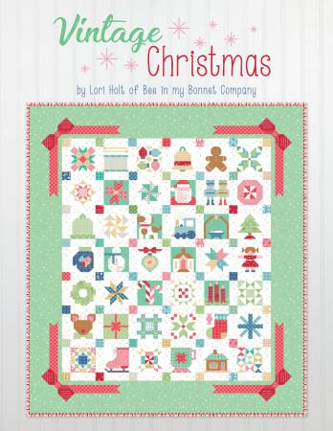
Nancy’s Vintage Christmas Club
March 28
Meets fourth Thursdays for nine months
5pm-7pm
Sewing Machine
Thread and bobbins
Scissors, snips, pins/clips
Seam ripper, hand sewing needles
Lori Holt’s Vintage Christmas book
Variety of fabrics, can be Christmas- prints will work also

