MITERED BORDERS*
Miter border corners when an angled seam complements the overall design of the quilt. For multiple borders, sew strips together first and attach to quilt as one unit.
Step 1. Cut 2 strips the width of the quilt plus twice the border width and 2" inches extra and 2 strips the length of the quilt plus twice the border width and 2" inches extra.
Example: Width of quilt before border = 65"; width of border(s) to be added = 6"
65" + 6" + 6" + 2" = strip 79" long. Cut 2 strips 79" long (width measurement).
Repeat steps for length of quilt.
Step 2. Center and pin border strips in place. Start and end seams 1/4" from raw edges: backstitch to secure. Press seams toward quilt top.
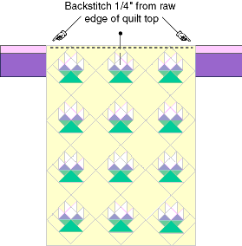
Step 3. Lay quilt top right side up on ironing board and fold each border end flat back onto itself, right sides together, forming a 45 degree angle at the quilt's corner. Press to form sharp creases.
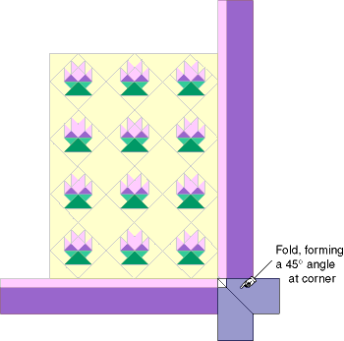
Step 4. Fold quilt on diagonal, right sides together. Align border strip raw edges, border seams at the 1/4" backstitched point, and creases; pin in place. Stitch along crease, backstitching at 1/4" border seam.
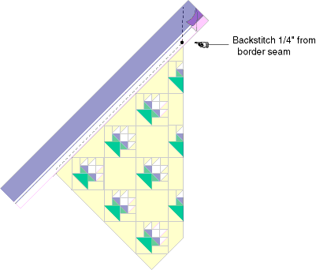
Step 5. Press seam open. With quilt right side up, align 45 degree angle line of square ruler on seam line to check accuracy. If corner is flat and square, trim excess fabric to 1/4" seam allowance.

Always In Stitches
1808 East Conner Street
Noblesville IN 46060
317-776-4227
www.alwaysinstitches1.com

*From the website: http://www.mccallsquilting.com/mccallsquilting/articles/mitered_quilt_borders

