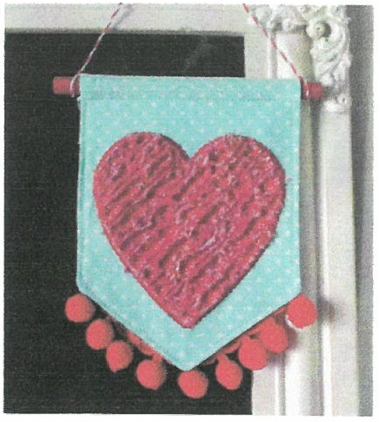
Kimberbell Embroidery Club
Feb. 7
12-3:30
4pm-7pm
