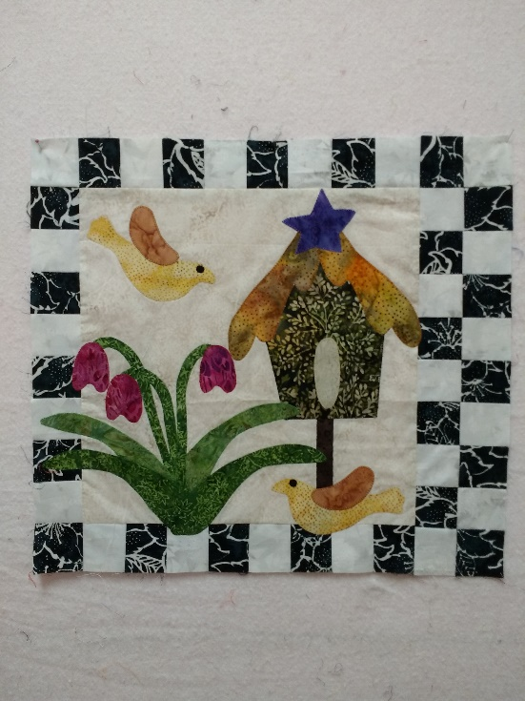

Kathy’s Sweet Applique March
March 5
1pm-3:30pm
Please check book for fabric requirements
And come to class with background and checkerboard finished
Then we will have more time for applique.
Soft fuse, thread, lightweight stabilizer
Sewing machine
Pencil, scissors, pins, open-toe applique foot

