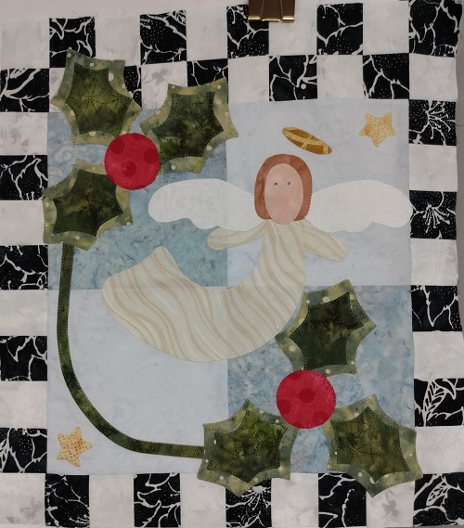

Kathy’s Sweet Applique December
Dec. 3
1:00-3:00
Pat Sloan’s book New Ideas for Applique
Four 8 ½” squares of fabric for background
1/8 yard each of 1 cream and 1 black for checkerboard
Construct background before class according to book
Paper-backed fusible for appliques
Backing stabilizer like poly mesh
Fabric assortment for appliques (see book)
Thread
Sewing machine (you may call the shop to borrow one of ours)
Sewing tools- scissors, pencil, seam ripper
Open-toe applique foot

