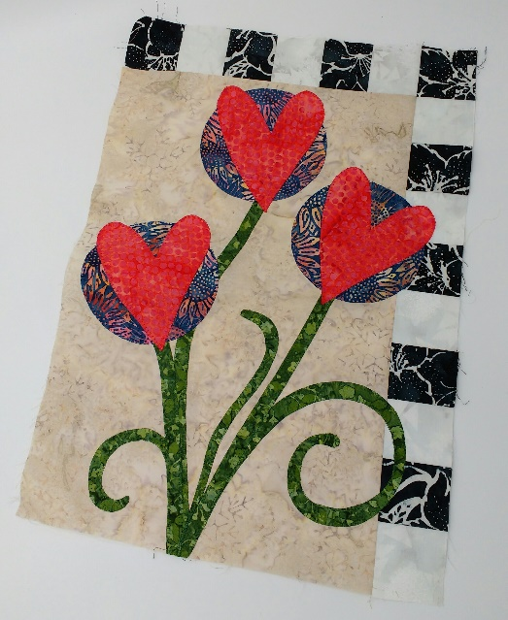
Kathy’s Sweet Applique Block of the Month
Tuesday February 5
1pm-3:30pm
You will need 1/8 yard of each for checkerboard: One light and one dark. If making the entire quilt, you will need 1 ¾ yards of each.
Book: New Ideas for Applique by Pat Sloan
1/2 yard of soft fuse fusible web and tear away
7” x 12” rectangle blue for circles
11”x14” rectangle for hearts
1 fat quarter green for stems and leaves

Sewing Machine
¼” foot, open toe applique foot
Pencil
Thread to match each fabric

