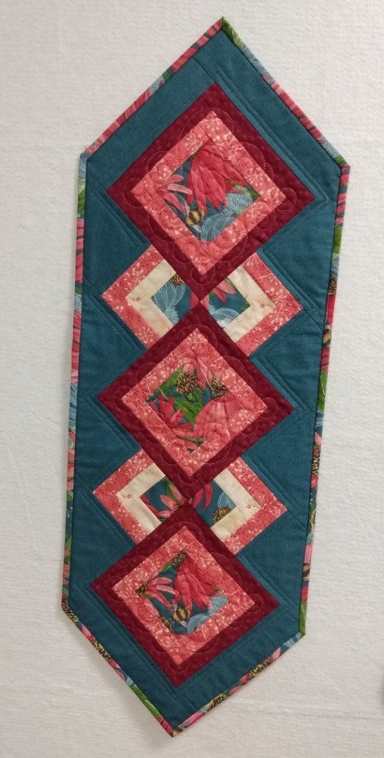
Kathy’s Let’s Do Lunch
Sewing Machine
¼” foot
Sewing tools- scissors, seam ripper, pins, etc
Rulers, rotary cutter, mat
Focus print 3/8 yard
Co-ordinating fabrics for three fat quarters or three ¼ yard cuts
Background 3/8 yard
Backing 5/8 yard
Table runner batting 1 1/3 yards

