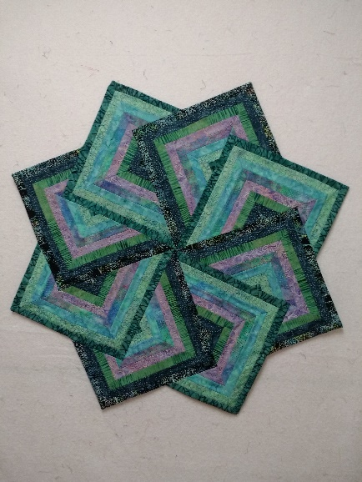
Kathy’s Experienced Quilters
Star Strata
March 5, 26 April 2
4:30-7pm
Eight /14 yard pieces of fabric in different values
Throw-sized batting
Thread
12 ½” square ruler
Sewing machine (you may call and arrange to borrow one of ours)
1/4 “ foot, walking foot
Scissors, pins, ruler, rotary cutter

