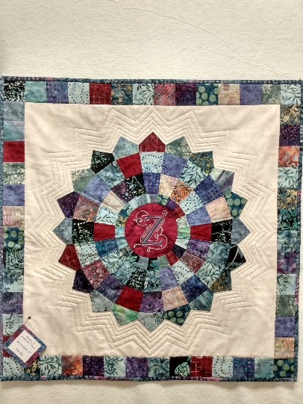

Kathy’s Evening Project Class-Checkered Dresden
Jan 7 & Feb 4
4:40pm-7:00pm

Sewing machine
¼” foot
Walking foot
Scissors, pins, seam ripper
Point turner
Missouri Star Dresden plate layer cake ruler
Rotary cutter and mat
Thread
Craft-size batting

