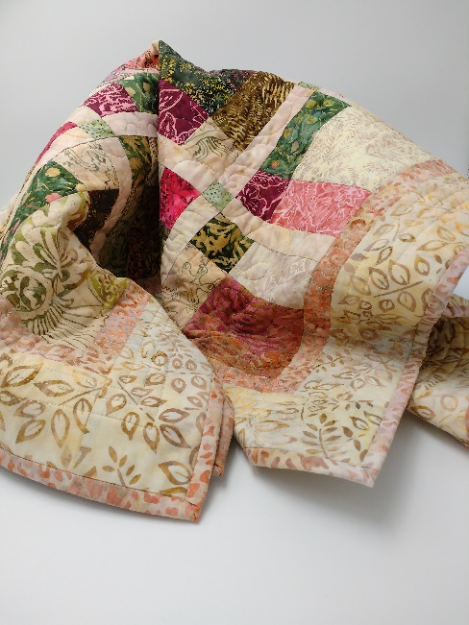
Kathy’s Beginning Quilters Disappearing 9-Patch
Jan. 15, 29, and Feb. 12
4:30pm-7pm
One Charm Pack
1/8 yard or fat quarters for cornerstones
¼ yard for sashing strips
¼ yard for inner border
½ yard for outer border
1 ¼ yards for backing
Crib size batting
Thread
Sewing machine (you may call to set up borrowing one of ours)
¼” foot
Sewing tools: scissors, seam ripper, pins, rulers, mat, rotary cutter

