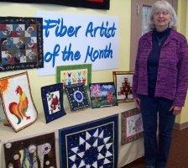
Jo Kidwell
Quilted Wallhangings
A sewist for most of her life, Jo Kidwell passed a quilt shop every time she
walked to the grocery store.
“I never went in,” she said, adding that she loved to look in the windows.
“It was intriguing.”
So one day about 14 years ago, she decided to try her hand at the art.
Jo was captivated, and the quilting world was blessed. Her pieces in the Fiber
Artist of the Month display show a wonderful sense of color and design,
imagination, talent, and enthusiasm for quilting.
“I like the freedom quilting gives me to do so many different things. I’m always
looking for something new to try,”said Jo, who also crochets, has done needle
punching, rug hooking, sewn for her three children and six grandchildren, and
is learning to knit.
Trying something new is how the brightly colored, confident
rooster on display came about. Jo heard about thread painting and wanted to
try it.
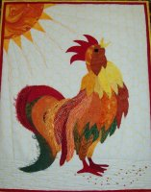
We think
you’ll agree she was very successful at the technique,
and since then,“I have not been afraid to do thread painting on other things.”
Her imagination is evident in the wallhanging that has washers attached.
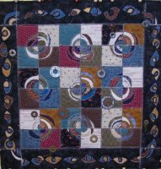
She found the pattern in a magazine but elaborated on it.“It’s so different, so
unique,” Jo said about the piece.“It’s fun to try something new.”
That’s not to say that she doesn’t enjoy and appreciate traditional quilts as
well. ‘I like it all traditional, modern, art blocks” she says, giving you the sense she could
never get enough of any kind of quilting.

Her advice to someone considering quilting or feeling a little intimated at
trying:
“Go for it! Start simple and work up to more complex. That’s what I did.
Once you’re hooked, you can’t stop. It’s addictive.”

