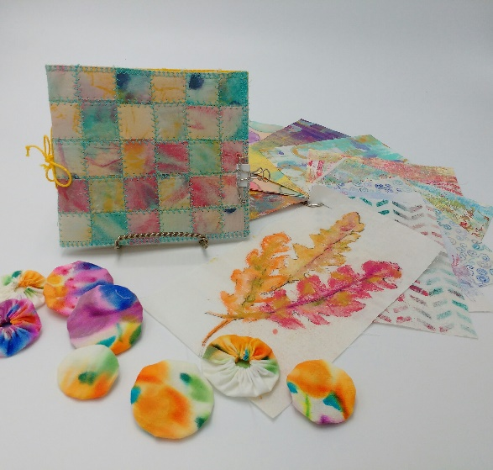

Jamie’s Fabric Painting
May 11, 2019
10am-3:30pm
If you have time, wash and press fat quarters. If not washed, at least press fabric.
1 black fat quarters
1 white on white patterned fat quarter
4+ White fat quarters
1 small patterned fat quarter
Wear old shirt or apron
Bring a sack lunch

