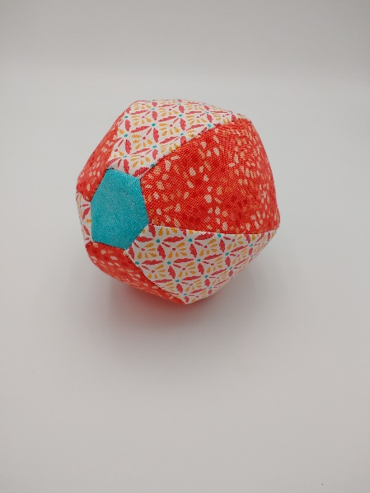

Jamie’s Fabric Bouncy Ball
April 10
10:30am-12:30pm
2 Fat Quarters Complimentary Colors or patterns
2 5” square solid color to match fat quarters
Sewing machine (you may call ahead and arrange to borrow a
machine from Always in Stitches)
thread to match
basic sewing kit
balloon will be provided.

