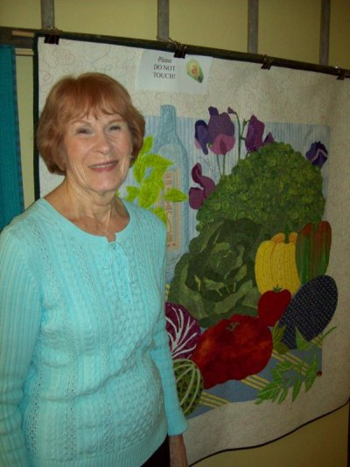
Eleanor's quilt samples changed the way a lot of us looked at quilting.
She uses fabrics to paint a picture.
Eleanor Hickman quilts when she sits down at her machine, but what she creates are landscapes “painted” with thread and fabric. Her machine embroidered quilts are
unspoken testimony to the art of sewing −though you might find yourself oohing and
aahing as you view them. Several of her pieces were featured in the shop during February, as she was ourFabric Artist of the Month. “My belief is that quilting is enjoying a long life, both as a hobby and a vocation because the processesare continually changing and growing into more and more diverse directions,”said the quilter,who lives
in Pendleton. Her ideas come from things she sees, and things she sees in her mind. A cottage was found in a Courier & Ives print, a bounty of vegetables came from a seed packet, a cabin on a lake is her dream retirement home.Her fabric choices are just as accidental, “I buy fabric at random when I see a design that begs to go home with me,” said Eleanor, who
began quilting about the time the country was celebrating its bicentennial. “That creates my stash so when a new quilt is started, I use what I have. That
requires looking through the stash until the right color is found. This way, I learned about good color choices.”
Eleanor was an accountant for 30 years with Guide Division, GMC and raised three sons. After
she retired, she started to branch out from traditional quilting to more contemporary designs, and then she found a book about English Machine Embroidery that set her on another path. “
I was thrilled with the results,”she said.
She has shown her quilts at shows around the country and enjoys competing. Several of her
pieces have won ribbons and occasional prize money.

