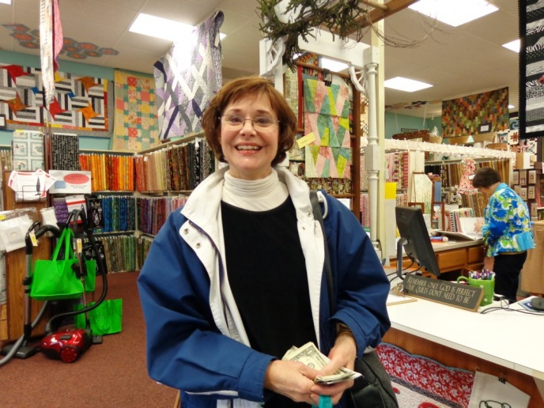
Debbie Lange specializes in t-shirt quilts, and works with her customers to create special keepsake
quilts from mementos and special garments. She keeps a blog of her work.
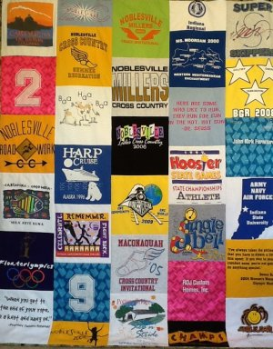
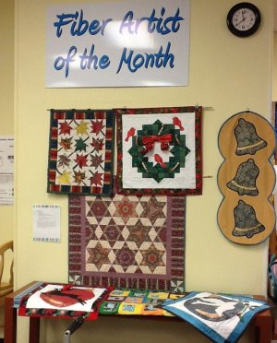
A beautiful memory quilt
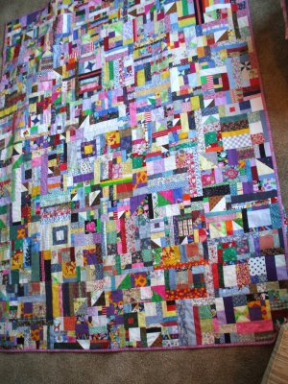
Debbie created cord tacos to keep electronics in check
