Bias Cut Binding
Step 1 - Measure the quilt to determine how many inches of binding you need. Allow 10" extra for turning corners and the closure. The equation is: [(height of quilt + width of quilt) x 2] + 10. Refer to chart to find the size square needed.
Size square to Cut
Length  Needed | 1½˝-Wide  Bias Strip | 2˝-Wide  Bias Strip | 2½˝-Wide  Bias Strip | 3˝-Wide  Bias Strip
110˝ | 14˝ square | 16˝ square | 18˝ square | 20˝ square
220˝ | 19˝ square | 23˝ square | 26˝ square | 28˝ square
340˝ | 23˝ square | 28˝ square | 32˝ square | 35˝ square
480˝ | 28˝ square | 33" square | 37˝ square | 40˝ square
Step 2. Cut the square in half diagonally (Diagram I).
Step 3. With right sides together, sew the triangles together with a 1/4" seam and press open.
Step 4. On fabric wrong side long edges, draw lines to make strips of your chosen binding width (Diagram II). Use a clear acrylic rotary ruler and a pencil or fine-point permanent pen to draw the lines.
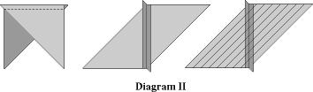

Step 5. Bring the short diagonal edges together, forming a tube (Diagram III). Offset the drawn lines by one strip. With right sides together, match lines with pins at the 1/4" seamline and stitch seam; press open.
Step 6. With scissors, cut along continuously drawn line.
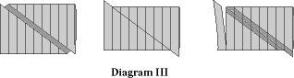

Compliments of
Always In Stitches
1808 East Conner Street, Noblesville IN 46060
317-776-4227 www.alwaysinstitches1.com

Formula for Figuring Backing:
__________” Quilt Top Length
+ 4” For Extra Backing
÷ 36”
= _________ yards
x 2 * if your quilt width is 38” – 80”
= __________ yards backing fabric
(round up to nearest ¼ yard)
*If your quilt width is 37” or less, multiply by 1
*If your quilt width is 80” or more, multiply by 3

Formula for Figuring Straight Cut Binding
__________” Top measurement
+_________” Bottom measurement
+_________” Left side measurement
+_________” Right side measurement
+ 12” just in case
÷ 40” usable fabric
= _________ number of binding strips
x _________ width of strip
÷ 36”
= _________ yards of fabric

Add a hanging sleeve to your quilt back:
- Measure width of quilt add 2” to find width of sleeve
- Standard finished height is 4” (4”x2 = 8” + 1” = 9” cut width)
Fold in 1”, then under ½” to finish both ends of sleeve
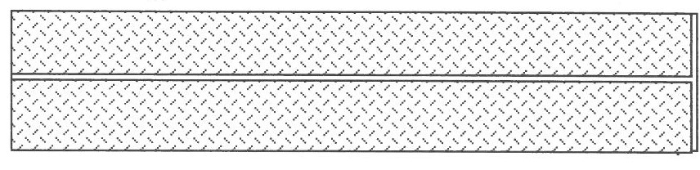
Fold right long sides together and sew
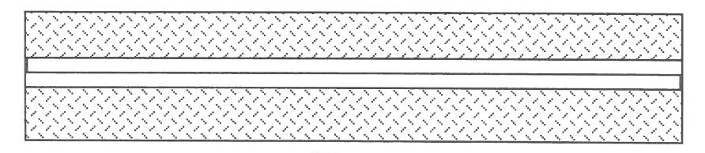
Press seam open

- Sleeve may be attached after binding is complete or before
- Be sure to secure the bottom long edge of the sleeve to the quilt

